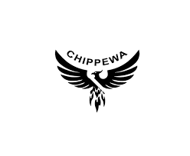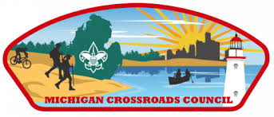

Lumberjacking in the Thumb

Klondike 2026 Leaders’ Guide

February 22, 2025 Memphis Lions Club

34758 Pratt Rd, Memphis, MI 48041

*A Youth-Run, Patrol-Based Winter Event for Scouts BSA, AOL Scouts, Venturers and Sea Scouts*

Co-Hosted by the Ma’iingan and Chippewa Chapters, Mishigami Lodge 29, Order of the Arrow

**Ma’iingan Chapter Chief: Zach Chisholm // Chapter Adviser: Joe Phillips**

**Chippewa Chapter Chief: Bella Taft // Chapter Adviser: Kevin Wicklund**

**East Area Adviser: Jennifer Sanker**

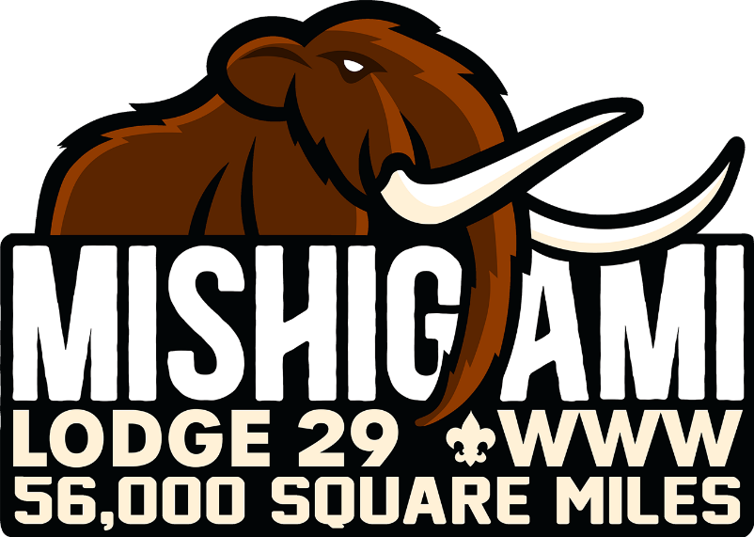

Klondike 2026 LEADERS GUIDE

All units need to ensure that the paperwork required by Council for your unit to gather is on hand in case it is needed. **An accurate roster must be turned in when you register.** This will be used for contact-tracing if needed. There must be a paper copy of each participant’s health form A & B. Digital copies are not acceptable.

Our staff is being trained to also watch over the safety aspects of their stations this weekend. Please help them. Remember, they are volunteers and mostly youth.

The Klondike is a winter event in which Scouts compete in Patrols/Crews in events variously emphasizing Scout skills, teamwork and spirit. Youth-led units compete. We are offering Troops, Crews and Ships he option to spend Friday night, Saturday night or both to complete a winter campout experience at no additional cost.

This year’s theme:

Lumberjacking in the Thumb

# Who Is Invited:

Scouts BSA Troops, Venture Crews, Sea Scout Ships and AOL Scouts may attend. AOL Scouts are required to attach themselves to a Scouts BSA Troop for competition preferably to a Troop they are considering joining. Scouts & AOL Scouts arrive Saturday morning. AOL Scouts must be attached to a Troop for the day.

# Patrol Method and Leadership

One of the two purposes of the Klondike is to learn and have fun while using the Patrol

Method. The competition is organized by patrol, crew or den. All Scout patrols should be under the leadership of a Patrol Leader (PL) at all times, with an Assistant Scoutmaster or other designated adult leader present. Scout troops should be under the direct leadership of a Senior Patrol Leader (SPL), guided by a Scoutmaster or other designated adult leader. Venture crews

should be under the leadership of their President, with the Adviser or other designated adult leader present.

# Youth Staff

The Klondike is a 100% youth-created, youth-run, youth-led event. The event and its activities have been planned and developed by youth and will be staffed by youth, as part of the Order of the Arrow’s leadership development mission.

The second purpose of the Klondike is to provide a learning experience for staff. Staff objectives include learning and practicing brotherhood, cheerful service, and an introduction to event management/leadership on a modest scale. While the staff and their advisers strive to prevent or minimize problems, we ask unit leaders, in the spirit of Scouting, to help turn any issues which may arise into positive learning opportunities for all.

Scout troops are strongly encouraged to provide at least one OA member (preferably a buddy system of 2) other than the SPL and PLs to help staff the Klondike (example: OA Troop Rep and a first-year Arrowman). Due to staff capacity limitations, not all applicants may be accepted, so it is important prospective staff members sign up in advance to receive the benefits of being on staff. Do not register approved staff members as part of your unit’s contingent.

*Facilities*

# THIS IS A LEAVE NO TRACE EVENT

Out of respect for the facilities made available to us, please ask your members to help us leave the grounds and buildings cleaner than we found them. Please, follow the LNT guidelines for this event and leave the facilities better than we found them.

# Restrooms

Restrooms are available on site. Please remind your members to respect others by leaving the restrooms as clean as or cleaner than they found them.

# Clothing

One of the most important parts of a winter event is to keep warm and dry. Each Scout must be prepared for the weather and temperature and dress appropriately. Weather is changeable, requiring preparedness for almost any condition. A nice day can turn into a blizzard or become rainy and cold.

For colder weather, dress in layers: A waterproof outer layer, a warm middle layer and a wicking layer next to the skin. Units should teach participants to avoid working up too much

perspiration and to regulate their temperature by removing or adding layers of clothing as needed. Waterproof boots, coats, headgear and gloves/mittens are essential, as are waterproof snow pants or rain pants. For warmth, insulated boots, wool or synthetic socks, hooded coats or wool or synthetic caps, wool shirts and synthetic long underwear are strongly recommended.

Teach your members to use good judgment when preparing for the weekend and to check the weather forecast to ensure a safe and comfortable event.

Unit leaders should visually inspect each Scout. Prior to the event beginning, ask every scout if their clothing is dry. If not, have him change into dry clothes before continuing.

# First Aid

Each unit should be prepared with first aid equipment and supplies (readily identifiable) for caring for cold exposure and small wounds. More serious injuries must be taken to the Health and Safety Officer at the event headquarters for immediate treatment or departure to a local hospital.

# Trading Post

# Mishigami Lodge Training Post

# Ma’iingan Trading Post

# Chippewa Trading Post

# Sites and Parking

Units are strongly encouraged to carpool. All vehicles are required to be parked in designated parking areas.

# Equipment

Each unit must provide its own event equipment. Please bring with you the following Unit Equipment:

* Above Ground Firepit.
  + No Ground Fires Allowed. No flames over 24 inches high.
* Packout stove for meals
* 4 pieces of 6-foot wood stave poles
* Matches & other fire starters, tinder and kindling
* Firewood will be provided for events. Units must provide their own firewood if camping.
* First Aid Kit
* Work Gloves
* Clothing for the weather
* Proper equipment for overnight if camping
* American flag to retire
* 25-foot rope 3/8 in diameter for lashing
* 4-quart pot with handle
* Klondike Sled Specifications
* 8-foot by 10-foot tarp

Sleds need to be built before you get to camp. This year's theme is Lumberjacking in the Thumb, please decorate your Klondike sled to theme, if you are able. ***Units/Patrols should include a wheel kit for their sleds in the event of limited snow cover on the trail.***

# Flags

Each unit and patrol/den are requested to bring a troop, patrol, crew, pack or den flag.

# Water

Water is available in the camp. However, units may wish to bring their own water with them. Please ensure that your Scouts remain hydrated by regularly offering warm drinks. Hydration is critical to participant safety.

# Meals and Cooking

Units are responsible for all meals for the weekend, including during the event.

# Trash in – Trash out.

Remember the Outdoor Code and leave the grounds cleaner than you found it. You will need to take your trash with you.

# Check In

Registration and check-in will be by Unit.

# Check Out

When a unit is ready to check out after the closing ceremony, the youth and adult leader must come to the registration headquarters to receive patches and pick up medical forms.

# Group Size

Patrols, dens and crews must have at least 4 youth participants to compete. Members of different units may be paired together to form a full patrol.

# Competition Skills, Activities and Preparation

The competition activities will be listed in the **Competition Summary** be distributed in a separate document. This will include the skills and equipment which patrols, crews or dens need to bring and equipment to be provided by the Klondike staff. Prepare your Scouts accordingly.

# Scoring

Scoring will be assessed on Teamwork, Spirit, Creativity and Achievement. The point values of each competitive activity will be listed in the Competition Summary.

Schedule of Events

**Friday Night, January 9st**

* 6:00 PM to 8:00 PM – Registration and Check-In for those units camping Friday night
  + No extra Charge for either or both Friday or Saturday night camping
  + Units are responsible for all equipment needed for overnight camping
  + Units are responsible for all meals for the weekend, including during the event
  + Check-out for those units camping Saturday night is Sunday at 11:00 AM

**Saturday, January 10th**

* 8:00 AM - Registration and Check-In
* 8:30 AM - Flags and Opening Ceremony
* 9:00 AM to Noon – Morning Program
  + 4 – 45-minute sessions
* Noon to 12:50 PM - Lunch
* 1:00 PM to 3:15 PM – Afternoon Program
  + 3 – 45-minute sessions
* 3:30 PM to 4:00 PM - Klondike Sled Race
* 4:15 PM - Awards & Closing Ceremony