Coin Collecting Merit Badge
Saturday, November 1, 2025, 11:00 am – 1:00 pm
Kalamazoo County Expo Center

The Coin Collecting Merit Badge will be offered for registered Scouts at the November 1, 2025 Kalamazoo Numismatic Club Coin Show. The show will be held at the Kalamazoo County Expo Center (Fairgrounds). The show will run from 9 am to 3 pm, and the Merit Badge session will run from 11:00 am to 1:00 pm. There is no charge for admission to the show or to participate in the Merit Badge session. The Merit Badge Counselors are Jim VanderRoest, Brad Bloom, and Peter Copeland, all registered Scouters and club members.

Scouts should obtain and read the Coin Collecting Merit Badge pamphlet in advance of the show. Please note that some requirements for the Coin Collecting merit badge changed effective January 1, 1024. The current requirements for Coin Collecting merit badge are listed on the reverse of this notice. As is the past, some advance work will need to be done by the Scout if the Merit Badge is to be completed at the show. Otherwise, the Scout will receive a “partial” and will need to complete any incomplete requirements on his/her own.

Requirement 4 (below) requires the Scout to have collected certain coins and to explain certain information about the coins to the merit badge counsellor. Each Scout should therefore bring to the merit badge session the coins listed in Requirement 4 and be prepared to discuss the prescribed information.

4. Do each of the following and explain to your counselor the design features, designer name, designer initials, and where to find them for each item:
- (a) Collect a one-cent coin from the year group: 1959-2008 (that is, dated between 1959 and 2008) and a one-cent coin from the year group 2010-present. Explain how and why the one-cent coins issued in 2009 were different from either of the other two year groups.
- (b) Collect two five-cent coins, one from each of these year groups: 1959-2003 and 2006-present. Explain how and why the five-cent coins issued in 2004-2005 were different from either of the other two-year groups.
- (c) Collect a ten-cent coin from 1965-present.
- (d) Collect a twenty-five-cent coin from 1965-1998, two examples from the 50-State Quarter® /territories Program 1999-2009, two designs from the America the Beautiful® program 2012-2021 and two designs from the American Woman Quarter® program (2022-2024). Explain the purpose of each of those programs.
- (e) Collect a half dollar coin from 1965-present.
- (f) Collect a dollar coin from each of these design groups: Susan B. Anthony 1979-81, Sacagawea 1990-2005, U.S. Presidents 2000-2014.

Please note that attendance at the show (with the parent’s permission) completes requirement 7. (7 (d)(1) Each Scout should attend the show with his/her parent or Scout leader. Scouts and Scout leaders should please wear their Scout uniforms. The Merit Badge session will begin at 11:00 am sharp and should be done by 1:00 pm. Each Scout will be required to complete each requirement individually.

All Scouts who attend the Coin Collecting Merit Badge program on November 1st will receive at no cost a special Whitman coin folder developed especially for the Coin Collecting Merit Badge, shown at right.
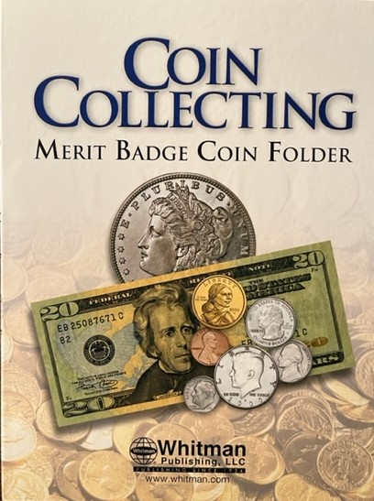

Questions: Call Peter Copeland at 908-672-8404 or send email to pacopeland73@aol.com.

Coin Collecting Merit Badge Requirements (2024)

1. Understand how coins are made and where the active U.S. Mint facilities are located.
2. Explain these collecting terms:
- (a) Obverse
- (b) Reverse
- (c) Reeding
- (d) Clad
- (e) Type set
- (f) Date set

3. Describe three different ways to store a collection, and the benefits, drawbacks, and cost of each method.
4. Do each of the following and explain to your counselor the design features, designer name, designer initials, and where to find them for each item:
- (a) Collect a one-cent coin from the year group: 1959-2008 (that is, dated between 1959 and 2008) and a one-cent coin from the year group 2010-present. Explain how and why the one-cent coins issued in 2009 were different from either of the other two year groups.
- (b) Collect two five-cent coins, one from each of these year groups: 1959-2003 and 2006-present. Explain how and why the five-cent coins issued in 2004-2005 were different from either of the other two year groups.
- (c) Collect a ten-cent coin from 1965-present.
- (d) Collect a twenty-five-cent coin from 1965-1998, two examples from the 50-State Quarter® /territories Program 1999-2009, two designs from the America the Beautiful® program 2012-2021 and two designs from the American Woman Quarter® program (2022-2024). Explain the purpose of each of those programs.
- (e) Collect a half dollar coin from 1965-present.
- (f) Collect a dollar coin from each of these design groups: Susan B. Anthony 1979-81, Sacagawea 1990-2005, U.S. Presidents 2000-2014.

5. Describe and discuss with your counselor the special reverse designs of the quarters, half dollar and dollar coin struck in 1975-1976 to honor the U.S. Bicentennial.
6. Identify for your counselor the people depicted on current currency: $1, $2, $5, $10, $20, $50, and $100 notes. Explain where United States currency is printed.
7. Do ONE of the following:
- (a) Collect and identify for your counselor 20 different world coins from at least 7 different countries. Identify the country, major design elements, and denomination of each.
- (b) Collect and identify for your counselor 20 different world paper money from at least 7 different countries. Identify the country, major design elements, and denomination of each.
- (c) Collect and identify for your counselor 20 different tokens and/or medals. Identify the issuer and use of each.
- (d) Complete one of the following and report to your counselor what you experienced:
- (1) Attend a coin show
- (2) Attend a coin club meeting
- (3) Tour a U.S. Mint facility or museum
- (4) Tour a virtual exhibit (with your parent or guardian's permission) approved by your counselor.

