BLUE WATER NESA Merit Badge DaY WILL BE AT PERCH POINT AGAIN!



***Perch Point Conservation Club***

***7930 Meisner Road, Casco MI.***

**The date is May 17, 2025.**

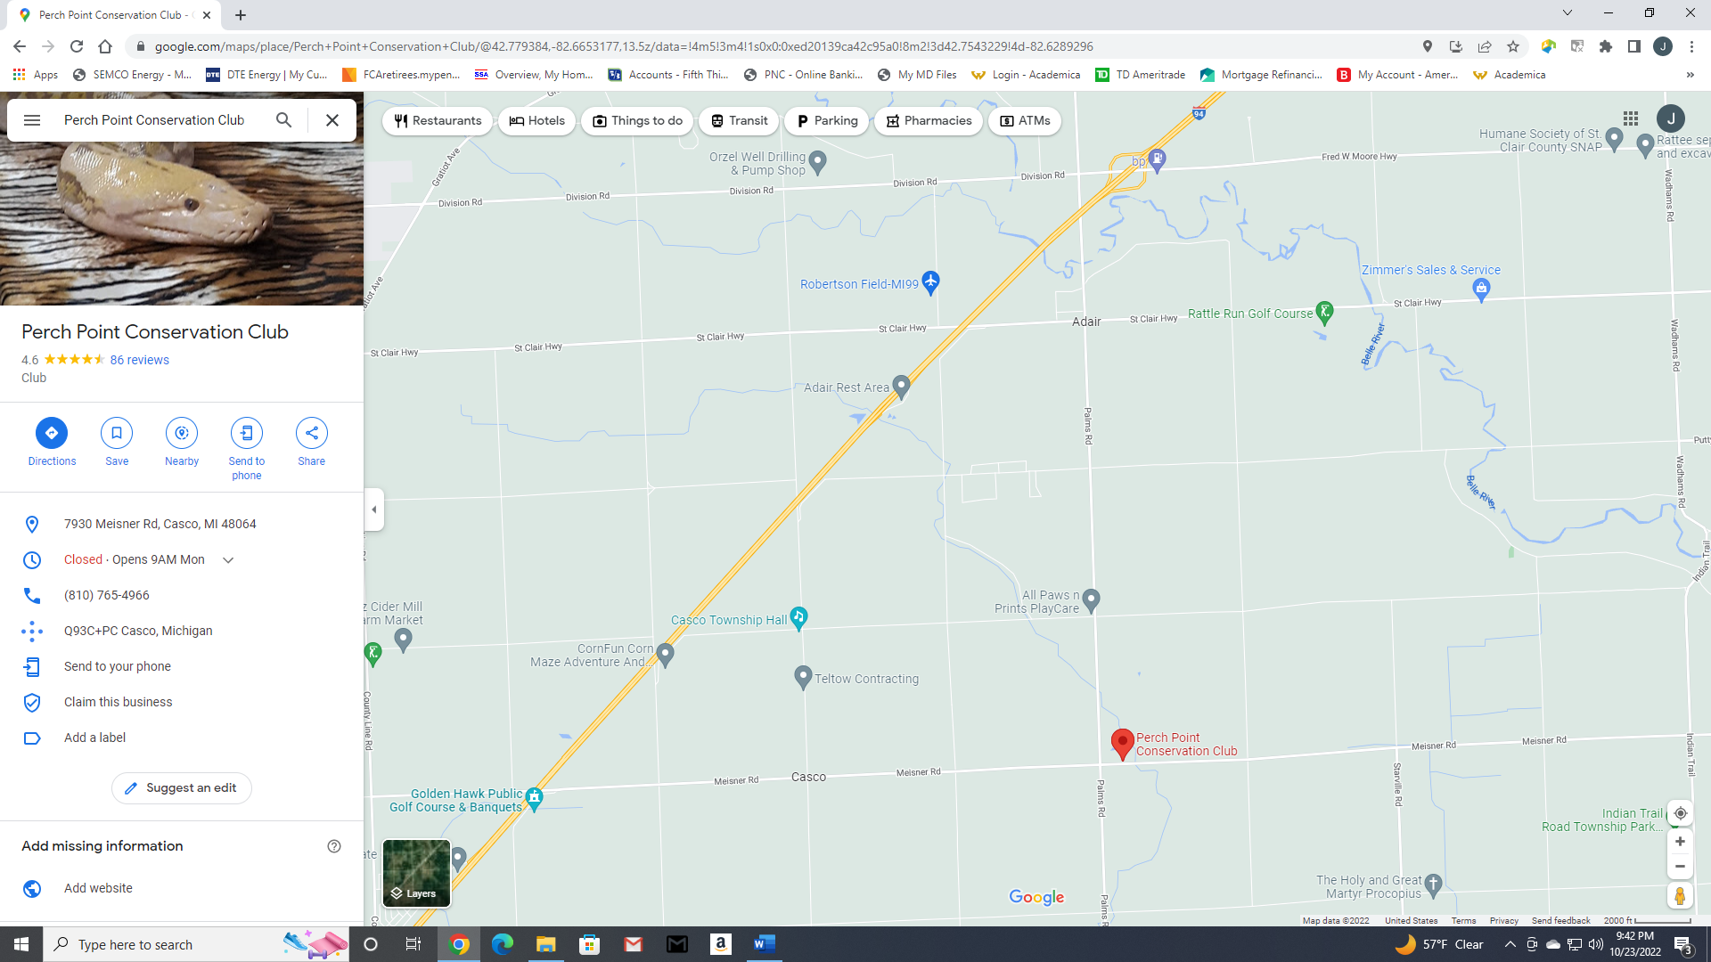

North