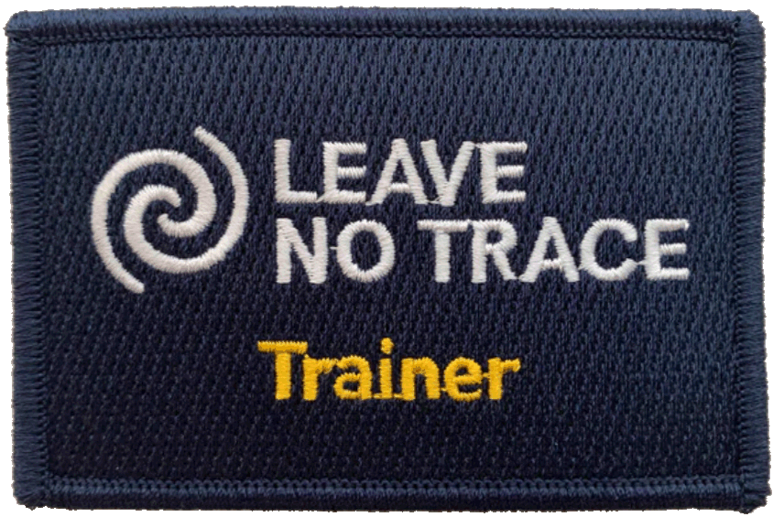
LEAVE NO TRACE TRAINER COURSE
WHY: Participants in the two-day Trainer Course learn Leave No Trace skills and ethics as well as techniques for educating others about these low impact practices. Graduates of a Trainer Course are prepared to offer Leave No Trace Awareness Workshops to their troops, packs, posts, and crews.
This course will significantly improve your knowledge and understanding of how Leave No Trace protects the outdoor places we love.
WHAT: 2 days of hands-on, experimental learning about our effects on the outdoors and ways to avoid or minimize the impacts.
WHEN: September 23 & 24, 2023 8:30 AM to 3:00 PM
WHERE: Nobscot Scout Reservation, 1 Nobscot Road Sudbury MA 01776
WHO: All outdoor enthusiasts with an interest in Outdoor Ethics. Open to registered adult Scouters and older youth*
Cost: $90.00/person. Fee includes supplies, handouts, meals and more.
REGISTER at: Mayflower Council - Leave No Trace Trainer Course-BSA (scoutingevent.com). Deadline: September 3, 2023
CONTACT: Pete Lane pete.lane@comcast.net
- Youth must be at least 14 years of age and must be willing and able to conduct themselves appropriately for an adult training experience that is tightly scheduled and highly interactive.
- All participants must submit BSA health form parts A & B and sign the Leave No Trace Disclaimer of Liability form.

