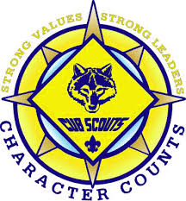
Cub Scout Training Day

Who: For All Registered Cub Scout Leaders
Cubmasters, Committee Chairs & Members, Den Leaders
Where: Montessori Renaissance Academy

1333 5th Ave, Anoka, MN 55303
When: Wednesday March 20th 2019
6:30 -8:00pm
Why: Because Every Youth Deserves a Trained Leader

Cost: Free

Registration link: https://www.scoutingevent.com/250-TRTraining19

Questions?
Contact Heather Klemm, District Training Chair
dancemom79@hotmail.com

