Where and How to Make Your Order of the Arrow Conclave On-Line Registration
(You can of course walk into your Conclave and pay at check in)

Here is the Web address: https://www.scoutingevent.com/250-2018oaconclaves

- Here is the 1st Screen where you will Choose Your Chapter Conclave
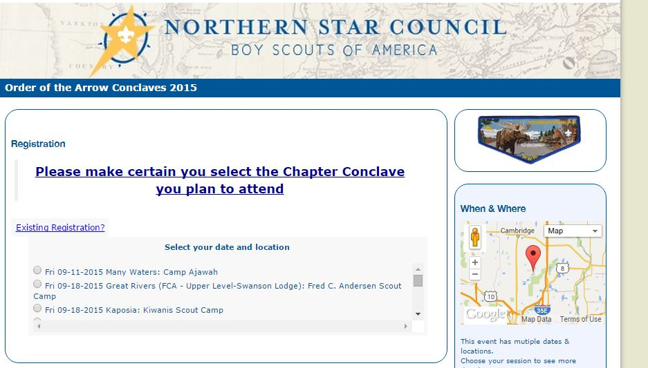

- Select Your OA Membership Level and Enter The total # of participants for each in your registration
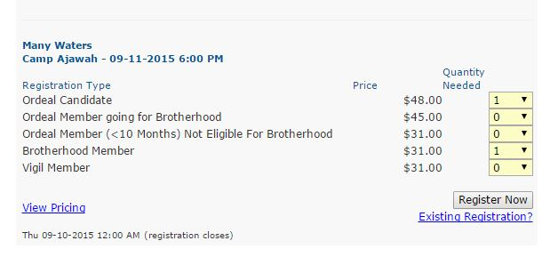

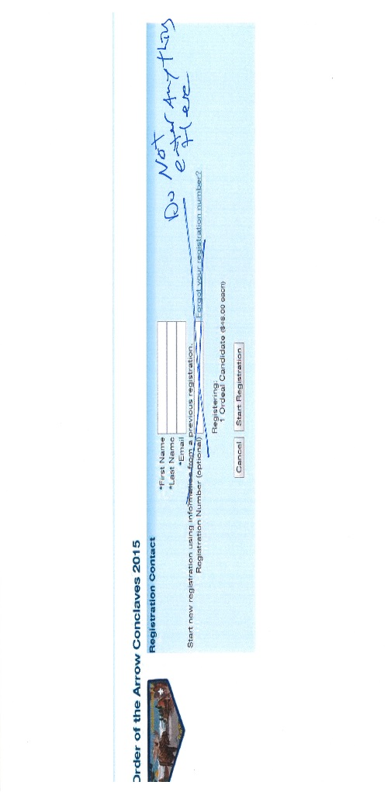

- Person Making this Registration enter your First, Last Name and Your Email Address

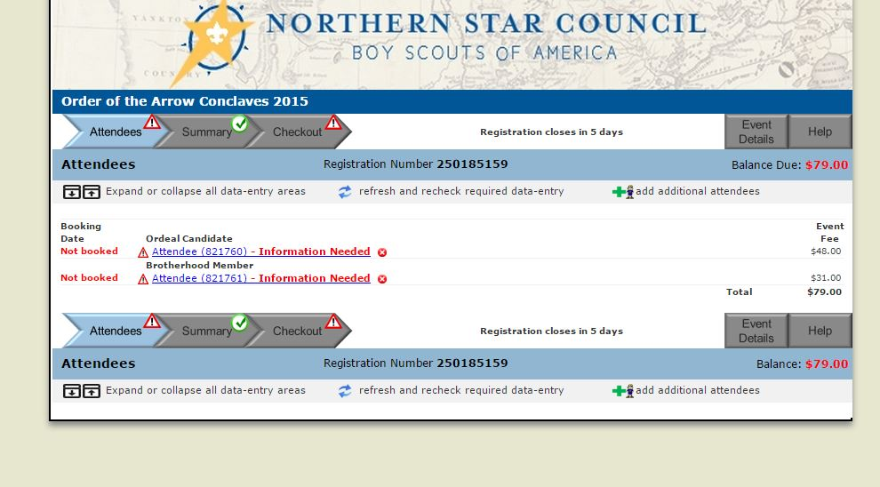
- Enter all the Attendee(s) information in by clicking on each Attendee Line

- Snap Shot of Attendee Information Started

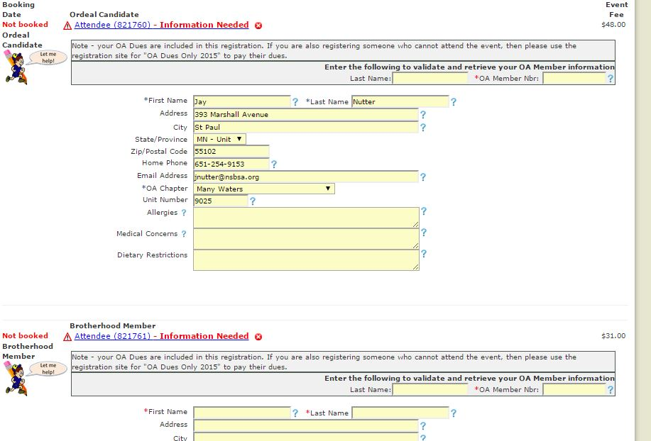

- You MUST Enter EACH attendees Last Name and Lodge Master OA LM ID# Which is found in your Conclave Invitation Letter
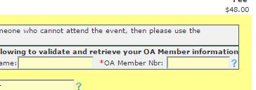

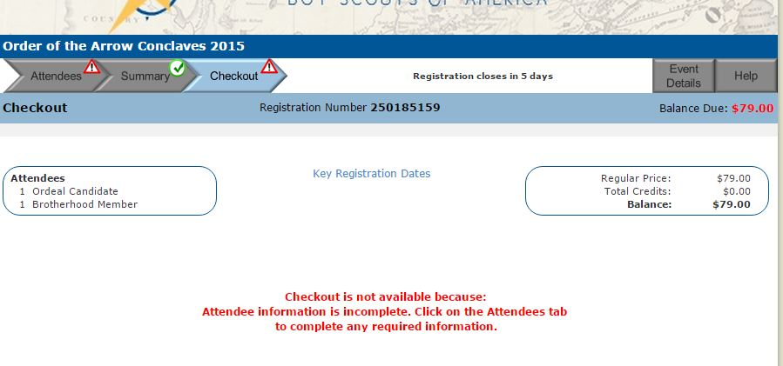
- If you get this Screen, click on the Attendees Tab and Finish entering the missing information

- After all information is in for each attendee, click the CHECK OUT Tab
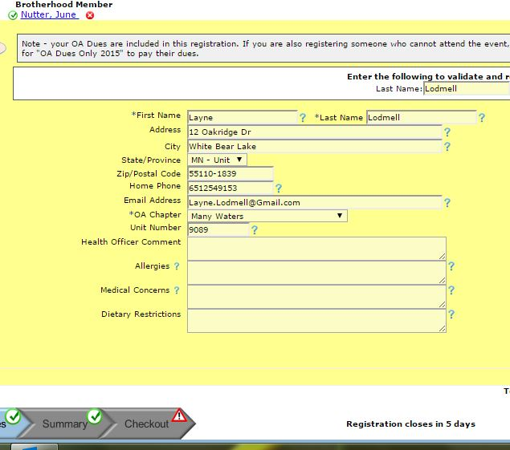

- On the next Screen Click BEGIN CHECK OUT
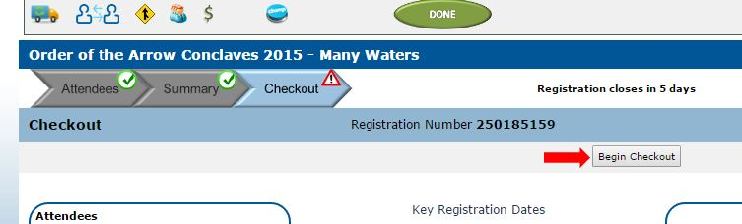

- Enter the correct Address for the Person Responsible for Payment (Person making the Registration) click NEXT
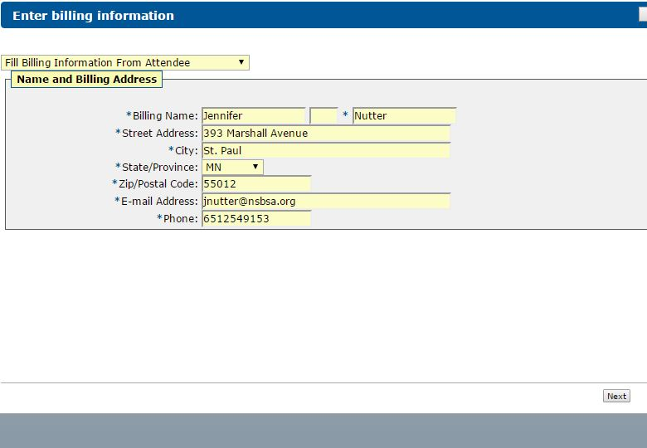

- Choose your method of payment and fill in all the details – Book Registration
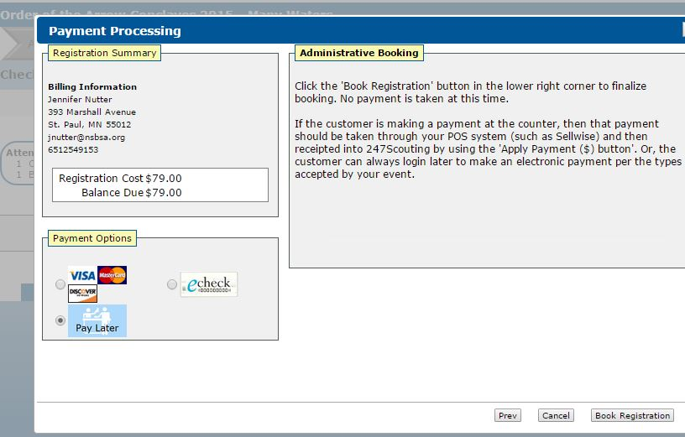

- IIf You Choose Credit Card: Fill in all the information, Book Registration
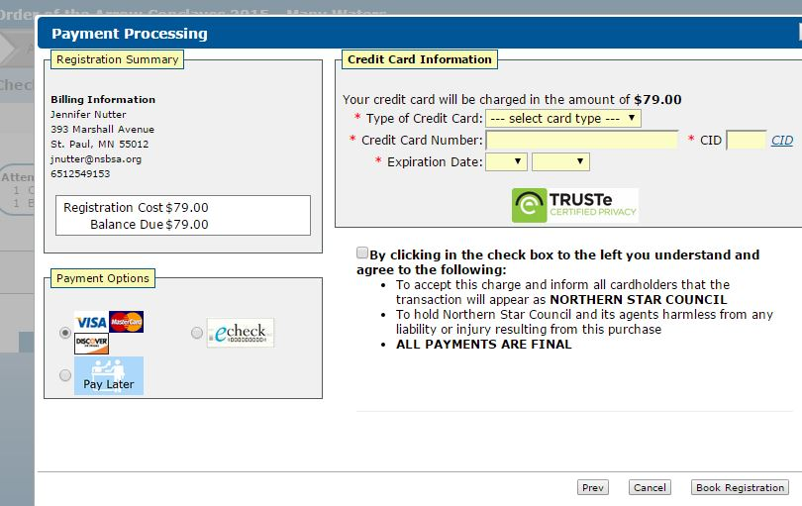

- If you Choose ECHeck: Fill in all the information, Book Registration
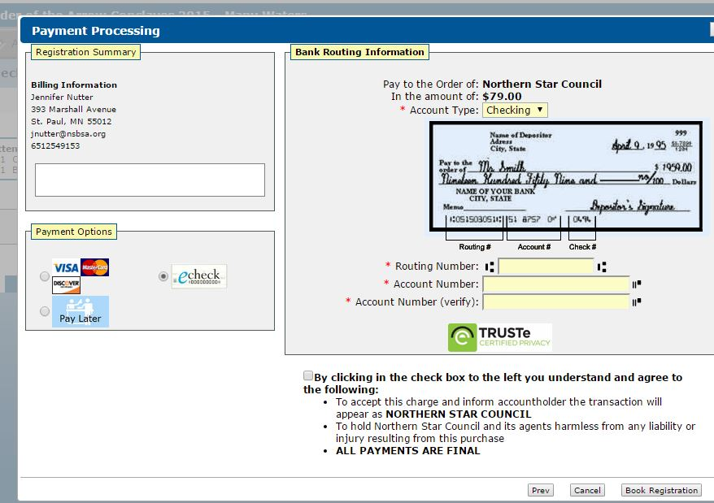

14 After Payment Page is finished, Here is your Confirmation Page – Click Done Suggested that you keep a copy of this page, however you will receive a confirmation email.
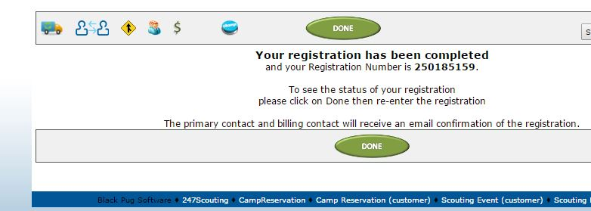

- Your Registration is complete. Thank you for utilizing the On Line Conclave Registration system.

