Conservation Day – October 3rd, 2026.
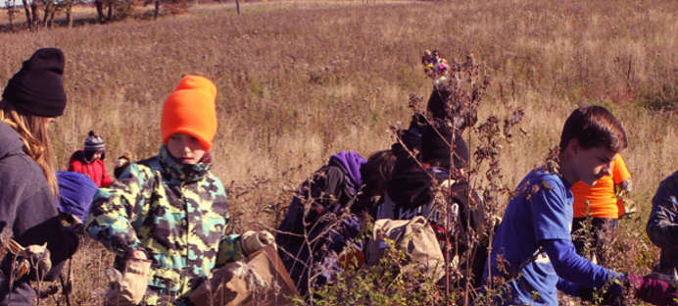
Conservation Day Camporee is a non-standard Camporee in the Scouting sense. Rather than games and competitions, Conservation Day Camporee offers the opportunity to earn up to 5 conservation service hours, support US Fish & Wildlife’s St Croix Wetland Management District prairie management techniques, and learn what is unique and fascinating about Waterfowl Production Areas and prairies.
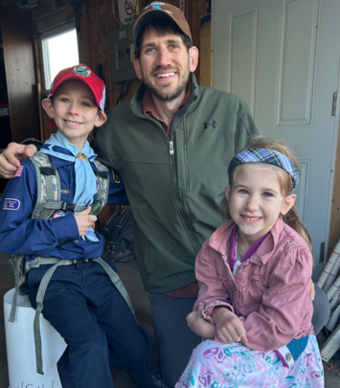
Day Schedule for participants in Fall Camporee at Fred C Andersen Scout Camp: October 2, 2026 to October 4, 2026.
- Breakfast in camp: 6:30 – 8:00am.
- 8:00 – 8:15am - Prep for field activities. Dress for the weather. Sturdy boots, dress in layers (it can start in the 30’s and get to 60’s by early afternoon. A hat, gloves and a water bottle (a must).
- Be ready to load onto busses at 8:30AM sharp. Directions will be provided at registration Friday night. Due to limited parking driving separately is discouraged.
- 8:30 – 8:50: Drive to either St Croix WMD Office or Seed Farm
- 9:00am Sharp – Safety and activity briefing by Fish & Wildlife.
- 9:00 – 11:30am. – Work activities – prairie seed collection (primary), invasive species remediation (secondary).
- 11:am – 12:30pm – Lunch. Hot dogs, chips, sweet treat and beverages.
- 12:30 – 2:00pm – Afternoon work activities.
- 2:00 – 2:30pm – Post day summary/ review and group pictures.
- 2:30pm – Load busses for return to Fred C Andersen Scout Camp.
- 3:00pm – Units are free to do as desired. Hike, camp activities, etc…
