River Hawk District
MERIT BADGE MANIA
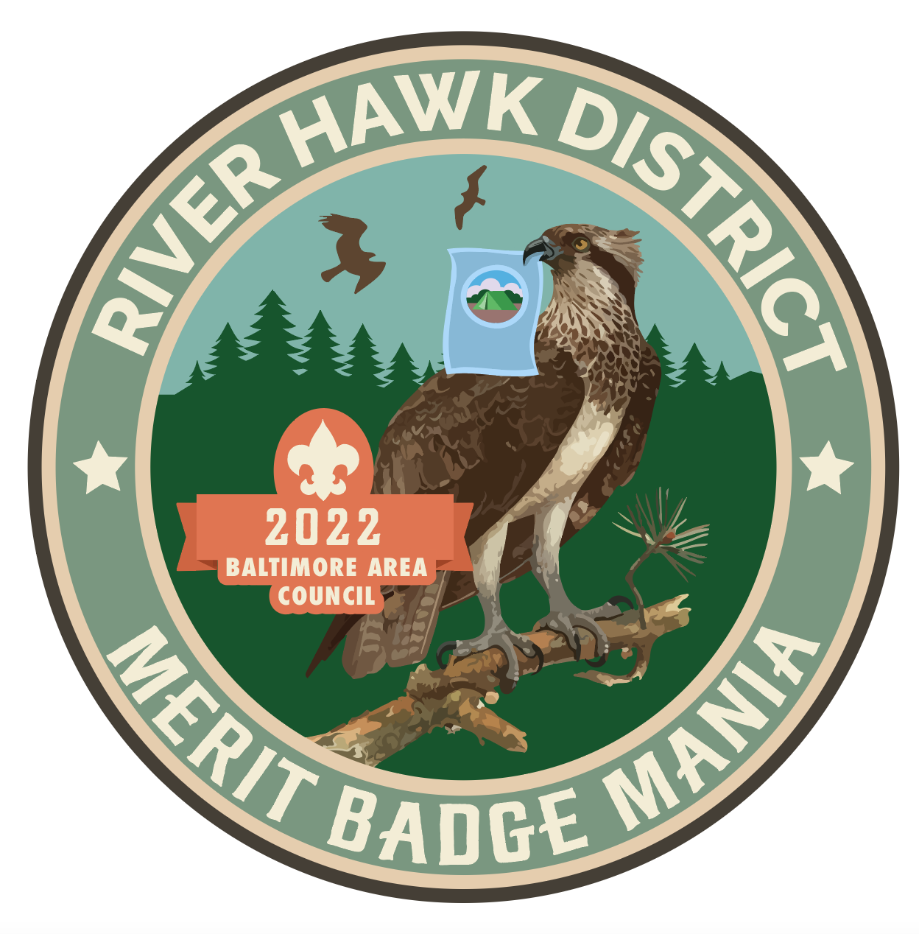
FALL 2022
LEADERS’ GUIDE

Camp Saffran
Broad Creek Memorial Scout Reservation
1929 Susquehanna Hall Rd, Whiteford, MD 21160

September 16-18, 2022

(Revised 08.27.22)

Introduction
Merit Badge Mania 2022 is the premiere Merit Badge weekend camporee presented by the newly-formed River Hawk District in the Baltimore Area Council. Troops will gather for a beautiful outdoor experience at Camp Saffran in Harford County, MD. Scouts will attend merit badge classes covering a variety of subjects from Camping and First Aid to Indian Lore and Radio. All participants are strongly encouraged to follow best practices for hygiene and safety and are expected to adhere to the Scout Oath and Law at all times.

Event Leaders

Merit Badge Mania 2022 is presented by the following dedicated Scouters, who will be happy to answer your questions and help as much as possible:

Event Chair | John Boia | 443-474-0366 | jboia@comcast.net
Registration | Debi Hayes | 301-741-1105 | RiverHawkDistrictRegistrar@gmail.com

Registration Information

Registration is on a first-come, first-served basis. Payment is due upon registration to reserve your spot. Registration deadline is September 9, 2022.

Participant Fees

Scouts | $30 | Staff | free
Scouts (Open Program) | $15 | Staff w/meals | $10
Scout leaders | $10

Online Registration
https://www.scoutingevent.com/220-RHDMeritBadgeMania

General Guidelines

The following guidelines apply to all participants and staff.

- Please remember that we will be guests of Broad Creek Memorial Scout Reservation (BCMSR). The Scout Oath and Law are the “words of the day” and are expected to be observed at all times. Anyone who is found violating the rules will be sent home.
- BSA Field Uniform (“Class A”) is the expected attire for most merit badge classes and other assemblies. Activity uniform (“Class B”) or casual attire is suitable at other times. Everyone should wear durable, closed-toe footwear.
- Blue-card packets will be distributed Sunday after all classes are completed. Scoutmaster or designee must sign for each packet.

Troop Camping

The following guidelines apply to all troops camping on-site for this event.

- Campsites will be assigned upon arrival unless prior arrangements have been made with event leaders. Some campsite pavilions may be needed for merit badge class locations.
- Troop leaders should bring a roster of all youth and adult participants, and a BSA Annual Health and Medical Record (“health form”) for each person. Keep them secure and accessible in the event of an emergency.
- Please submit any patrol-planned campfire skit or song when checking-in Friday evening. Use the form included in this Guide.
- Troops must plan to be self-sufficient and bring their own camping gear.
- Water will be available at camp but troops should plan for contingencies.
- Troops will provide their own meals at their designated campsites. Staff meals will be provided by the Event Quartermaster at Cole Lodge/Dining Pavilion.
- Troop leaders are responsible for monitoring their Scouts, particularly when classes are not in session.
- Sleeping in trailers is prohibited. Consumption of alcohol is prohibited.

Day Trip Attendees

The following guidelines apply to Scouts who will attend the event as a day trip and who will not camp overnight with a troop.
- Day trip attendees should bring a day-pack including food, snacks, water bottle, rain gear (if needed), and any other personal items, in addition to any items listed per the pre-requisites described in the Leaders Guide.
- We strongly recommend that a parent accompany a lone Scout for the day. This is not a drop-off-and-pick-up type of event.
- Class periods begin at 8:00 am Saturday, 1:00 pm Saturday, and 7:30 am Sunday. Please allow sufficient drive time to get to camp, park, and walk to your class location.

Provisional Campers

In order to make our event as accessible as possible, we can host a limited number of provisional campers. These Scouts will be placed with a host troop for the weekend.

- Provisional campers should bring their own tents and personal camping gear, such as they would take on a typical troop outing. Do not assume the host troop will have everything you need.
- They must bring their BSA annual health and medical record, and a copy of parent’s medical insurance card, and any prescribed medications in original containers.
- They should bring $15 cash to pay the host troop for meals for the weekend.
- Host troop leaders will contact the Scout’s family within two weeks of the event, in order to make arrangements for the Scout’s medical and dietary needs.
- Provisional campers may be asked to participate in troop chores and activities beyond the attendance of merit badge classes.
This option should be considered as a last resort, and the number of slots is limited.

Merit Badge Classes

The following guidelines apply to ALL Scouts attending any merit badge classes.

- Some activities and classes will be held outdoors. Be aware of the weather forecast. Bring appropriate gear.
- Classes are limited to 12 Scouts unless otherwise stated.
- Scouts must bring an Application for Merit Badge (“blue card”), completely filled out and approved (signed) by the Scoutmaster, for each separate class. Scout name and Troop number are essential.
- Scouts must bring pen/pencil and paper/notebook for all classes. Merit Badge worksheets (found online) may be helpful.
- Scouts are expected to bring the appropriate merit badge pamphlet (“booklet”) to each class and should have read it before class.
- Scouts are expected to complete all pre-requisites (specified later in this Guide) prior to class, in order to earn the merit badge.
- Scouts who do not complete all requirements will receive partial credit for their efforts and will need to work with their troops to complete the merit badge.
BSA Merit Badge requirements may be found at these websites:
https://www.scouting.org/programs/scouts-bsa/advancement-and-awards/merit-badges/
http://usscouts.org/usscouts/meritbadges.asp

Open Program

Due to overwhelming interest in this event, we are endeavoring to provide some limited Open Program options for attendees who could not get into a merit badge class. The following activities may be available, at times to be announced: hiking, fishing, climbing, ball sports, Scout Skills.

Scouts who register for Open Program will receive an event patch and may participate in all other non-class activities at the event. They are also free to work with their troop leaders on rank or merit badge requirements at their troop campsites.

Event Schedule

FRIDAY September 16, 2022

1700 Check-in at Event HQ until 8:30 pm
1914 Sunset
2100 Leaders Meeting – Staff, SMs AND SPLs, at Dining Pavilion
SATURDAY September 17, 2022

0630 Reveille
0630 Breakfast
0648 Sunrise
0730 Opening Ceremony at flag field
0800 FIRST PERIOD – 8:00 am until 12:00 noon
0900 Adult training – Intro. to Advancement
1200 Lunch
1300 SECOND PERIOD – 1:00 pm until 5:00 pm
1400 Adult training – Eagle Coach Training
1700 Dinner
1912 Sunset
1915 Benediction & Retreat (flags lowered)
1930 Campfire Program & Social at Dining Pavilion
2030 Cracker Barrel for all
SUNDAY September 18, 2022

0630 Reveille
0630 Breakfast
0649 Sunrise
0720 Flags raised
0730 THIRD PERIOD – 7:30 am until 11:30 am
1140 Closing Ceremony at flag field
1150 Packet Distribution at Dining Pavilion
1200 Dismissal

Merit Badge Class Schedule
Classes are limited to 12 Scouts unless otherwise indicated.

Merit Badges | Sessions | Class Duration
Archery (max 14) | Saturday 8 am to 5 pm  Sunday 9 am to 11 am | All three periods
Art (max 14) | Saturday 8 am to 12 pm  Saturday 1 pm to 5 pm | Choose one
Camping* | Saturday 8 am to Sunday 11:30 am | All three periods
Citizenship in the Community* | Saturday 8 am to 5 pm  (One large class is planned.) | Both periods
Citizenship in the Nation* (max 15) | Saturday 8 am to 5 pm | Both periods
Citizenship in the World* | Saturday 8 am to 5 pm | Both periods
Communication* | Saturday 8 am to 5 pm | Both periods
Crime Prevention &  Fingerprinting (max 18, each) | Saturday 8 am to 12 pm  Saturday 1 pm to 5 pm | Choose one
Dog Care | Sunday 7:30 am to 11:30 am | Sunday only
Environmental Science* | Saturday 8 am to 5 pm | Both periods
Exploration (max 8, each) | Saturday 8 am to 12 pm & Sun 7:30- 9:00 am  Saturday 1 pm to 5 pm & Sun 9:30-11:00 am | Choose one
First Aid* | Saturday 8 am to Sunday 11:30 am | All three periods
Forestry (max 10) | Saturday 8 am to 5 pm | Both periods
Indian Lore (max 18) | Sunday 7:30 am to 11:30 am  (One large class is planned.) | Sunday only
Leatherwork (max 14, each) | Saturday 8 am to 12 pm  Saturday 1 pm to 5 pm  Sunday 7:30 am to 11:30 am | Choose one
Mammal Study | Sunday 7:30 am to 9:00 am  Sunday 9:30 am to 11:00 am | Choose one,  Sunday only
Metalwork (max 8) | Saturday 8 am to 5 pm  Sunday 7:30 am to 11:30 am | All three periods
Radio (max 10) | Saturday 8 am to 5 pm | Both periods
Rifle Shooting (max 8) | Saturday 8 am to 5 pm | Both periods
Scholarship (max 14, each) | Sunday 7:30 am to 9:00 am  Sunday 9:30 am to 11:00 am | Choose one,  Sunday only
Shotgun Shooting (max 8) | Saturday 8 am to 5 pm | Both periods
Signs, Signals, and Codes (max 10) | Saturday 8 am to 5 pm | Both periods
Textiles | Sunday 7:30 am to 11:30 am | Sunday only
Wood Carving | Saturday 8 am to 12 pm  Saturday 1 pm to 5 pm | Choose one
Wilderness Survival | Saturday 8 am to Sunday 11:30 am | All three periods

*Merit badge is a requirement for the rank of Eagle Scout.

Map and Directions
Camp Saffran: 1929 Susquehanna Hall Rd, Whiteford, MD 21160

From the Baltimore area, take I-95 N to MD-543 N to MD-136 N. Continue 13 miles, then turn right onto Peach Orchard Road. Pass Camp Spencer, turn right onto Susquehanna Hall Road, then turn right into Camp Saffran.

Google Maps location: https://goo.gl/maps/Cci64b5TMxkJCNKb8
For more information, visit: https://broadcreekbsa.org/about/

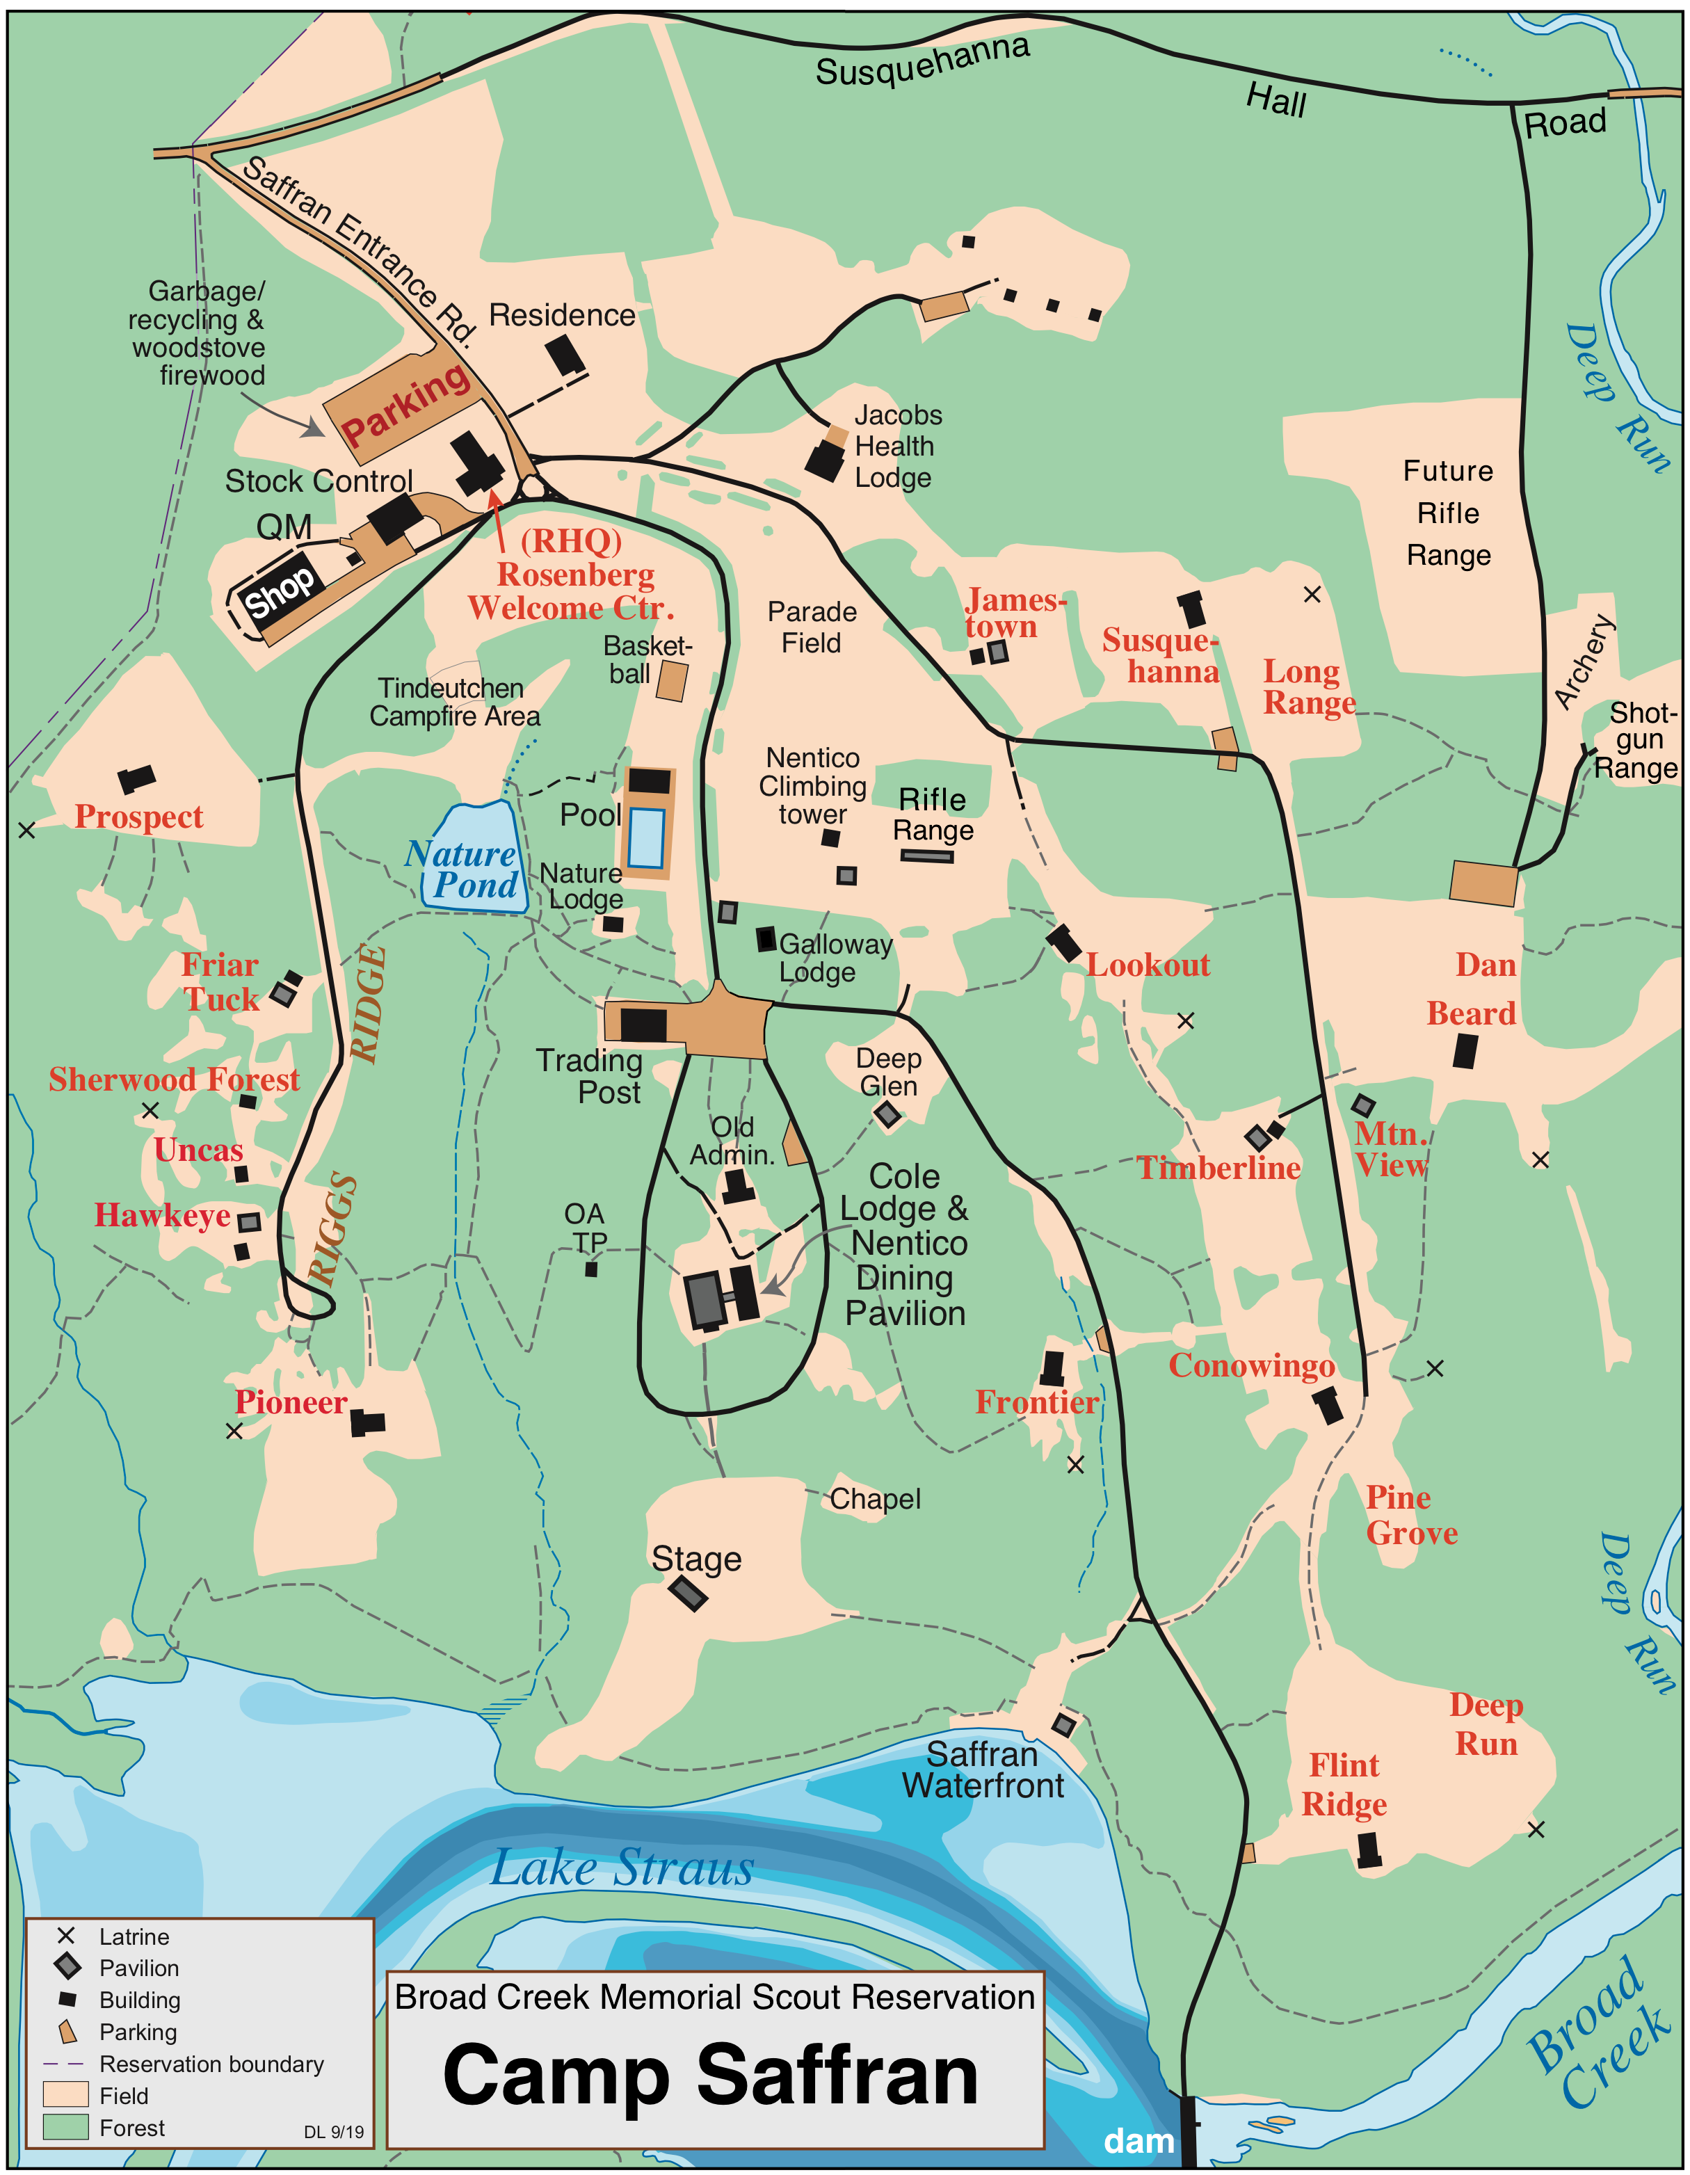
Figure 1. Map of Camp Saffran

Pre-Requisites & Requirements

For all merit badge classes…
- Bring the appropriate merit badge pamphlet (booklet) and make sure you have read it before coming to class.
- Bring an Application for Merit Badge (“blue card”) that has been signed by your unit leader and is legible. Scout name and troop number are essential.
- Bring pen/pencil and paper/notebook.
- Be prepared for the weather. Many classes will be held outdoors. Bring a water bottle and day-pack with any personal items you may need.
See the following pages for additional items needed and requirements that should be completed before coming to class. Pre-requisites should be brought in written, photographic, or other physical form as evidence that the Scout has completed those requirements.

Requirements cited below may be shortened for brevity. In all cases, the official, current requirements are to be followed as written. Refer to the merit badge websites listed on page 5 for current requirements.

Archery
(Saturday 8 am to 5 pm)

Bring a camp chair or stool.
Additional range time may be available Sunday from 9 am to 11 am.

Art
(Saturday 8 am to 12 pm; Saturday 1 pm to 5 pm)

Please bring a smock, apron, or old shirt to wear, as art can be messy.
Complete requirement 6 and be prepared to discuss. If unable to visit a museum, art exhibit, art gallery, co-op, or artists workshop, please complete a virtual tour.

A few good resources are available at the following links:
- https://www.travelandleisure.com/attractions/museums-galleries/museums-with-virtual-tours
- https://artsandculture.google.com/
- https://www.louvre.fr/en/online-tours

Camping
(Saturday 8 am through Sunday 11:30 am)

Scouts should be age 13 or older and First Class rank or higher to participate in this class.

Complete the following requirements in advance, and bring written documentation:
- Req 2: A written statement on “leave no trace” implementation
- Req 3: A written plan for an overnight hike
- Req 4a: A written duty roster of your patrol organization
and a list of patrol members’ assignments
- Req 5a: A written lists of clothes for winter & summer campouts
- Req 5e: A note from Scoutmaster on pack presentation
- Req 7a: A written check list of personal and patrol gear
- Req 8c: A written menu and food list to purchase for a campout
- Req 8d: A note from Scoutmaster on your experience with trail meal cooking
- Req 9a: A written list of when and where Scout camped for 20 nights
- Req 9b: A written statement of two camping experiences signed by SM
- Req 9c: A written statement of conservation project signed by the SM

Scouts are encouraged to use this worksheet:
http://usscouts.org/mb/worksheets/Camping.pdf

Citizenship in the Community
(Saturday 8 am to 5 pm)

Complete the following requirements in advance:
- Req 3a – Attend a meeting. A community organization meeting is okay.
- Req 4a, 4b, 4c – Choose an issue important to citizens of your community.
- Req 5 – Watch a movie… positive effect on community.
- Req 7a, 7b, 7c – Identify three charitable organizations…
- Req 8 – Develop a presentation…
Scouts may use this worksheet:
http://usscouts.org/mb/worksheets/Citizenship-in-the-Community.pdf

Citizenship in the Nation
(Saturday 8 am to 5 pm)
Complete the following requirements in advance. Bring your responses in written form,
and be prepared to read and discuss them with your counselor.

- Req 5 – National news or major media stories for five days in a row…
- Req 6 – Choose a speech of national historical importance…
- Req 7 – Visit/tour certain places; choose a national monument.
For each of the two choices, write a paragraph or two describing what you learned.
- Req 8 – Name your representatives in the United States Congress... Write a letter…
Show your letter and any response you receive...
Scouts may use this worksheet:
http://usscouts.org/usscouts/mb/worksheets/Citizenship-in-the-Nation.pdf

Citizenship in the World

(Saturday 8 am to 5 pm)

This is a complex Eagle-required merit badge recommended for Scouts age 13 and older. In order to earn the badge, these prerequisites MUST be completed in advance. Bring your responses in written form. We will cover the other requirements in class.

Complete these requirements in advance:
- Req 3a – Pick a current world event… (other than COVID-19 )
- Req 4c – Select TWO of the following organizations and describe their role in the world…
- Req 7 – Do TWO of the following…

Citations (sources, footnotes, etc.) are NOT required, but the Scout must demonstrate a working knowledge of the topic to receive credit for the requirement.

Sources: Internet, public library, your school, teachers, knowledgeable adults.

Scouts may use this worksheet:
http://usscouts.org/usscouts/mb/worksheets/Citizenship-in-the-World.pdf

Communication
(Saturday 8 am through Sunday 11:30 am)

Be prepared with the materials or ideas to complete the requirements following:
- Req 2b will be completed in class. Bring the object you will prepare the sales pitch for.
If completing 2a, bring the materials needed for your presentation.
- Req 3 – Think of the subject for your 5 minute speech. Scouts will create their speech in class.
- Req 5 – Attend a public meeting (city council, school board, debate) approved by your counselor where several points of view are given on a single issue. Practice active listening skills and take careful notes of each point of view.
- Req 6 – With your counselor’s approval, develop a plan to teach a skill or inform someone about something. Prepare teaching aids for your plan.
- Req 7a – Write to the editor of a magazine or your local newspaper to express your opinion or share information on any subject you choose. We will write the letter in class. Bring a magazine, or newspaper article that you have read.
- Req 9 – Find out about three career opportunities in communication. Pick one and find out the education, training, and experience required for this profession. Be prepared to discuss why you might be interested about this career as well as the information you researched.

This requirement needs to be completed before or after the event weekend:
- Req 8 – Plan a troop or crew court of honor, campfire program, or interfaith worship service. Have the patrol leaders’ council approve it, then write the script and prepare the program. Serve as master of ceremonies.
Scouts may use this worksheet:
http://usscouts.org/usscouts/mb/worksheets/Communication.pdf

Crime Prevention
(Saturday 8 am to 12 pm; Saturday 1 pm to 5 pm)
Note: This merit badge will be worked in conjunction with Fingerprinting.
Complete these requirements in advance:
- Req 2, 4, 5, 6a or 6b or 6c, 7a or 7b, 9b, and 9d

Dog Care
(Sunday 7:30 am to 11:30 am)

This class is recommended for Scouts who already own a dog.

Complete these requirements in advance:
- Req 4 – Keep & care for a dog, maintain a log…
Log does not need to be 2 full months, but Scout must have started it.
- Req 8 – Visit a veterinary hospital or animal shelter and give a report…
Report should describe the facility that was visited and what the Scout learned.
Report should be no longer than 10 sentences.
- Req 9 – Research the local laws and ordinances for your community regarding dogs.

Environmental Science
(Saturday 8 am to 5 pm)

This class is recommended for Scouts age 14 and older.

Complete these requirements in advance:
- Req 1 -- Make a timeline of the history of environmental science in America…
- Req 2 – Define the following terms…
- Req 6 -- Find out about three career opportunities…
Bring a ruled notebook, pen/pencil, and water bottle. Wear appropriate clothing for spending time outside doing field observations (rain or shine).

Fingerprinting
(Saturday 8 am to 12 pm or Saturday 1 pm to 5 pm)

Note: This merit badge will be worked in conjunction with Crime Prevention.

- Download and bring a Fingerprint Card (Excel file) for requirement 4a.
Available here: http://www.baltimorebsa.org/document/fingerprint-card/206089

First Aid
(Saturday 8 am through Sunday 11:30 am)

Scouts must be First Class rank or higher to participate in this class.

Complete these requirements in advance:
- Req 5a - Prepare a home first-aid kit in advance, and bring it.

Forestry
(Saturday 8 am to 5 pm) Maximum: 10 Scouts

Bring a book about trees.

A notebook and pen/pencil are required in order to complete Req 1 (prepare
a field notebook). Requirements 1, 2 and 5 will be completed outside. Be prepared
for the weather.

A written test will be given at the end of the class.

Indian Lore
(Sunday 7:30 am to 11:30 am)

Complete these requirements in advance:
- Req 1 – Identify cultural areas…
- Req 2 – Give history of one tribe…
- Req 5f – Write about eight thing adopted by others from American Indians
Use this worksheet: http://usscouts.org/usscouts/mb/worksheets/Indian-Lore.pdf

Leatherwork
(Saturday 8 am to 12 pm; Saturday 1 pm to 5 pm; Sunday 7:30 am to 11:30 am)

Complete these requirements in advance:
- Req 5c – Recondition or take proper care of…
Be prepared to discuss requirements 1 and 2. Activity uniform is recommended.

Mammal Study
(Sunday 7:30 am to 9:00 am or Sunday 9:30 am to 11:00 am)

Complete these requirements in advance:
- Req 3c – Life history of one non-game mammal…
- Req 4c – Life history of a native game mammal…
Dress for the weather. Wear hiking boots and durable pants.
We will do a conservation project in damp and muddy terrain.

Metalwork
(Saturday 8 am to 5 pm) Maximum: 6 Scouts
Scouts must be age 14 or older to participate in this class.
Required: cotton clothing that can get dirty, jeans, closed-toe shoes, leather work gloves, and safety glasses.

Do not wear BSA uniform for this class!

Complete these requirements in advance:
- Req 1 – Read the safety rules…
- Req 2 – Define terms and name things…
- Req 4 -- Find out about three career opportunities…
Requirement 5d, “Blacksmith,” will be completed on-site.

Have some ideas for small, manageable projects. We will work on two projects over the weekend. We will NOT make knives, broad swords, or battle axes!

Radio
(Saturday 8 am to 5 pm)

Scouts should become familiar with the subject in advance. A thorough reading
of the merit badge pamphlet is strongly recommended.

Complete these requirements in advance:
- Req 8 – Find out about three career opportunities…
Scouts may use this worksheet: http://usscouts.org/mb/worksheets/Radio.pdf

Rifle Shooting
(Saturday 8 am to 5 pm) Maximum: 8 Scouts

Class will be conducted on the shooting range at Camp Saffran.

Complete these requirements in advance:
- Req 1d - Research the main points of the laws for owning and using guns in your community & state (visit a website and print out and bring to class.
- Req 1f - Obtain a copy of the hunting laws for your state and be able to explain the main points (go to a website, print out and bring to class).
- Req 1i - Make a list of sources you could contact for information on firearms and their uses and bring to class.

Scholarship
(Sunday 7:30-9:00 am or 9:30-11:00 am)

Complete these requirements in advance and bring documentation.
- Req 1a or 1b – Bring copy of report card or proof of grades.
- Req 3 – Bring note from school official.
- Req 5a or 5b – Write a report… and bring it with you.

Shotgun Shooting
(Saturday 8 am to 5 pm) Maximum: 8 Scouts

Class will be conducted on the shooting range at Camp Saffran.

In the Shotgun Shooting Merit Badge Pamphlet, pay special attention…
- Review page 32, Shooting Hygiene.
- Review pages 34-41, Fundamentals of Shotgun Shooting.
- Review pages 81-84, Conservation and hunting.
Complete Requirements 1d, 1f, 1g, and 1i in advance.

Signs, Signals, and Codes
(Saturday 8 am to 5 pm) Maximum: 6 Scouts

Bring a camp chair or stool.

Complete these requirements in advance and bring items and notes as indicated.
- Req 9a – Show examples of 10 traffic signs….
- Req 9c – Discuss text message symbols…
- Req 10 – Briefly discuss the history of secret code writing (cryptography)…

Textiles
(Sunday 7:30 am to 11:30 am)

Bring a camp chair or stool.
Review the material in the merit badge pamphlet and come prepared to learn.

Wilderness Survival
(Saturday 8 am through Sunday 11:30 am) Maximum: 8 Scouts

Scouts must be at least age 13 and First Class rank to participate in this class.
A thorough reading of the merit badge pamphlet is strongly recommended.

Complete these requirements in advance, and/or be prepared to discuss and
demonstrate in class, and bring items and notes as indicated.
- Req 1 – Hazards you may encounter, and first aid related to this subject.
- Req 2 – From memory, list the seven priorities…
- Req 5 – Begin to prepare and assemble your personal survival kit, and bring it with you.
  - Items to include: personal first aid kit, pocketknife or multi-tool, flashlight or
head-lamp, 25 feet of 550 paracord, water bottle, rain gear, an empty 12-15
ounce metal coffee can.
- Reqs 3, 4, 7, 9, 11, and 12 – review the material and be prepared to discuss and demonstrate.
Also bring a sleeping bag and pad, and a daypack to carry your small items. The class
will spend Saturday night at an outpost site, where each Scout will improvise a shelter
from natural materials and sleep in it (Req 8).

Scouts are encouraged to use the merit badge worksheet:
http://usscouts.org/usscouts/mb/worksheets/Wilderness-Survival.pdf

Wood Carving
(Saturday 8 am to 12 pm or Saturday 1 pm to 5 pm)

Scouts must be age 13 or older to participate in this class.
Bring a sharpened knife or an Exacto knife with spare blades. Wood will be provided.
Complete these requirements in advance and bring documentation.
- Req 2a – Earn the Totin’ Chip recognition. Bring your card.

Introduction to Advancement
(Saturday 9 am to 10:30 am)

This class for adult Scout leaders will review the basics and best practices of Scouts BSA advancement. Topics may include: requirements tracking, processes and procedures, conflict resolution, and the Guide to Advancement.

Complete these requirements in advance:
- Register as an adult BSA volunteer and complete Youth Protection Training (YPT).

Eagle Coach Training
(Saturday 2 pm to 3:30 pm)

This class for adult Scout leaders will review the procedures for assisting a Life Scout with the requirements to achieve the rank of Eagle Scout. Topics may include: using the Eagle Scout Service Project Workbook, selecting and executing a project, dealing with the District Advancement Committee, and the Guide to Advancement.

Complete these requirements in advance:
- Register as an adult BSA volunteer and complete Youth Protection Training (YPT).

Campfire Skit or Song

Please provide this information at check-in.

Troop Number | _________________________
SPL Name | _________________________
Skit Name | _________________________
Staff Approval | _________________________

