Carroll District Klondike 2026
Cub Scout Guide
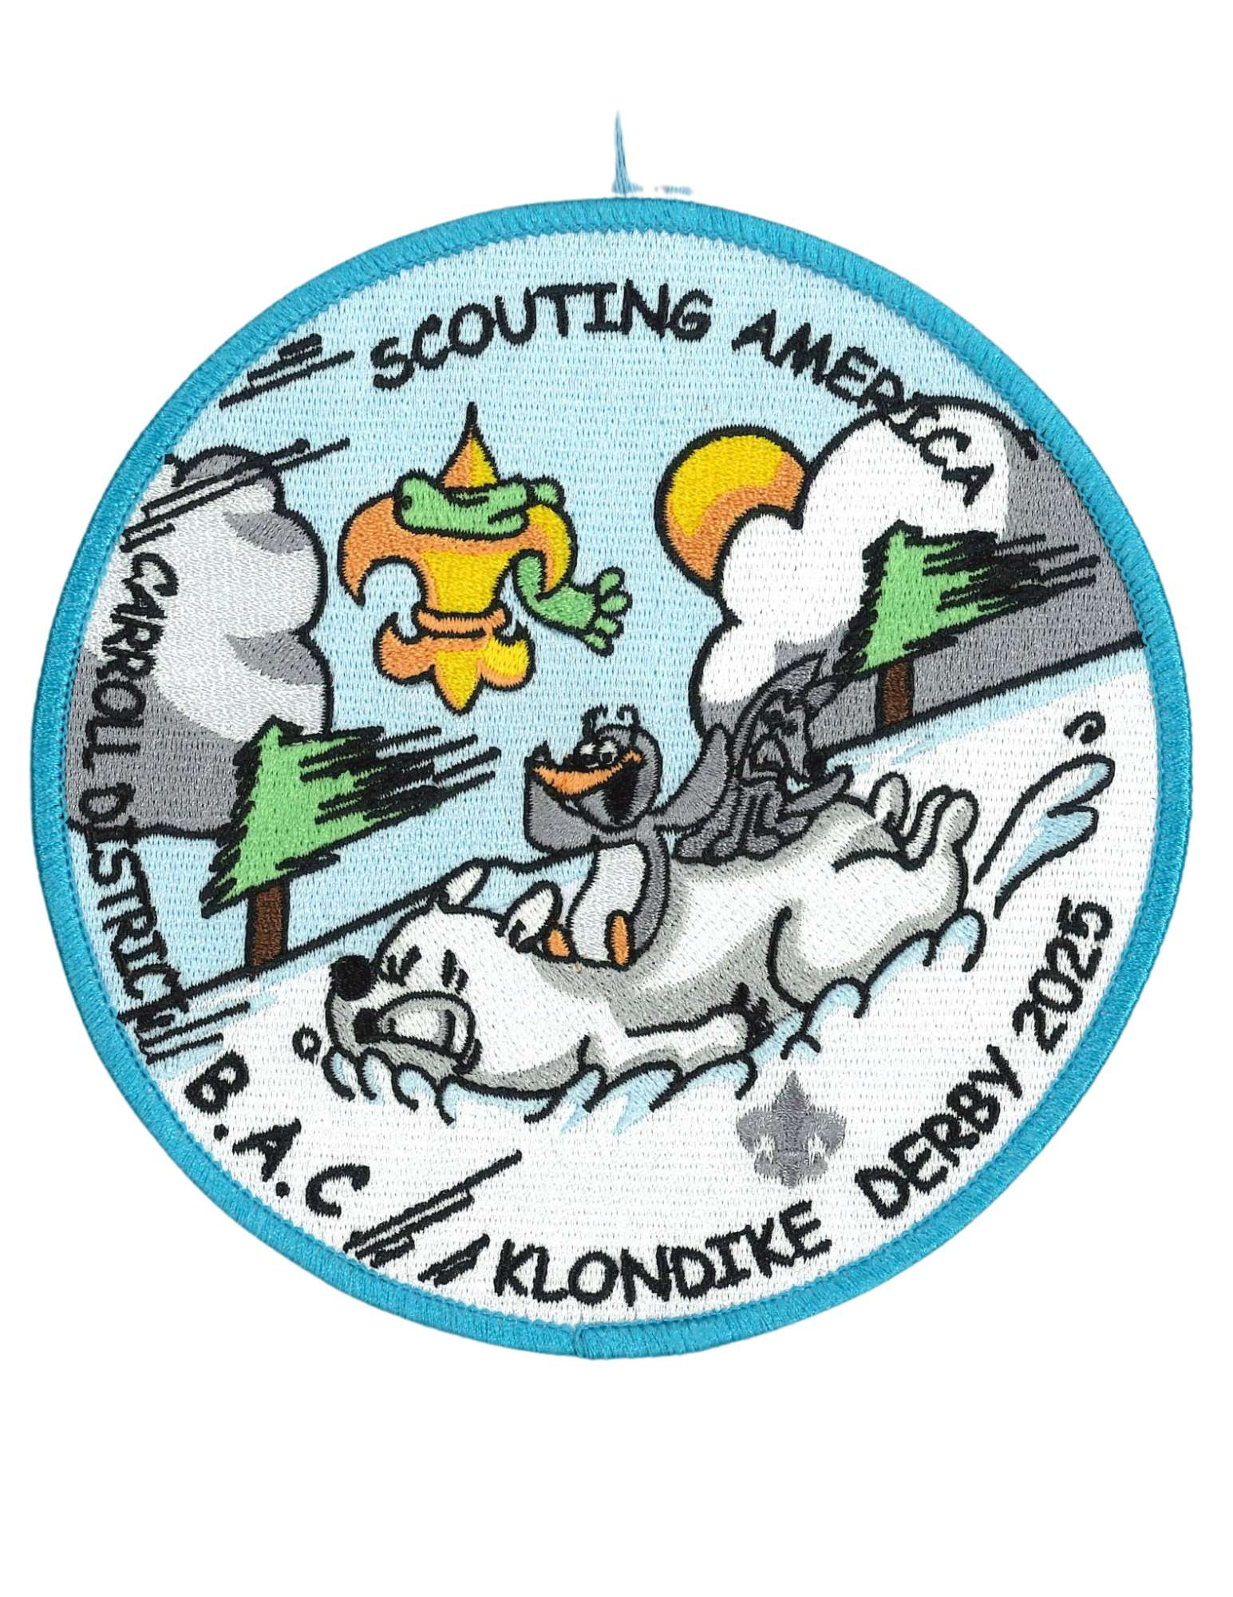
Patch designed by John Waddell Tr. 420
January 31, 2026
Carroll County Agricultural Center
706 Agricultural Center Dr, Westminster MD 21157
For questions email Klondike Chair Colleen Kelly
Carrollklondike2023@gmail.com
Early bird registration ends: January 4th
Registration closes: January 18th
INFORMATION

Fees: Adults – free
Early Bird Youth fee: $10
Youth fee: $20 if registering after January 4th
All fees cover rental fees, insurance, competitions costs and a patch.
If adults wish to purchase a patch, or you wish to purchase extra patches, you may do so when registering. There may be additional patches for sale the day of the event.
Emergency phone number: Colleen Kelly Klondike Chair 410-236-3033
Weather – Unless the Governor declares a “State of Emergency” or closes the roads – the DERBY WILL GO ON! Be Prepared
Stations/areas can be requested during online registration. Priority preference will be given based on units who register early.
Leadership: Two Unit Leaders per unit, are required to be responsible for all youth accompanying a unit and be registered scouters and are required to be trained in BSA’s Youth Protection Program.
Medical Forms: As stated in the Guide to Safe Scouting, leaders should have the Annual Health and Medial Form part A and B for each unit member participating in the Klondike. These are especially important to have if a scout will be attending Klondike without a parent.
Adult Participation: As with any scouting event, adults need to be present during the day.
Cub Scouts need adults with each den as they go around the activities but please let them complete the activities on their own.
Visitors: All visitors are required to check in at Klondike Headquarters for their respective grouping.
Trash - No trash facilities will be available at the AG Center, what you bring in you take out.
Fire - Ground fires are not allowed but raised fire pits are acceptable. Do not dig holes or trenches.
Water: There is no water source at the AG center. Bring plenty for any cooking or drinks. Everyone needs to keep hydrated throughout the day!
Smoking: BSA National Policy states that smoking is not only a safety hazard, but is also objectionable in the presence of Scouts. Therefore, we strongly recommend that there will be no smoking at the Derby.
Trees: Cutting Live trees is prohibited
Lost and Found: Located at Klondike Headquarters. Please have scouts label all gear with their name and unit number.
Parking: DO NOT Park on the grass if there is a sign that says no parking on the grass!
Parking will be in front of the Carroll Agricultural Buildings on the large pavement closest to the grass Cub scout area.
You may have 1 vehicle and trailer at your site as long as it is behind your kitchen area.
First Aid – Minor issues go to your unit or the unit nearest you. In the event of a serious medical issue please call 911 and make sure to tell them you are at Carroll Agricultural Center. Please send runners to Klondike headquarters to let them know or call Colleen Kelly at 410-236-3033.
Alcoholic beverages and drugs: Possession and/or use of alcoholic beverages or drugs are prohibited per Scout BSA rules. You will be asked to leave Klondike if found with either and may be prosecuted.
CLOTHING: Each Cubmaster will tell their pack the clothing for the event.
Unit Areas
Every Scout Unit is encouraged to run an activity station, if possible, set up a new station. Some of these youths have been attending for years and new stations are always a hit. Stations may be set up the night before or the day of Klondike. Each activity station will have a “Station Mayor” responsible for running their event. Make sure that there is a specific place for the dens to go for the start and that the dens know where to go and who to see.
Each unit will be assigned an area for their station. Information about which site is yours will be emailed to the contact person of each unit approximately 1 week prior to the event. Each unit is encouraged to set up a food area behind your station. Please make sure there is a clear distinction/distance between the station and your food area. We want to make sure that the dens know exactly where the stations are.
Email Carrollklondike2023@gmail.com if you wish to set up the day before.
Dens
Dens should be by rank or as a Mixed Rank Den. We would prefer Arrow of Light Scouts be registered with, and compete with, a Scout BSA troop but that is not a requirement.
All Dens should have a minimum of 4 (four) and a maximum of 8 (eight) scouts.
Each Den is required to have a Den Flag and Den Cheer.
Adults should allow Cubs to complete the stations on their own. One of the objectives of this event is to encourage Scouts to use their own resources and make their own decisions.
- There will be beads given at each station. Each scout will receive a pipe cleaner for their bead which they will receive at each station as long as they participate. Each participating scout will earn 1 bead per station to put on their pipe cleaner.
- Check – in – your stations will be marked on the ground with paint. Please wait for assistance in finding your station. Only those who have a lot to unload should drive to the station area, all others should park in the parking lot and walk to the station.
CUB SCOUT Day Of Procedures
1. ONE representative from each Pack must check in at the admin table to receive your patches, pipe cleaners and station beads.
2. 8:30 meet in the middle for opening ceremonies
3. The goal is to complete all stations. The Klondike is set up so that Dens should be able to complete all stations. If there are long lines at a station, move on to another station and come back to that station later.
4. Once a Den completes ALL stations, they may re-visit as many stations as they desire. If a Den is re-visiting a station that another Den hasn’t completed, please exercise Scouting courtesy and allow the other Den to go first. You will only receive 1 bead per station. If you redo a station you will NOT receive another bead.
5. All Packs should have medicals, permission slips, and have prepared a Pack Leader(s) phone contact list as well as a phone contact list for each participant in case of an emergency.
Schedule:
7:00 a.m. Station Set-up
8:25 a.m. Start gathering for opening ceremonies
8:30 a.m. Opening Ceremonies – Fun time Begins
11am Food break– stations closed - This is a change and an hour earlier than the troops! Cubmaster please check in with den leaders on how many stations their den still needs to complete so you can report at the 11:30 meeting.
11:30pm – Pack leader meeting in the middle of the area to come up with a time for our closing ceremony.
11:45p.m. Stations re-open for competition
Closing ceremony

