Carroll District Klondike
Cub Scout Guide

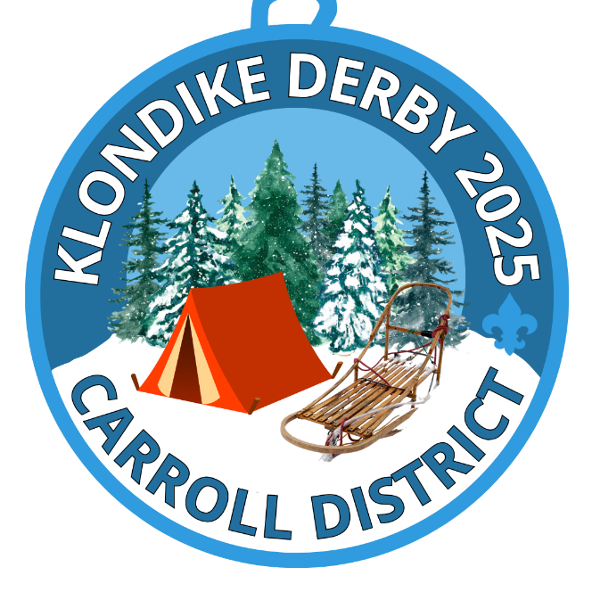

February 7-9, 2025
Carroll County Agricultural Center
706 Agricultural Center Dr
Westminster MD 21157
For questions email Klondike Chair Colleen Kelly
Carrollklondike2023@gmail.com
Early bird registration ends: January 12th
Registration closes: January 19th

INFORMATION

Fees: Adults – free
Early Bird Youth fee: $10
Youth fee: $20 if registering after January 12th
All fees cover rental fees, insurance, competitions costs and a patch.
If adults wish to purchase a patch, or you wish to purchase extra patches, you may do so when registering. There may be additional patches for sale the day of the event.

Emergency phone number: Colleen Kelly Klondike Chair 410-236-3033

Weather – Unless the Governor declares a “State of Emergency” or closes the roads – the DERBY WILL GO ON! Be Prepared

Stations/areas can be requested during online registration. Priority preference will be given based on units who register early.

All units are responsible for making sure all attendees are registered.

Leadership: Two registered unit leaders (adults) per unit, are required to be responsible for all youth accompanying a unit and be registered scouters as well as are required to be trained in BSA’s Youth Protection Program.

Medical Forms: As stated in the Guide to Safe Scouting, leaders should have the Annual Health and Medial Form part A and B for each unit member participating in the Klondike. These are especially important to have if a scout will be attending Klondike without a parent.

Adult Participation: As with any scouting event, adults need to be present during the day.
Cub Scouts need adults with each den as they go around the activities but please let them complete the activities on their own.

Visitors: All visitors are required to check in at Klondike Headquarters for their respective grouping.

Trash - No trash facilities will be available at the AG Center, what you bring in you take out. THIS INCLUDES ANY HAY YOU USE AS GROUND COVER.

Fire - Ground fires are not allowed but raised fire pits are acceptable. Do not dig holes or trenches.

Water: There is no water source at the AG center. Bring plenty for any cooking/hot drinks and have each scout and leader have a full water bottle. Everyone needs to keep hydrated throughout the day!

Smoking: BSA National Policy states that smoking is not only a safety hazard, but is also objectionable in the presence of Scouts. Therefore, we strongly recommend that there will be no smoking at the Derby. If you must smoke, please ask Klondike staff to point out a designated smoking area.

Trees: Cutting Live trees is prohibited

Lost and Found: Located at Klondike Headquarters. Please have scouts label all gear with their name and unit number.

Parking: DO NOT Park on the grass if there is a sign that says no parking on the grass!
Parking will be in front of the Carroll Agricultural Buildings on the large pavement closest to the grass Cub scout area.

First Aid – Minor issues go to your unit or the unit nearest you. In the event of a serious medical issue please call 911 and make sure to tell them you are at Carroll Agricultural Center. Please send runners to Klondike headquarters to let them know.

Alcoholic beverages and drugs: Possession and/or use of alcoholic beverages or drugs are prohibited per Scout BSA rules. You will be asked to leave Klondike if found with either and may be prosecuted.

CLOTHING: NEW THIS YEAR!!!!. There will be NO INSPECTION this year! Each Cubmaster will tell their pack the clothing for the event.

Unit Areas
Every Scout Unit is encouraged to run an activity station, if possible, set up a new station. Some of these youths have been attending for years and new stations are always a hit. Stations may be set up the night before or the day of Klondike. Each activity station will have a “Station Mayor” responsible for running their event. The station mayor will NOT have a hat so make sure the dens know where to go and who to see.
Each unit will be assigned an area for their station. Information about which site is yours will be emailed to the contact person of each unit approximately 1 week prior to the event. Each unit is encouraged to set up a cooking tent near to their station and provide a hot lunch for their unit. Please make sure there is a clear distinction/distance between the station and your cooking area. We want to make sure that the dens know exactly where the stations are.

Email Carrollklondike2023@gmail.com if you wish to set up the day before.

Dens
Dens should be by rank or as a Mixed Rank Den. Arrow of Light Scouts are expected to be registered with, and compete with, a Scout BSA troop.
All Dens should have a minimum of 4 (four) and a maximum of 8 (eight) scouts.
Each Den is required to have a Den Flag and Den Cheer.
Adults should allow Cubs to complete the stations on their own. One of the objectives of this event is to encourage Scouts to use their own resources and make their own decisions.
NEW THIS YEAR!
- There will be beads given this year. Each scout will receive a pipe cleaner for their bead which they will receive at each station as long as they participate. Each participating scout will earn 1 bead per station to put on their pipe cleaner.
- Lunch will be 45 minutes
- Check – in – there will be cones with your station letter on them to help find your station. Please wait for assistance in finding your station. Only those who have a lot to unload should drive to the station area, all others should park in the parking lot and walk to the station.
- You will be assigned a station depending upon when you register unless you have an activity that has specific needs in where your station will be located.
CONTINUE READING ON THE NEXT PAGE, THERE IS MORE INFORMATION


CUB SCOUT Day Of Procedures
- ONE representative from each Pack must check in at the admin table to receive your patches, pipe cleaners and station beads.
- At 8:55 a.m., begin to line up for the opening ceremony.
- When the flag ceremony is completed, wait for the starting horn.
- The goal is to complete all stations. The Klondike is set up so that Dens should be able to complete all stations. If there are long lines at a station, move on to another station and come back to that station later.
- Once a Den completes ALL stations, they may re-visit as many stations as they desire. If a Den is re-visiting a station that another Den hasn’t completed, please exercise Scouting courtesy and allow the other Den to go first. You will only receive 1 bead per station. If you redo a station you will NOT receive another bead.
- All Packs should have medicals, permission slips, and have prepared a Pack Leader(s) phone contact list as well as a phone contact list for each participant in case of an emergency.
Stations: You should have enough room to have your station apart from your lunch area. Feel free to move more into the center of the field if you need more room. I would like to have a clear separation from the lunch area and the station to make it easier for the dens to know where to go and who to talk to for the station.

Food: Lunch will be at noon for all. If your cubs get hungry earlier feel free to eat earlier but know that stations will be closed from noon until 12:45.

Schedule:
7:00 a.m. Station Set-up
8:25 a.m. Start gathering for opening ceremonies
8:30 a.m. Opening Ceremonies – Fun time Begins
12:00pm Lunch – stations closed
12:30pm – Pack leader meeting middle of area to determine how many more stations your dens need to complete to come up with a possible time to finish.
12:45p.m. Stations re-open for competition
2pm – Closing ceremony. There are no prizes just a thank you to all for coming

The event may end early based on station activities and completion of stations. At lunchtime I will meet with all Pack leaders to see what we will decide. Please check in with your den leaders at lunch to see how many have completed all stations.

