Carroll District Klondike
Troop Guide

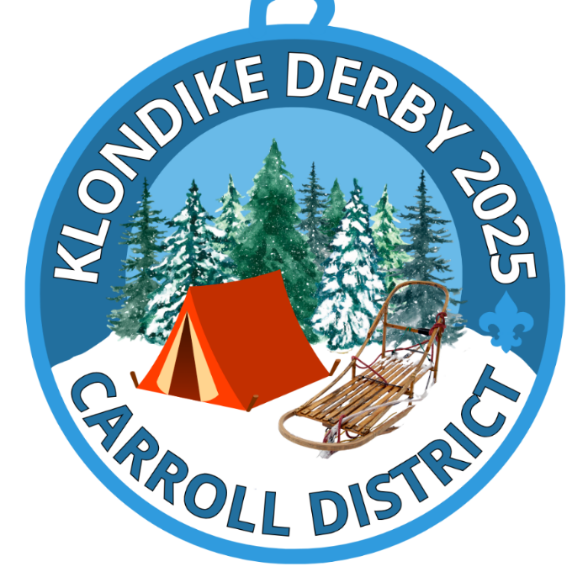

February 7-9, 2025
Carroll County Agricultural Center
706 Agricultural Center Dr
Westminster MD 21157
For questions email Klondike Chair Colleen Kelly
Carrollklondike2023@gmail.com
Early bird registration ends January 12
January 19th - Station activity and items needed due
Registration closes: January 19th

INFORMATION FOR TROOPS AND PACKS
Fees: Adults – free
Early Bird Youth fee: $10
Fee $20 if registering after January 26, 2025
All fees cover rental fees, insurance, competitions costs and a patch.
If adults wish to purchase a patch, or you wish to purchase extra patches, you may do so when registering. There may be additional patches for sale the day of the event.

Emergency phone number: Colleen Kelly Klondike Chair 410-236-3033

Weather – Unless the Governor declares a “State of Emergency” or closes the roads – the DERBY WILL GO ON! Be Prepared

Stations/areas can be requested during online registration. Priority preference will be given based on units who register early.

All units are responsible for making sure all attendees are registered.

Leadership: Two Unit Leaders per unit, are required to be responsible for all youth accompanying a unit and be registered scouters as well as are required to be trained in BSA’s Youth Protection Program.

Medical Forms: As stated in the Guide to Safe Scouting, leaders should have the Annual Health and Medial Form part A and B for each unit member participating in the Klondike. These are especially important to have if a scout will be attending Klondike without a parent.

Adult Participation: As with any scouting event, adults need to be present during the day.
Scouts BSA - the patrols are to go around to complete the activities without adults. This is time for patrols to really work together on their own, without assistance from adults.

Visitors: All visitors are required to check in at Klondike Headquarters for their respective grouping.

Trash - No trash facilities will be available at the AG Center, what you bring in you take out. THIS INCLUDES ANY HAY YOU USE AS GROUND COVER.

Fire - Ground fires are not allowed but raised fire pits are acceptable. Do not dig holes or trenches.

Water: There is no water source at the AG center. Bring plenty for any cooking/hot drinks and have each scout and leader have a full water bottle. Everyone needs to keep hydrated throughout the day!

Smoking: BSA National Policy states that smoking is not only a safety hazard but is also objectionable in the presence of Scouts. Therefore, we strongly recommend that there will be no smoking at the Derby. If you must smoke, please ask Klondike staff to point out a designated smoking area.

Trees: Cutting Live trees is prohibited

Lost and Found: Located at Klondike Headquarters. Please have scouts label all gear with their name and unit number.

Parking: DO NOT Park on the grass if there is a sign that says no parking on the grass!
Scouts BSA units that will be camping overnight can park near your unit as long as the cars/trailers do not interfere with the path the sleds need to travel. Parking will be in front of the Carroll Agricultural Buildings on the large pavement closest to the grass Cub scout area.

First Aid – Minor issues go to your unit or the unit nearest you. In the event of a serious medical issue please call 911 and make sure to tell them you are at Carroll Agricultural Center. Please send runners to Klondike headquarters to let them know.

Alcoholic beverages and drugs: Possession and/or use of alcoholic beverages or drugs are prohibited per Scout BSA rules. You will be asked to leave Klondike if found with either and may be prosecuted.

CLOTHING: NEW THIS YEAR! There will be NO INSPECTION this year! Each Scoutmaster will tell their troop the clothing for the event.

Unit Areas
NEW THIS YEAR! Please provide station information by January 19th so it can be sent to all units. Troops will then be responsible for having the necessary items on their sled rather than Klondike staff sending a generic packing list.
  - Station Name
  - Items Needed
  - General skills needed/tested.

Every Scout Unit is encouraged to run an activity station, if possible, set up a new station. Some of these scouts have been attending for years and new stations are always a hit. Units may be set up the night before or the day of Klondike.
You will receive a pole on Saturday at check in to place at the starting point of your station which should be away from your camping area. If you do not have a station, you will not receive a pole.
Each unit will be assigned an area for their station. Information about which site is yours will be emailed to the contact person of each unit approximately 2 weeks prior to the event. Each unit is encouraged to set up a cooking/camping area near to but separate from their station. We want to make sure that the patrols know exactly where the stations are.
- There is no food for sale at this event, you need to provide all food and water for your unit.
Email Carrollklondike2023@gmail.com if you wish to set up the day before.
IMPORTANT INFORMATION
- You may camp until Sunday, but there will not be any district members on site. You will be in charge of your unit just like other camping trips. District personnel will be there Friday into Saturday afternoon.
- I need an adult, from each troop, on Saturday morning at 6amish to help with the cub scout check in. Please come to admin for your directions.
- We will have a runner to show you where your site is. Please have patience Friday night and Saturday morning. You may show up as early as 4pm Friday afternoon to drop items off/put up something to show where your site is.
- You need to register your station along with what items the sleds need to have on them to complete your activity before January 19th
- Leave a distance between camping/troop area and where your station starts. Put up the pole at the beginning of your station where the patrols need to report for the activity.
- No clothing inspection.
CONTINUE READING ON THE NEXT PAGE, THERE IS MORE INFORMATION


Scouts BSA
PATROLS: Out on the trail you will meet challenges that will require thought, skill, teamwork and Scout Spirit. To meet these challenges, you will need to work as a patrol and draw upon the skills of the patrol and its members. When you complete the activity, you will be rewarded with beads. These beads are to be strung on your rope thong and guarded throughout the day. THESE BEADS ARE YOUR SCORE! DO NOT LOSE THEM!
When you arrive at a station, marked where the tall pole is, announce yourself with a loud patrol cheer, then proceed to the station Mayor and give the mayor your Troop number and Patrol name. Follow the instructions for the activity, have fun, and show your Scout Spirit! The goal is to complete all the stations. Move onto other stations if the lines are too long.
In your packet there will be a site map with all troop stations marked on them as well as a paper that shows approximately how many patrols are registered.
The number of patrols is to help the stations know about how many to expect during the day.
While it is a competition don't forget to enjoy the day and stay for the closing awards ceremony. Do not leave early and miss out on possibly receiving an award. The ceremony will be at admin at 4:45pm. Have a fun, safe, and great day at the Klondike!

Materials needed on your sled are as follows:

New this year: Klondike staff will consolidate station information (see request on page 4
of guide) and send a customized material list for sleds to troops along with a list of the stations within a few days of January 19th

Stations: There will be about 15-20 stations. These stations are designed in such a way as to allow your patrol to show the skills, back country knowledge, teamwork and spirit that you have learned in Scout BSA.

BEADS: 1 bead for scout cheer, 1 for patrol flag, 1 for scout spirit, 1 participation and one at the choice of the station leader. Station leaders should tell the scouts how they can earn their 5th bead.

KLONDIKE SLEDS
There are many sled designs. The following design is to be used as a guide. Patrols are encouraged to paint, decorate or otherwise modify the sled as long as it meets this general design.
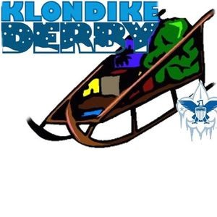Figure 1: Picture from Camp Cachalot
Sled Specifications
Length 4 ft. to 7 ft.
Width 18 in. to 24 in.
Height 36 in. to48 in.
NO METAL RUNNERS
NO WHEELS
NO PRE-FABRICATED SLEDS
• Sleds must be carried across all roads. Points will be deducted if an official sees a sled being pulled across the road.
• The maximum number of scouts per sled is 8. If you have more than 8, then you must run additional sleds.

SCOUTS BSA WEEKEND INFORMATION
Schedule:
Friday, February 7th 4pm – can set up for stations and camping. Please email and let us know if you need to arrive earlier than 4pm.
We will connect with you as you enter the Ag center grounds. We will have someone to show you where your station is, please do not try to find it on your own.

Stations: You should have enough room to have your station apart from your camping area. I would like to have a clear separation from the camping/lunch area and the station to make it easier for the patrols to know where to go and who to talk to for the station. There will not be station hats but we will use large golf type poles with numbers on them to show the station starts.

Saturday, February 8th
7am- Can pick up packet at this time.
Packet will have approximate number of patrols (so stations know how many patrols are left towards the end of the day), number of stations (so patrols know how many more stations they need to go to), map, schedule of the day, patches, thongs for beads for each patrol and beads for each station)
8:15 - Opening Ceremonies, wait for the horn and GO! We will not wait for units that are not on time. NOON - Mandatory Lunch, all stations will be closed until 1pm
1pm – Start competition again
4pm – Competition ends. Return all beads to admin. Beads must be turned in by 4:20pm.
4:30 – Closing ceremony
4. New Prizes:
- Glow in the dark capture the flag
- Glow in the dark football
- Glow in the dark soccer ball
- Glow in the dark slingshot helicopters

This will be a TIMED event! We will start the timer upon the buzzer at the start of the day. We will write down the time you arrive back at the admin at the end of the day as soon as you get to the table and then write down how many beads you have. Once you arrive at the table you cannot go back out. This is an easy way to break any ties due to the same number of beads.
Prizes: We will have a 1st, 2nd and 3rd place prize for 2 different sized patrols. You will have patrols with 4 or 5 members competing against each other and patrols with 6+ scouts competing against each other.

Patrol Awards:
First place for both 4/5 scout patrol and 6+ scout patrol as well as the participation drawing will be a 2025 Klondike Carabiner.
There will be a 1st, 2nd and 3rd place for the 4/5 scout patrol and the 6+ scout patrol. There will be 2 of each prizes to pick from. The prizes are:
Glow in the dark Capture the Flag
Glow in the dark soccer ball
Glow in the dark football
Glow in the dark slingshot helicopters

All participating patrols will be put in a drawing where any patrol can win. The patrol that is drawn out of every patrol at Klondike, each patrol member will receive a prize which will be a 2025 Klondike Carabiner.

