Carroll District
Klondike Derby

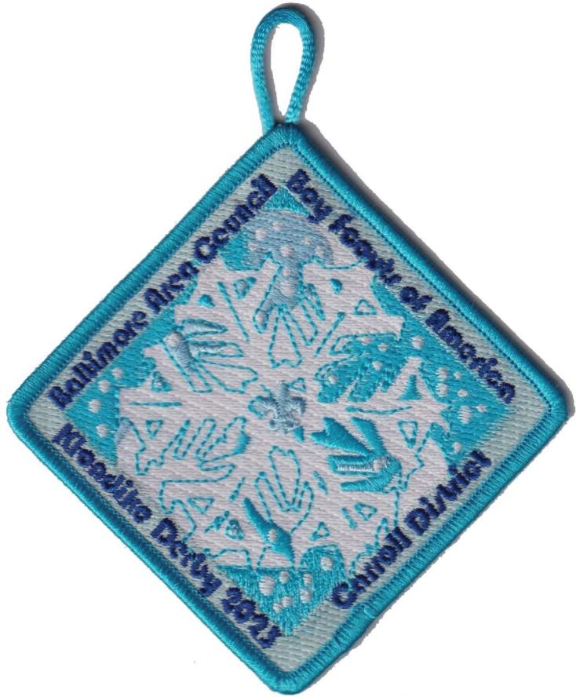

February 10-12, 2023

Carroll County Agricultural Center
706 Agricultural Center Dr
Westminster MD 21157

Cub Scout Information

Contact Information

Cub Scout Chair: Colleen Kelly Carrollklondike2023@gmail.com
Scouts BSA Chair: Carrollklondike2023@gmail.com

Registration Closes: January 27, 2023
Fees: All Cub Scouts will pay $10, adults will be free.
Scouts BSA – all who attend will need to pay $10.
All fees cover rental fees, insurance, competitions costs and a patch.

Weather - Unless the Governor declares a “State of Emergency” or closes the roads – the DERBY WILL GO ON! Be Prepared

STATIONS/AREAS CAN BE REQUESTED DURING ONLINE REGISTRATION. PRIORITY PREFERENCE GIVEN BASED ON UNITS WHO REGISTER EARLY!!

BSA Requirements

For insurance purposes, youth must be a registered Scout to participate in a Klondike Derby.

Leadership: Two Klondike Unit Leaders (adults) are required to be responsible for all youth accompanying a unit and be registered scouters as well as are required to be trained in BSA’s Youth Protection Program.

Medical Forms: As stated in the Guide to Safe Scouting, leaders should have the Annual Health and Medial Form part A and B for each unit member participating in the Klondike. These are especially important to have if a scout will be attending Klondike without a parent. The form can be downloaded from:
680-001_AB.PDF (scouting.org)
This specific guidance from the Guide to Safe Scouting can be found at:
Online Version | Boy Scouts of America (scouting.org)

Adult Participation: As with any scouting event, adults need to be present during the day. Cub Scouts need an adult with each den as they go around the activities but please let them complete the activities on their own.
Scouts BSA the patrols are encouraged to go around to complete the activities without adults. This is time for patrols to really work together on their own, without assistance from adults.

Visitors: All visitors are required to check in at Klondike Headquarters for their respective grouping (Cubs or Scouting BSA).

Trash - No trash facilities will be available at the AG Center, what you bring in you take out. THIS INCLUDES ANY HAY YOU USE AS GROUND COVER.

Fire - Ground fires are not allowed, but raised fire pits are acceptable. Do not dig holes or trenches.

Water: There is no water source at the AG center. Bring plenty for any cooking/hot drinks and have each scout and leader have a full water bottle. Everyone needs to keep hydrated throughout the day!

Smoking: BSA National Policy states that smoking is not only a safety hazard, but is also objectionable in the presence of Scouts. Therefore, we strongly recommend that there will be no smoking at the Derby. If you must smoke, please ask Klondike staff to point out a designated smoking area.

Trees: Cutting of Live trees is prohibited

Lost and Found: Located at Klondike Headquarters. Please have scouts label all gear with their name and unit number.

Parking: DO NOT Park on the grass if there is a sign that says no parking on the grass!

Scouts BSA units that will be camping overnight can park near your unit as long as the cars/trailers do not interfere with the path the sleds need to travel. Set up your site for easy visibility to the sleds so they know where they will be going and not traveling through your site to another unit.
Parking will be in, around and behind the Shipley arena. Parking in front of the Carroll Agricultural buildings on the pavement and gravel is for Cub Scouts.

Cub scouts: Parking will be in front of the Carroll Agricultural Buildings on the pavement and gravel, in the demolition derby area, and if need be, in and around and behind the Shipley arena.

First Aid – Minor issues go to your unit or the unit nearest you.

- In the event of a serious medical emergency, and fire department personnel are nearby (within yelling distance) please get their attention. They will radio and notify the appropriate parties.
- In the event of a serious medical issue, and fire department personnel are not within earshot of you, please call 911 and make sure to tell them you are at Carroll Agricultural Center. They will notify the personnel that are present. Please send runners to Klondike headquarters to let them know.

Alcoholic beverages and drugs: Possession and/or use of alcoholic beverages or drugs are prohibited per Scout BSA rules. You will be asked to leave Klondike if found with either and may be prosecuted.

CLOTHING: SCOUT UNIFORMS ARE NOT REQUIRED!
Dress Warmly – anyone dressed improperly will be refused entry to the Klondike. The Scouts unit will be responsible for getting the scout home. There will be no exceptions or refunds. This applies to both youth AND adults. Improper dress could result in serious health & safety problems.

Mandatory
Winter Coat
Boots - NO SNEAKERS OR LIGHTWEIGHT SHOES ALLOWED!
Appropriate Layering/Long Johns - NO SHORTS ALLOWED!!!!
Hat, Gloves – those with hoods must have hat underneath.

Recommended
Rain / Foul Weather Gear
Heavy Socks / Scarves / Extra Socks / Extra Clothes / Sunglasses
Trash bags – for really wet and muddy clothes

Optional
Snow Pants / Hand and Foot Warmers

Unit Areas

Every Scout Unit is encouraged to run an activity station. Units may be set up the night before or the day of Klondike. Each activity station will have a “Station Mayor” responsible for running their event. The station mayor will have a specific color hat so that you know who is in charge of that station.

Each unit will be assigned an area for their station. Information about which site is yours will be emailed to the contact person of each pack approximately 2 weeks prior to the event. Each unit is encouraged to set up a cooking tent, in close proximity to their station, and provide a hot lunch for their unit. The ground you will be at is NOT flat, please bring boards to help level your tables/stoves. Email Carrollklondike2023@gmail.com if you wish to set up the day before.

Cub Scout Information

One of the most important requirements to be prepared for cold or possible adverse conditions is to know how to keep warm and dry. There’s an old adage that says; “Your best piece of cold weather clothing is your mind!” But, for Cub Scouts, it’s up to parents and unit leaders to keep the scouts warm and dry. Along that line, it’s critical that adults be mindful that youth do not “feel the cold” as adults do. Please keep an eye on them.

Dens

Dens should be by rank or as a Mixed Rank Den. Arrow of Light (Webelos IIs) Scouts are expected to be included in and compete with a Boy Scout troop but they do not have to be.

All Dens should have a minimum of 4 (four) and a maximum of 8 (eight) scouts.

Each Den is required to have a Den Flag and Den Cheer.

Adults should allow Cubs to complete the stations on their own. One of the objectives of this event is to encourage Scouts to use their own resources and make their own decisions.

Scoring: There will be no scoring or beads given this year. We hope the scouts come out for a day of fun and fellowship!

CUB SCOUT Day Of Procedures

- Proceed to the Inspection Station which will be near registration.

- After most of your scouts in your Pack have completed inspection, ONE representative (Pack Leader) from each Pack must check in at the registration table to receive their hat. This hat is to be worn by the Station Mayor so that all scouts know who is in charge at each station.

- At 8:55 a.m., begin to line up for the opening ceremony.

- When the flag ceremony is completed, wait for the starting horn.

- The goal is to complete all stations. The Klondike is set up so that Dens should be able to complete all stations. If there are long lines at a station, move on to another station and come back to that station later.

- Once a Den completes ALL stations, they may re-visit as many stations as they desire. If a Den is re-visiting a station that another Den hasn’t completed, please exercise Scouting courtesy and allow the other Den to go first.

- All Packs should have medicals, permission slips, and have prepared a Pack Leader(s) phone contact list as well as a phone contact list for each participant in case of an emergency.

7:00 a.m. | Station Set-up
8:30 a.m. | Registration Opens – Inspections begin. All scouts must be inspected.
8:55 a.m. | Start gathering for opening ceremonies
9:00 a.m. | Opening Ceremonies – Fun time Begins
Noon | Lunch – stations closed. We will have a MANDATORY Lunch break at 12:00 pm. Your Pack must bring lunch, as there will be no food served
1:00 p.m. | Stations re-open for competition
3:00 p.m. | Closing ceremony – just a thank you for coming and see you next year

The event may end early based on station activities and completion of stations. At lunchtime I will meet with all Pack leaders to see what we will decide. Please check in with your den leaders at lunch to see how many have completed all stations.

SCOUTS BSA WEEKEND INFORMATION

Schedule:
Friday, February 10th 4pm – can set up for stations and camping.

Saturday, February 11th
7am- Inspection station opens. Can pick up packet at this time.
8am - Scout patrols meet at headquarters with sleds for inspection
8:15 - Opening Ceremonies, wait for the horn and GO! We will not wait for units that are not on time.
NOON - Mandatory Lunch, all stations will be closed until 1pm
1pm – Start competition again
4pm – Competition ends. Return all beads to headquarters. Beads must be turned in by 4:20pm.
4:30 – Closing ceremony

Sunday, February 12th – All units need to be gone by 11am taking everything with you including any items you used for insulation under your tent.

PATROLS:
Out on the trail you will meet challenges that will require thought, skill, teamwork and Scout Spirit. To meet these challenges, you will need to work as a patrol and draw upon the skills of the patrol and it’s members. When you complete the activity, you will be rewarded with beads. These beads are to be strung on your rope thong and guarded throughout the day. THESE BEADS ARE YOUR SCORE! DO NOT LOSE THEM!

When you enter a station, announce yourself with a loud patrol cheer, then proceed to the station Mayor (they may be wearing a Klondike hat) and give the mayor your Troop/Pack number and Patrol name. Follow the instructions for the activity, have fun, and show your Scout Spirit! The goal is to complete all stations. The stations are set up so that you will not be able to see all stations once you arrive at the Klondike. Move onto other stations if the lines are too long. There will be a site map with all troop stations marked on them

While it is a competition don't forget to enjoy the day; and stay for the closing awards ceremony. Do not leave early and miss out on possibly receiving an award right at Klondike. The ceremony will be at headquarters at 4:45pm. Have a fun, safe, and great day at the Klondike!
Materials needed on your sled are as follows:

• 1 bottle of water, for station activity purposes. (possible fire building/soup making)
• 5 wooden staves, 6’
• Scout pocket knife
• Equipment to make a matchless fire
• Fuel wood to build two small fires
• Kindling and tinder
• Matches/flint and steel
• 1 Compass PER SCOUT
• Patrol flag
• Trash bag
• 1 Scout BSA handbook
• 1 Patrol first aid kit
• Material to make stretcher (with above staves)
• Pen/pencil/Sharpie and paper
• Clipboard • Equipment to make AND TIE splints
• Eight pieces of 1/4 to 3/8-inch rope, 6 feet long, suitable for splicing
• 1 cook kit
• Soup makings (canned or dry-but you need to be able to make hot soup from it)
• 1 cup PER SCOUT suitable for hot liquids, 1 water bottle for each scout

Optional: Light snacks

Stations: There will be about 15-20 stations. These stations are designed in such a way as to allow your patrol to show the skills, backcountry knowledge, teamwork and spirit that you have learned in Scout BSA. Scouting Skills Here are some possible scouting skills that each patrol may need to demonstrate at the derby: Knots, Whipping and Splicing, Lashings Wildlife, Tree, or leaf ID, First Aid, Constellations, Orienteering, Height and Distance estimating, Log raising, Map symbols, Fire Building- with and without matches (Flint and Steel), Water rescue, Cooking, and Patrol method/Teamwork

KLONDIKE DERBY KLONDIKE SLEDS There are many sled designs. The following design is to be used as a guide. Patrols are encouraged to paint, decorate or otherwise modify the sled as long as it meets this general design.

Sled Specifications
Length 4 ft. to 7 ft. Width 18 in. to 24 in. Height 36 in. to48 in.
NO METAL RUNNERS NO WHEELS NO PRE-FABRICATED SLEDS
• Sleds must be carried across all roads. Points will be deducted if an official sees a sled being pulled across the road.
• The maximum number of scouts per sled is 8. If you have more than 8, then you must run additional sleds.
• Sleds will be checked for conformance at the inspection station. This is a required station. If you do not enter this station and get inspected, your sled will be disqualified.

