Parsons Lake, Kiwanis Shelter
A GUIDE FOR
YOUNG VIKING CLANS

Table of Contents
Table of Contents
The Days of Vikings
Viking Vernacular
Registration
Preparing for the Camporee
Decorating shield
Making a Viking Tent
The Right Apparel
Wooden mug
Catapults
Rune stones
Packing List Camporee Schedule
Advancements
Camping
Cooking
Fire Building
Knots 16 Orienteering
Drug and Weapon Policy

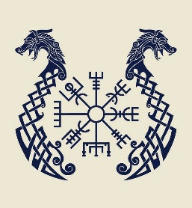

The Vikings Spring Solstice
Farmers, explorers, and merchants. But to some they were considered pirates. Vikings were the Scandinavian warriors of the sea, known as barbarians by those who feared them. Travel with us to the tenth century - to the days of the Vikings! https://www.britannica.com/topic/Viking-people

Viking Vernacular
Vikings: Boy Scouts with swords and shields and helmets who are registered for Vikings Camporee.
Clan: Vikings from the same Boy Scout Patrol. Chief: The Patrol Leader from a Viking Clan.
Tribe: A group of Viking Clans from the same Boy Scout Troop.
Head Chief: The Senior Patrol Leader from a Viking Tribe.
Judges: Adults on the Days of Vikings Committee who have a specific responsibility. If you want to be a Judge, contact the Viking King (defined below).
Viking Elders: Adults with swords and shields and helmets who are registered for the Days of Vikings Camporee.
The Viking King: Camporee Director

Registration
While playing on the river bank in the early morning of a hot spring day, a Tenderfoot Scout discovered a clay jar containing a parchment with strange characters. Experts believe it to be in Old Norse.

COME YOUNG WARRIORS IN TRAINING AND JOIN A VIKING CLAN. CLANS CANNOT BE LARGER THAN NINE VIKINGS. A TRIBE WITH TEN VIKINGS WILL JOIN AS TWO CLANS. EACH CLAN MUST HAVE A CHIEF. EACH TRIBE MUST PROVIDE AT LEAST TWO VIKING ELDERS PER TEN YOUNG VIKING ELDERS. THERE MUST BE A MINIMUM OF ONE ELDER PER TEN YOUNG VIKINGS IN ATTENDANCE.
PAY YOUR FARE IN GOLD OR SILVER.

(English Translation)
Registration is by patrols. Patrols cannot be larger than nine scouts. A troop with ten scouts will register as two patrols. Each patrol must have a patrol leader. Each troop must provide a minimum of two adult leaders. There must be a minimum of one adult leader per ten youth in attendance. Registration is $15 per scout if paid in full by May 10(Late Registration Fee $25 after May 10) Take advantage of the early-bird discount $10 per scout by registering before May 7 Adults $5
Register on line:

A note to the Viking Elders (That is you Scoutmasters)
Viking Elders, you are welcome to participate in the activities. Your presence is appreciated. If you see something unsafe, you have the right and responsibility to take corrective action. You may take pictures, cheer for the youth, and give encouragement.

Now, there are some things you may not do. Don’t aid your Vikings in the competitions. Don’t give advice, answers, or provide them with any advantage. Let the Head Chiefs be responsible for their tribes. Your role between now and April 24th is to train your Chiefs to lead their tribes. Here are some activities and rank advancements you can help your youth with to prepare them to be at their best at the Camporee.
Preparing for the Camporee
Vikings, this camporee will take some preparation. Use this section of the guide book to plan your clan meetings in the months leading to the camporee. Have fun, build memories, and take some pictures along the way.
Decorating your shield
Every good Viking knows how to handle a shield. Each Viking will have an opportunity design a shield. Each Viking will provide their own paints and boss (At the center of every Viking shield is a steel center boss. The boss protects the warrior's hand. The warrior can purchase a boss or purchase a replacement, metal dog bowel that is at least 5 inches inside diameter.

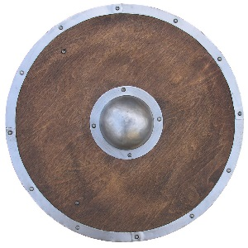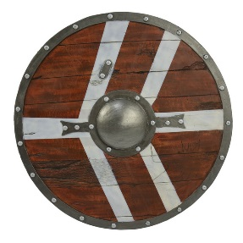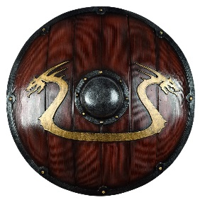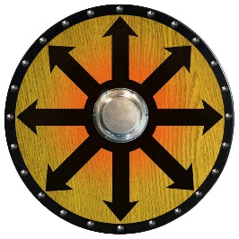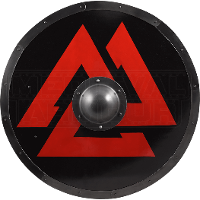

Making a Viking Tent
When a ship was no longer suitable for the sea, its parts were converted to make a shelter.
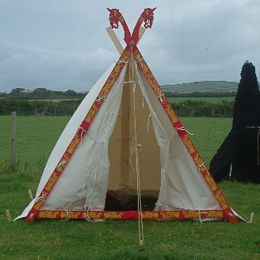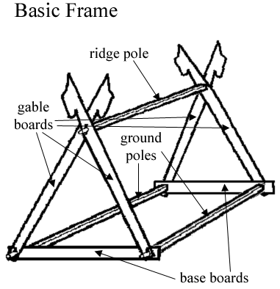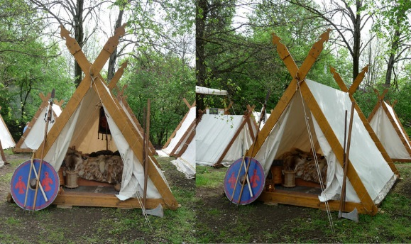
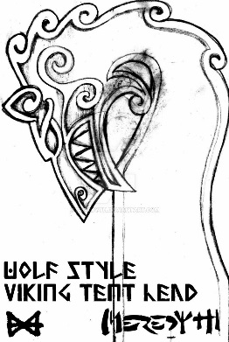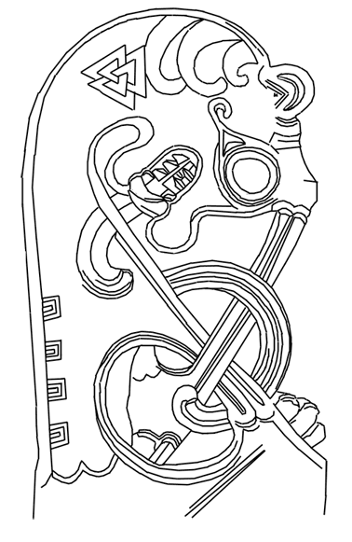

http://my-sword-is-bigger.deviantart.com/art/Secrets-of-the-Viking-Tent-431237254
Although I know you may not have any oars or sails. Canvas tarps and 2X4 boards can make an adequate Viking tent.
Be creative with yours.

The Right Apparel
How far you want to take this is up to you. Come in full costume, or just bring a sword and shield. (But don’t bring any real weapons - that could go bad quickly.)
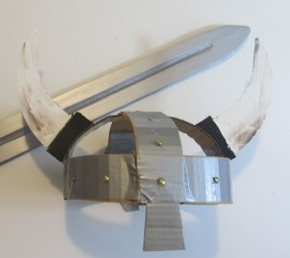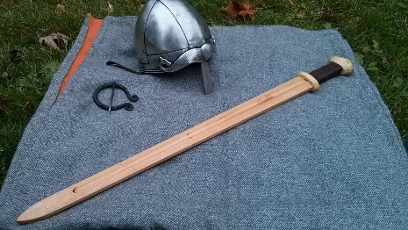 Make it from wood, cardboard, cardboard wrapped in foil… It’s up to you. You’ll look out of place if you’re dressed like a 21st century observer. As for headgear, do you want to be authentic or iconic? Historically speaking, Vikings never put horns on their helmets. On the other hand, everyone knows you’re a Viking if you do.
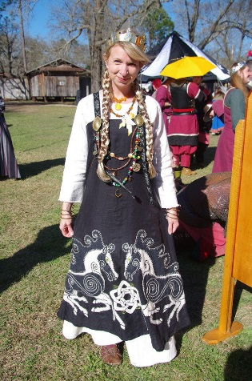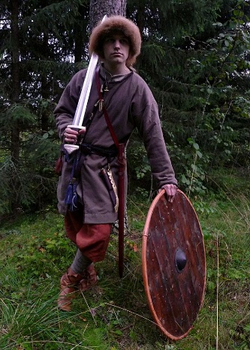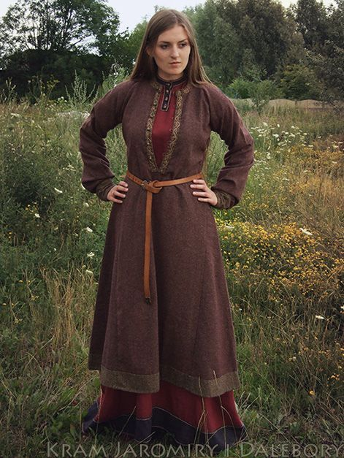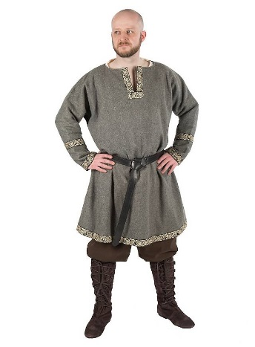

Each Viking will have the opportunity to make a Viking mug. The parts will be cut out, the young Viking will have to glue it together and carve the handle.
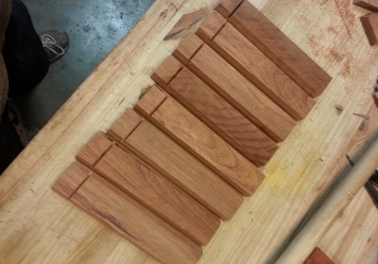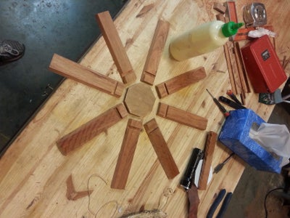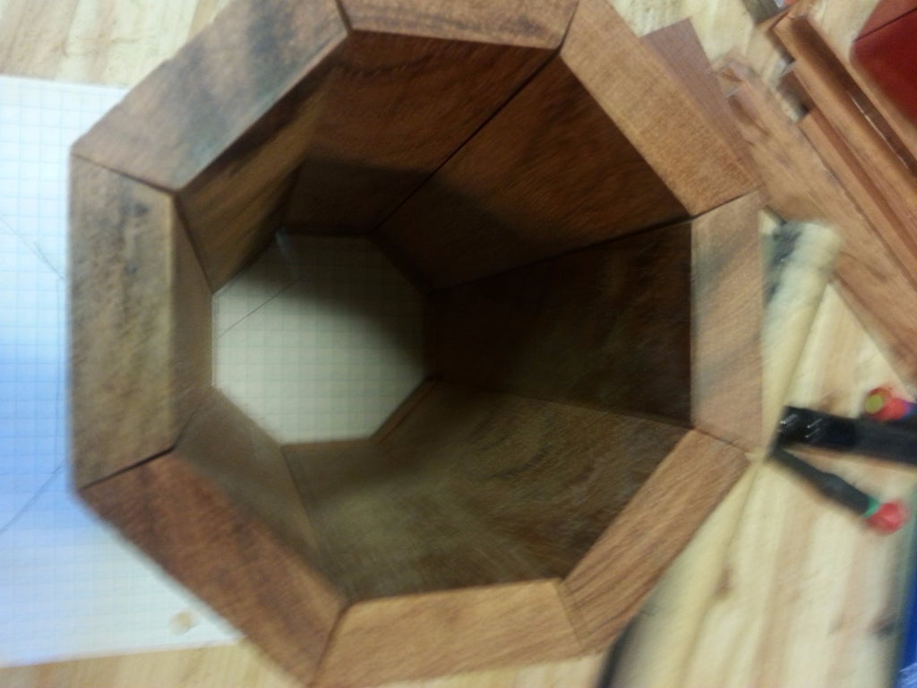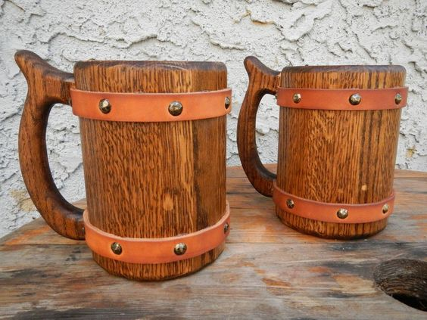

Building a Catapult
The catapult that is described here will throw a water balloon several hundred feet. Obviously if you reduce the dimensions of the components the distances you can throw will change accordingly.
Equipment List
Quantity | Item | Comments
3 | 2.4m (8ft) spars (front face) | All spars must be good quality. DO NOT use dowelling.
3 | 4.5m (15ft) spars (back brace)
1 | 4.5m (15ft) spar (throwing arm) | Best results will come from a good but relatively thin spar.
1 | 1m (3.5ft) spar (throwing arm cross piece) | Must be strong
15m (50ft) | .6cm (1/4in) or thicker rope | Launching rope
7 X 3.5m (12ft) | .6cm (1/4in) rope | These are for lashing. I prefer braided nylon or better still, braided polyester.
1 | double pulley or 2 single pulleys | Must fit the launching rope above.
1 | throwing tin | (see diagram belowsee diagram below)
2 X 1/2m  (20in) | .6cm (1/4in) rope | to attach pulley(s) and throwing tin
1 supply | water balloons
Step 1 - Build front face triangle
Lay out the 2.4m spars as shown in the diagram and lash the spars together with a square lashing where they cross.
Step 2 - Attach the back supports
Lash the back brace spars to the front face triangle as shown in the diagram. Note: The two side spars should be lashed to the inside of the triangle about 2/3 of the way up from the bottom. The bottom spar should be attached on the outside.
1

Step 3 - Build the throwing arm
Lash the throwing arm cross piece to the bottom side of the throwing arm about 1m (3.5Ft) back from the thickest end. If the throwing arm has a curve in it make sure the apex of the curve is up (see diagram).
Attach the throwing tin to the tip of the throwing arm.
Step 4 - Assemble the catapult
Set the completed throwing arm into the catapult as shown.
Attach the pulley(s) to the end of the lower back support.
Attach the middle of the launching rope with a clove hitch to the large end of the throwing arm.
Run the two ends of the launching rope through the pulley(s) and lay them back beside the two back supports.

Step 5 - Safety considerations
The excitement of watching the water balloon sail out and hit its mark is the fun of building a catapult. However, what goes up will also come down and the throwing arm is no exception. Once the balloon is launched all eyes will follow the balloon and unfortunately not the decent of the arm. One person MUST act as safety control and control the decent of the arm. (see the diagram). This means that they must stand just in front of the catapult and keep their hand on the short end of the throwing arm. The same person can check the path of the throwing arm before they call "fire" to ensure everyone is clear.

Step 6 - Operation
Assign youth to pull the launching ropes. Depending on their strength and size,
2

you can assign several on each rope. When the water balloon is in the tin and everyone is clear of the arm, the safety control person should yell "fire" and both ropes pulled. If the throwing arm is heavy then the safety control person may want to assist the throw by pushing down on the throwing arm extension. (Remember to control the descent of the arm after the water balloon has been thrown.)
Step 7 - Have fun!
As with all games a set of rules will help keep the excitement under control. If you are building several catapults to throw balloons at each other, then here are some simple rules that have work for me.
No balloons will be thrown until all the catapults are built and operational. (This keeps the focus of the teams on the building process.)
No balloons will be thrown by hand.
Only water balloons can be thrown.

Throwing Tin
The throwing tin is made from a large coffee tin. The side is cut down to a 8cm (3in) height and the edge is turned over. Two slots 1.25cm (.5in) wide X 10cm (4in) long, about 2.5cm (1in) apart. (see diagram). Tape the edges with duct tape. (Note: If the tin is to be used on several occasions, then add a stiffener that fits inside the tin between the two slots and extends out to the sides. Hold it in place with more tape!)
Special Note: The distance that this catapult can throw a water balloon is a related to the square of the length of the throwing arm i.e., an arm ½ the length will only through a water balloon ½ X ½ or ¼ of the distance. In addition, the weight of catapult itself is too light.
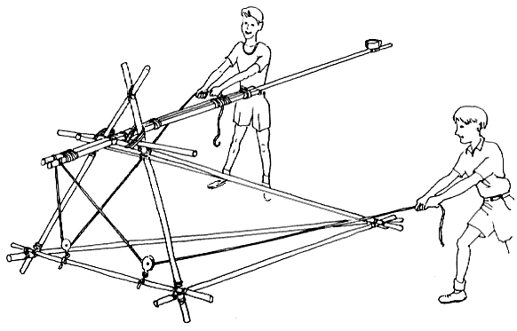

Viking Rune stones and Viking symbols

Viking Runes’ History
One more exciting fact “futhark” – the name of the runic alphabet. It is known so because of the first six letters of the runic alphabet– f, u, þ, a, r, k.
There are three primary forms of futhark:
- Elder Futhark – included 24 characters; was used between 100 and 800 AD;
- Younger Futhark – included 16 characters (language was becoming more complicated); was used between the 8th and 12th centuries
- Medieval (Anglo-Saxon) Futhorc– included 33 characters; was used mostly in England during the Viking Age (1100 to 1500 AD)

Viking Symbols
Each symbol had a different meaning. However, each of them was of particular importance in Nordic culture. Spirituality was as crucial for Vikings as our religion is essential for us today. No parting was between reality and faith (as there occurs so often today). Mostly everyone knows Thor’s hammer (Mjölnir) because of the famous Marvel movies. It was an ancient, highly appreciated symbol, which was frequently used to ornament different Viking's jewelry, including rings, necklaces, bracelets and armor.

Warriors will be able to carve/write ruins and or symbols.
We have limited supplies.

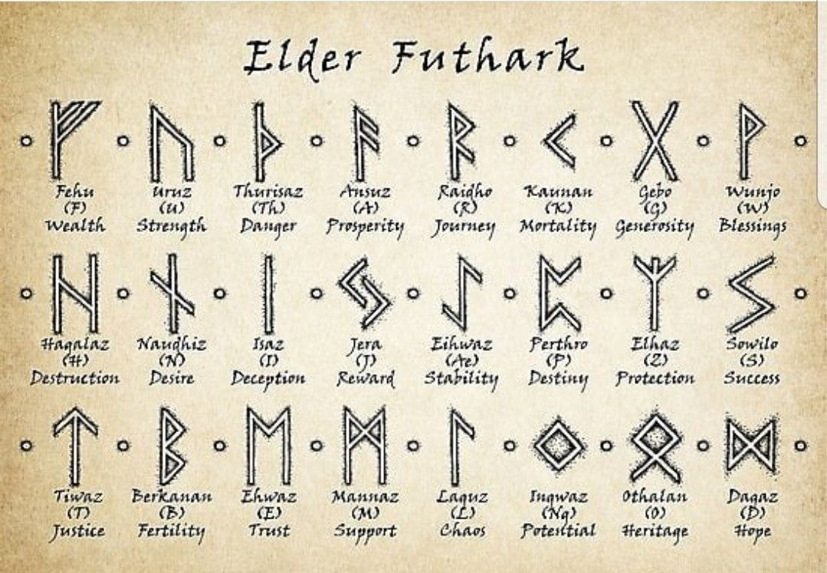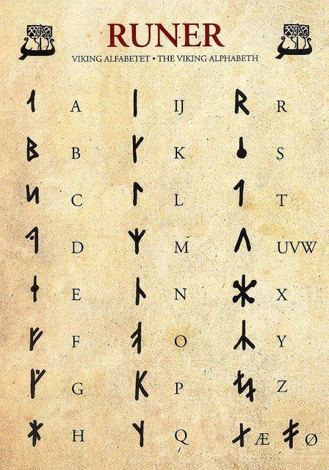
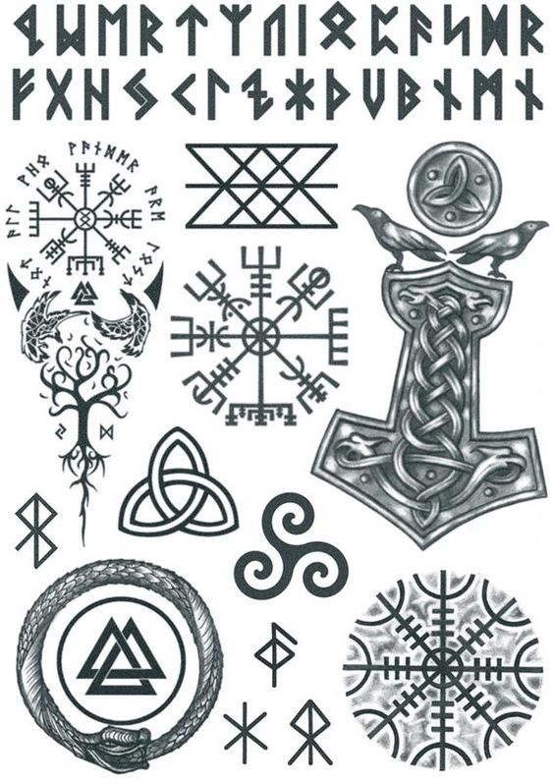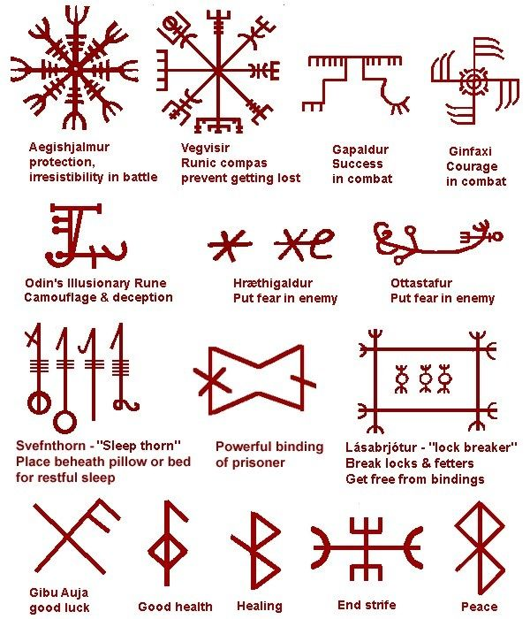

Contest

Test your skills playing Viking board games
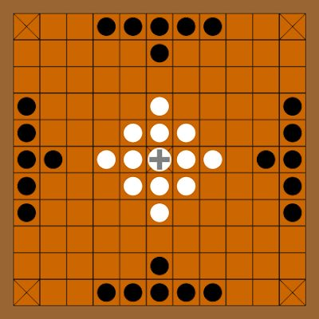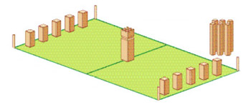
Try your hand at building a Viking bed or chair. Use your imagination and creativity to create a master piece.
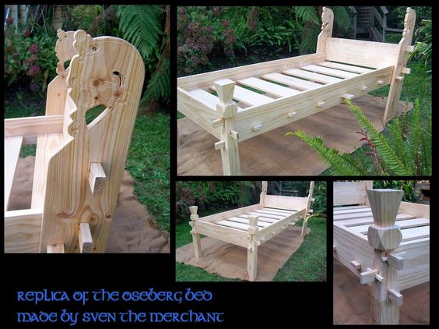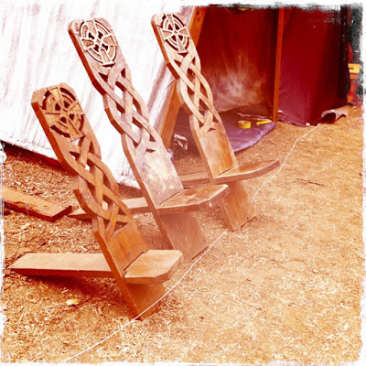
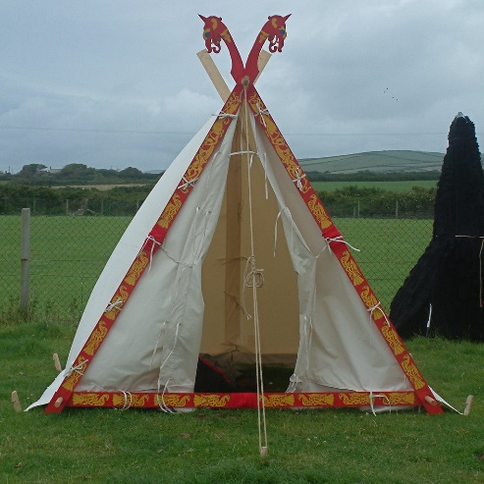

Tribes  ❏ Troop box  ❏ Gateway  ❏ Troop Flag  ❏ Campfire song/skit  ❏ Lanterns  ❏ Tables  ❏ BSA Medical forms parts AB for all scouts and adults  ❏ $15 per vehicle (just in case)  - Catapult  - Wood carving chisels | Clans  ❏ Patrol Flag  ❏ Shovel  ❏ Viking Tent  ❏ Cooking gear  ❏ Dishwashing supplies  ❏ Trash bags  ❏ Tables  ❏ At least 1 gallon drinking water per scout per day.  ❏ At least 5 gallons washing water per day.  ❏ Food storage container ❏ Charcoal chimney  ❏ Water and sand buckets for putting out fires  ❏ Cooler with ice  ❏ Patrol First Aid kit  ❏ Extra toilet paper | Vikings  ❏ Field Uniform  ❏ Viking Cloths  ❏ Pack/duffel bag  ❏ Sleeping bag/blankets, sleeping pad  ❏ Eating utensils, cup, plate, bowl (if not included in troop box)  ❏ Flashlight and extra batteries  ❏ Camp Chair  ❏ Change of cloths  ❏ Warm clothes  ❏ Rain gear (check the weather report before you go)  ❏ Toiletries  ❏ Pocket knife with Totin’ Chip Card  ❏ Firem’n Chit Card  ❏ Personal First Aid kit  ❏ Water bottle  ❏ Compass  - Paint and boss for shield
The above list is provided as a guide. Tribes, clans, viking youth, and tribe elders generally know their needs better than anyone else. Please bring everything necessary.

Camporee Schedule
Friday: 6-8PM Check-in. A camp site will be assigned when you arrive.
Dinner on your own
9PM Chief’s Council (For Patrol Leaders and Senior Patrol Leaders)
10PM Lights-out

Saturday: 6 AM Revelry
6:15 AM Breakfast on your own
7:30 AM Opening Ceremonies
8:00 AM Begin putting catapults together and other Viking Games
Noon: Lunch on your own
1:00 PM Clan Competitions
5:00 PM Dinner on your own & Cooking Competition
7:30 PM Award Ceremony & Campfire Program
8:30 PM Flag retirement ceremony

Sunday: Breakfast on your own
Clean up and return home

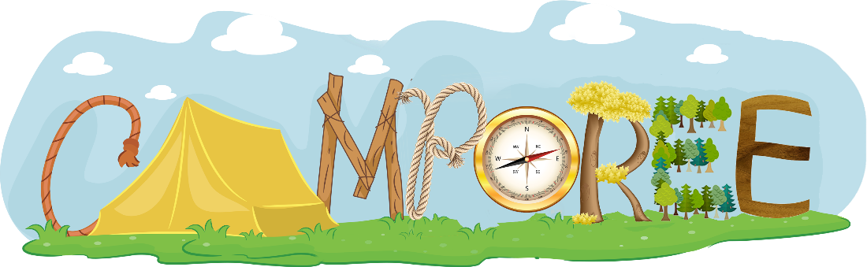

Advancements
Note to Viking Elders (Scoutmasters): Opportunities will be available for your Vikings to do rank requirements.
Camping
Tenderfoot
____ 1a. Present yourself to your leader, prepared for an overnight camping trip. Show the personal and camping gear you will use. Show the right way to pack and carry it.
____ 1b. Spend at least one night on a patrol or troop campout. Sleep in a tent you have helped pitch.
____ 1c. Tell how you practiced the Outdoor Code on a campout or outing.
2nd Class
____ 1a. Since joining Boy Scouts, participate in five separate troop/patrol activities, at least three of which must be held outdoors. Of the outdoor activities, at least two must include overnight camping. These activities do not include troop or patrol meetings. On campouts, spend the night in a tent that you pitch or other structure that you help erect, such as a lean-to, snow cave, or tepee. *
____ 1b. Explain the principles of Leave No Trace and tell how you practiced them on a campout or outing. This outing must be different from the one used for Tenderfoot requirement 1c.
1st Class
____ 1a. Since joining Boy Scouts, participate in 10 separate troop/patrol activities, at least six of which must be held outdoors. Of the outdoor activities, at least three must include overnight camping. These activities do not include troop or patrol meetings. On campouts, spend the night in a tent that you pitch or other structure that you help erect, such as a lean-to, snow cave, or tepee.*
____ 1b. Explain each of the principles of Tread Lightly! and tell how you practiced them on a campout or outing. This outing must be different from the ones used for Tenderfoot requirement 1c and Second Class requirement 1b.
____ 9c. On a Scouting or family outing, take note of the trash and garbage you produce. Before your next similar outing, decide how you can reduce, recycle, or repurpose what you take on that outing, and then put those plans into action. Compare your results.
*Rank requirement revision effective August 1, 2017 https://blog.scoutingmagazine.org/2017/07/11/revised-campout-requirements-aug-1-2017/

Cooking
Tenderfoot
____ 2a. On the campout, assist in preparing one of the meals. Tell why it is important for each patrol member to share in meal preparation and cleanup.
____ 2b. While on a campout, demonstrate an appropriate method of safely cleaning items used to prepare, serve, and eat a meal.
____ 2c. Explain the importance of eating together as a patrol.

Fire Building
Second Class
____ 2a. Explain when it is appropriate to use a fire for cooking or other purposes and when it would not be appropriate to do so.
____ 2b. Use the tools listed in Tenderfoot requirement 3d to prepare tinder, kindling, and fuel wood for a cooking fire.
____ 2c. At an approved outdoor location and time, use the tinder, kindling, and fuel wood from Second Class requirement 2b to demonstrate how to build a fire. Unless prohibited by local fire restrictions, light the fire. After allowing the flames to burn safely for at least two minutes, safely extinguish the flames with minimal impact to the fire site
Knots
Tenderfoot
____ 3a. Demonstrate a practical use of the square knot.
____ 3b. Demonstrate a practical use of two half-hitches.
____ 3c. Demonstrate a practical use of the taut-line hitch.
2nd Class
____ 2f. Demonstrate tying the sheet bend knot. Describe a situation in which you would use this knot.
____ 2g. Demonstrate tying the bowline knot. Describe a situation in which you would use this knot.
1st Class
____ 3b. Demonstrate tying the timber hitch and clove hitch.
____ 3c. Demonstrate tying the square, shear, and diagonal lashings by joining two or more poles or staves together.

Drug and Weapon Policy
Drugs and Alcohol
Illegal drugs and alcohol are not permitted at any time, and all tobacco use should be out of sight of scouts and others. All waste needs to be packed out. Standard rules from the Guide to Safe Scouting apply with respect to prescription medications.
Knives, Weapons, and Firearms
Scouts with Totin’ Chip cards may carry one pocket knife.
We encourage you to come dressed in Viking attire. That said, weapons must be limited to costume accessories and be time period appropriate. If your sword, ax, or quiver of arrows have the appearance of being dangerous, staff will have to assume you are donating them to the district.
Thank you for keeping scouting safe.
With the exception of law enforcement officers, no one is permitted to carry firearms.

Spring 2022

