WHITE BUFFALO
Webelo WOODS
Leader’s Guide
October 16 - 18, 2026
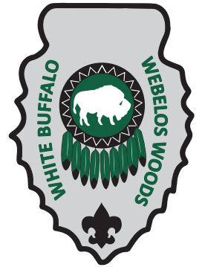
Quivira Scout Ranch
Register at: https://quivira.org/camping-with-quivira/
For Questions Contact:
Event Coordinator:
Assistant Scout Executive: Kevin Gorman Kevin.Gorman@scouting.org
Webelo Woods Information
What is Webelo Woods?:

Webelo Woods serves as a stepping stone for Webelo and Arrow of Light scouts and their parents to transition from Cub Scouts into Scouts BSA through a series of troop scout lead fun-filled demonstrations, activities, and adventures that represent what awaits them in a troop.

What to Expect:

First Aid, Camp Cooking, Knots, Nature Hikes, Shooting Sports, Equipment Branding, and More!
Webelo scouts will focus on rank requirements, Arrow of Light scouts will focus on transitioning to Scouts BSA, and everyone will have fun!

General Information:
The most important part of a successful camping trip is planning. The following information will help you plan for this event. Enclosed in this packet is an event guidelines, agenda, requirements that will be completed at camp, recommended requirements to complete before coming to camp, a sample menu, and a suggested packing list.
- Webelo Woods will take place at Quivira Scout Ranch (1781 Rd 19, Sedan, KS 67361)
- All units must register online, units MUST register as a pack and not with their associated troop! (https://quivira.org/camping-with-quivira/)
- If there are any participant mobility or camping limitations, please note it in your registration and contact the event coordinator. We will do our best to accommodate all reasonable requests.
- All Packs have the option to and are encouraged to arrive and camp out Friday evening
- Troop scouts that are attending as Den Chiefs and are planning on camping, eating, and assisting their associated Pack must register with the Pack as adults in Black Pug.

Check-In:
For normal operating hours, check in will take place at the entrance to camp. For all other times, please check in at HQ which resides in the trading post.

Units are encouraged to have all attendees arrive at the same time and check in together, this will facilitate an expedited check in.

Units can check in as early as 12:00pm on Friday afternoon, Friday check ins will close at 8:00pm. If you cannot make it until after 8:00pm please coordinate arrival with the event coordinator or plan on checking in Saturday morning. Check in will begin Saturday at 7:00 am and must be complete by 8:15am.

Please arrive at camp with a Black Pug registration receipt, complete roster of Youth & Adults, and BSA Health forms (part A/B) for each attendee. These will be returned to you before departure on Sunday. It’s recommended each unit brings a printed copy of the Leader’s Guide for reference.

Packets given at check-in will have the following items enclosed:
a. Campsite location
b. Schedule
c. Unit’s rotation assignment
d. Activity map

Youth Protection:
Youth Protection shall be strictly adhered to while at Webelo Woods. All participants 18yrs old and older must have taken BSA Guide to Safe Scouting within the last year. Every unit shall have 2 registered leaders over 21 years of age in attendance with one of these leaders being a female if the unit serves female scouts. Only parents and guardians may share a tent with their family. Youth sharing tents must be of the same gender and no more than 2 years apart in age. Separate restrooms are provided for youth and adults. Under no circumstances are youth allowed to accompany adults into the adults restrooms. All showers and restrooms in the dining hall are closed to ALL youth. If medical needs dictate it, there are restrooms in the first aid station that can be used.

Additional guidance can be found here: https://www.scouting.org/health-and-safety/gss/gss01/

Arrival:
Please review the “Check In” section for check in requirements at arrival. Upon arrival, each unit will receive their assigned campsite (there may be multiple units in a single campsite). If your unit arrives before other units assigned to the same campsite, please leave room for them to setup camp as well.

Units will only be allowed a single trailer with attached truck in camp. Flatbed trailers will be available to shuttle gear to and from your campsite. It’s recommended that units fit as much equipment as possible into your trailer (if available) expedite camp setup. All other vehicles must be parked in designated parking areas at the entrance to camp and will not be permitted within camp.

During Camp:
Each unit is responsible for their own food, food preparation, and camp gear. This includes tables, chairs, tents, and kitchen supplies. Typically, scouts cook on gas stoves or in dutch ovens. This would be a great opportunity to acclimate your scouts to troop cooking. If something is lost during camp, please check for, or report, missing items at the Lost and Found located in HQ by the trading post.

Activity shirts may be worn during the activity session but Field Uniforms should be worn to flags and campfire.

Do not leave camp property without notifying the staff.

A medical team will be on hand to help with First Aid and to communicate with the local hospital for more serious problems. Inform the staff at registration of any serious medical conditions of which you are aware and report all major accidents to the camp office.

There will be 2 campfires on Saturday night. One for Webelo scouts and a separate one for Arrow of Light scouts. Each campfire will be run by staff so your unit can relax and enjoy the show.

Check Out:
Before leaving, everyone should police each campsite. Webelo Woods Staff will sign off on the campsite cleanliness. Return to check in to retrieve your medical forms and pick up your patches.
Available Activities:
Station Rotations
 | Webelos | AOLs
Station 1 | BB Guns | Archery
Station 2 | Hiking | Hiking
Station 3 | Cooking | Climbing Wall
Station 4 | Orienteering | First Aid
Station 5 | Skits & Songs | Camp Tools
Station 6 | Knots | Pioneering
Station 7 | Team Building | Patrol Spirit
Station 8 | Open Time
Shooting Sports: BB Gun & Archery
Come test your skills with a BB Gun and Archery to see who’s the best shot in White Buffalo!
Hiking: Walkabout & Into the Wild
Make sure to fill up your water bottles first, then learn about the natural beauty of QSR, its wildlife residents, and trees and plants that grow around QSR’s property as you hike some of the camp trails.
Cooking
All troop scouts cook their own food while camping. Stop by and learn different recipes and methods of cooling delicious dishes. While the scouts are learning Cooking, parents and Den Leaders will learn all about the transition from Cub Scouts to Scouts BSA.

Climbing Wall
Test your mettle on QSRs climbing wall!

First Aid
At some point during a troop activity you’ll need to know First Aid, it may be needed sooner than you think!
Orienteering
Lost in the woods with only a map and compass? You’ll learn how to find your way home.
Songs and Skits
Tired of the invisible bench? Come learn some new songs and skits to liven up any campfire.
Camp Tools
You may not be able to use an ax yet, but you can learn how to use one as well as how to start fires without matches.
Knots & Pioneering
Square knot, taut line, two half hitch, and lashings this is how Scouts put together camp and setup tents. Also learn how to fuse a rope and make a keychain.
Patrol Spirit
Come make a patrol yell, cheer, and flag.
Team Building Activities
Learn how to work better as a team through a series of fun games
Open Time
Want to get equipment branded? Visit the trading post? Earn your Whittling Chip? Participate in Jamboree Over the Air? Take some time to explore QSR? These activities are available all day Saturday and are located around the perimeter of the Dining Hall.
Trading Post
Forget your toothbrush or deodorant, need some light camp equipment (carabiner, cup, paracord), looking for some souvenirs, or just want some snacks? Stop in at the famed Webelo Woods Trading Post!

Event Schedule:
Unit/Rank to Group assignments will be announced at Check-In
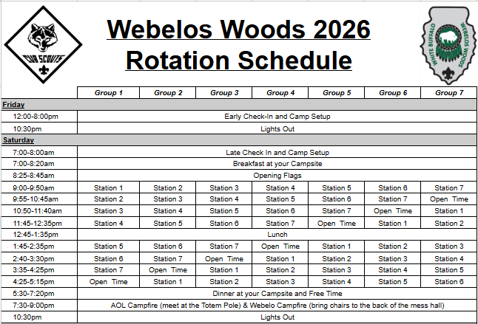
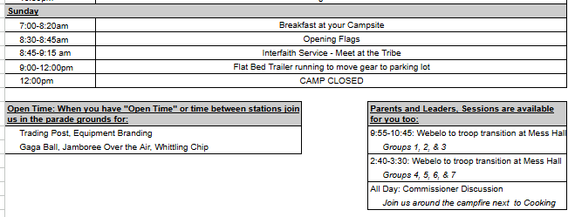
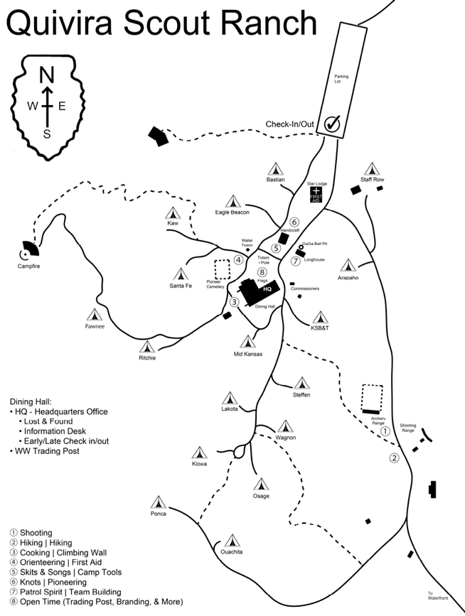
Recommended Packing List:
Individuals:
- Cub Scout Uniform: To be worn at all Flag Ceremonies and campfires
- Standard clothing and toiletries
- Raincoat or poncho
- Hat
- Sunscreen & Insect repellent
- Small backpack/string sack for carrying projects
- Water cup/bottle
- Money for Trading Post: equipment, souvenirs, and snacks.
- Pocket knife and whittling chip
- Flash Light: with extra batteries
- Sleeping bag and pillow
- Sleeping pad
- Chair
- Mess Kit
Units/Dens:
- Tent
- Ground Cloths
- Extra rope and tarp
- Stove/dutch oven/cooking supplies

Example Den Menu:
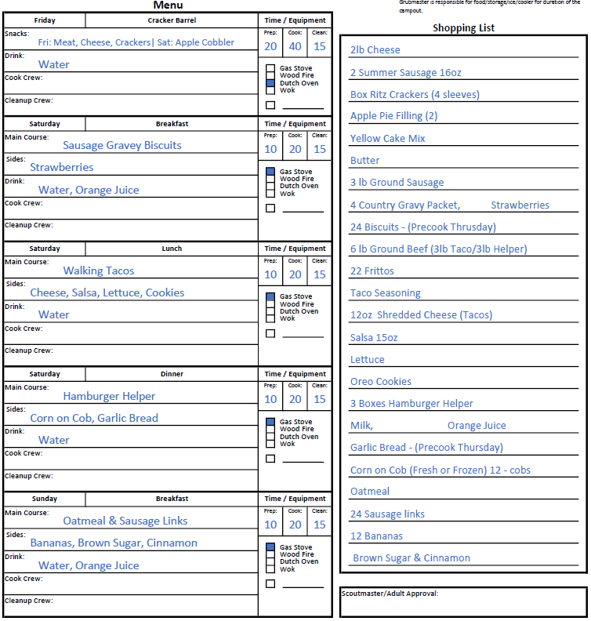
Adventure Pin Requirements:

All scouts attending Webelo Woods will have had the opportunity to complete the following requirements, it’s up to the Den Leader to verify they have been completed:

Webelo Completions:
Let’s Camp Webelos: 5
Webelo Walkabout: 1, 2, 3, 4, 6, 7
BB Gun Webelo: 1, 2, 3, 4, 5, 6, 7, 8

Arrow of Light Completions:
First Aid: 2, 3, 4, 5, 6, 7
Into the Woods: 1, 2, 3, 4, 5
Archery Arrow of Light, 1, 2, 3, 4, 5, 6, 7, 8

