BALOOS/IOLS
To: Cub/Scout Leaders, Committee Members
The Quivira Council invites you to participate in BALOO Basic Adult Leader Outdoor Orientation and the Introduction to Outdoor Leader Skills Training (IOLS). This fun-filled program of hands-on outdoor training is designed for Scout leaders to help master basic camp skills required for Tenderfoot to First Class and for Webelos leaders to take Webelos dens on overnight camping outings. IOLS will run like a troop in that participants will be formed into and participate as patrols including selecting a Patrol Leader. A staff member will serve as the Senior Patrol Leader. A Scoutmaster and several Troop Guides will provide instruction throughout the weekend. Field (Class “A”) uniform is recommended.
Sessions will include how to set up camp, cook, work with hand tools, ropes and knots, first aid, campfire program planning, map reading and compass skills, hiking and packing techniques, nature identification, and Leave No Trace. Each outdoor session will bring to life the pages of the Scout Handbook to help you deliver the promise of Scouting to yourself and the youth you serve. IOLS will help to increase your comfort level and give you confidence as a trained, skilled leader. This training will give you the opportunity to work with other Scout leaders from our council, meet new friends, and reinforce skill teaching techniques with fellow unit leaders.
Sign up, follow the link to Survivor - Spring Camporee
Friday through Sunday, April 10-12, 2026

https://scoutingevent.com/198-108887

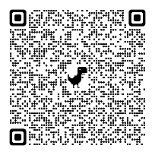
WHEN: , April 10-12, 2026. Check-in: Starts at 7:00 PM on Friday
WHERE: Greenbush, 947 W 47 Hwy, Girard, KS 66743
Coords: 37.506459, -94.989134
COST: $5, meals will not be provided Registration is required for this training. WALK-INS ALLOWED.
You must provide your own food.
To register or for more information, please use the online registration form Black Pug.
At check-in: show completion certificates or pocket cards for Leader Specifics and YPT.
If you have completed the Leader Specifics for your chartered position (Webelos DL or SM Specifics)
and the YPT, you will be qualified to wear the "trained" patch at the completion of this IOLS training.
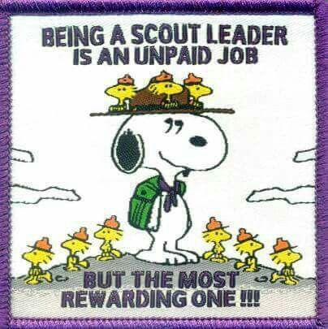
The trained patch can be purchased at the Scout Service Center in Wichita.
Electricity is not provided.
There is space for pitching a tent.
IOLS Coordinator: Thomas Nelson (Text) (620)875-0728
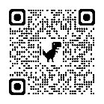
Facebook
The items listed below are for an overnight camping experience as indicated in the references: Scout Handbook or Webelos Handbook.
Overnight gear, outdoor essentials, and appropriate clothing are the heart of camping equipment. Carry a light load of only what you need to keep yourself safe and make a good camp; leave all unnecessary items at home.
Use lightweight tents – two- four-person type-- no wall or large recreation types. This training will take place regardless of rain or shine, so please come prepared. We do have access to shelter in case of inclement weather. However, we will spend most of our time outside for the sessions. We also have access to vaulted bathrooms by the shelter building
PERSONAL OVERNIGHT CAMPING GEAR All items should be marked with your name. Unit # is optional.
Bring an appropriate Scout Handbook.
Wear leader FIELD UNIFORM
Outdoor Essentials Cleanup Kit
pocketknife
soap (in container)
personal first-aid kit toothpaste/ toothbrush / dental floss
extra clothing
comb
rain gear
towel / washcloth
water bottle filled with potable water (Nalgene type)
extra plastic bag for dirty clothes
flashlight (extra batteries and bulb)
matches and fire starters
Personal Extras
sun protection (optional in this season) watch
insect repellent (seasonal) camera (optional)
clothing for the season (changes for number of days camping) notebook or paper / pen or pencil
outer clothing appropriate for spring outdoor sessions extra hat and gloves
clothes for sleeping sunglasses (optional)
backpack, suitcase, or laundry bag boots (depending on weather)
rain cover for backpack (large leaf bag works well) folding chair
sleeping bag, or 2-3 blankets
small tent (two-person)
sturdy shoes - no open toed or open heeled
sleeping pad
ground cloth (old shower curtain works well)
compass
Eat Kit bowl, plate, cup, spoon, fork, knife
(for this training we will supply paper plates and utensils)

