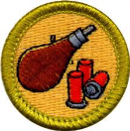
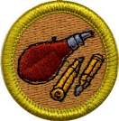
Rifle & Shotgun
Shooting
Merit Badge Workbook
Year: _______
First Name: _____________________
Last Name: _____________________
Unit: _________ ⃝ Quivira ⃝ Other
Session: ⃝ 1 ⃝ 2 ⃝ 3 ⃝ 4 ⃝ 5

Explain why BB and pellet air guns must always be treated with the same respect as firearms.

Describe how you would react if a friend visiting your home asked to see your or your family’s firearm(s).

Explain the need for, and use and types of, eye and hearing protection.

Give the main points of the laws for owning and using guns in your community and state.

Explain how hunting is related to the wise use of renewable wildlife resources.

Obtain copy of the hunting laws for your state. Explain the main points of hunting laws in your state and give any
special laws on the use of guns and ammunition.

List the kinds of wildlife that can be legally hunted in your state. (Shotgun shooting)

Identify and explain how you can join or be a part of shooting sports activities.

Identify and explain three shotgun sports. (Shotgun shooting)
1.
2.
3.

Explain to your counselor the proper hygienic guidelines used in shooting.

Give to your counselor a list of sources that you could contact for information on firearms and their use.

Identify and demonstrate the three fundamental RULES for safe gun handling.
1.
2.
3.

Identify and explain each additional rule for safe shooting.

Explain to your counselor what a misfire, hang fire, and squib fire are, and explain the procedures to follow in
response to each.
 | Define | Procedure
Misfire
Hang fire
Squib Fire

Identify the basic safety rules for cleaning a gun, and identify the materials needed.

Discuss what points you would consider in selecting a gun.

RIFLE SHOOTING (Modern Cartridge Type)
Identify the three main parts of a rifle, and tell how they function.
2
1
3

2b
1c

2c
1c

2a
1c

1a
1b
3a
3b
1c
1c

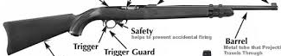

3e
1d
3d
3c

Part |  | Function
1. | a.
 | b.
 | c.
 | d.
2. | a.
 | b.
 | c.
3. | a.
 | b.
 | c.
 | d.
 | e.

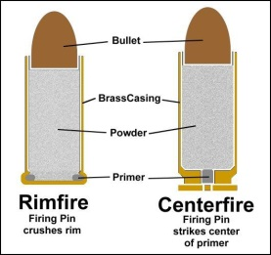
Identify the two types of cartridges, their parts, and how they function.
a b c d

2
1

a b c d

Type | Part | Function
1. | a.
 | b.
 | c.
 | d.
2. | a.
 | b.
 | c.
 | d.

Identify and demonstrate the five fundamentals of shooting a rifle safely.
1. | 3. | 5.
2. | 4
SHOTGUN SHOOTING (Modern Shotshell Type)
Identify the principle parts of a shotgun, action types, and tell how they function.
2
1
3

2a
1c

2b
1c

2c
1c

1b
1c

3a
1c

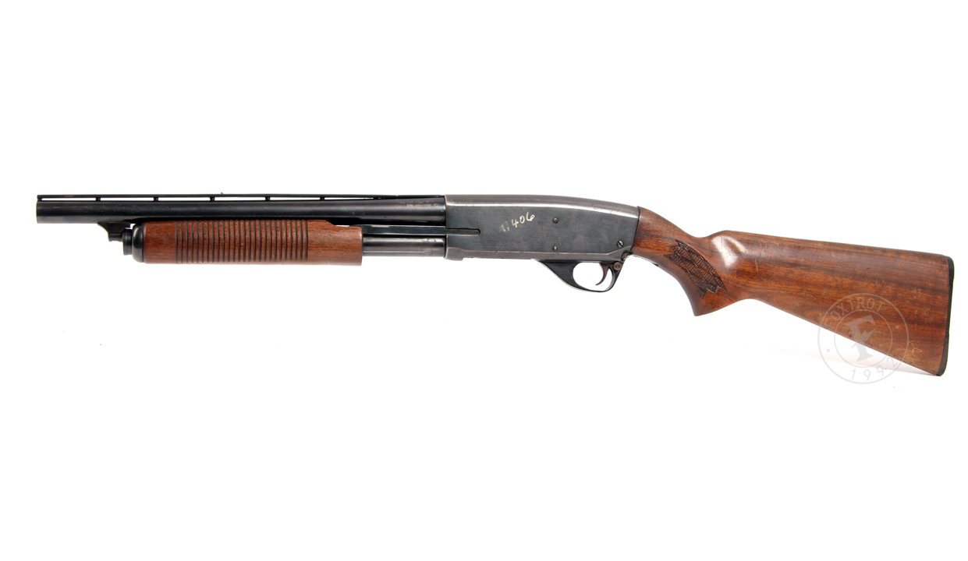
1a

1c
1c

3b
1c

3c
1c

1d
1c

Part |  | Function
1. | a.
 | b.
 | c.
 | d.
2. | a.
 | b.
. | c.
3. | a.
 | b.
 | c.

Action Types
1. | 3. | 5.
2. | 4.
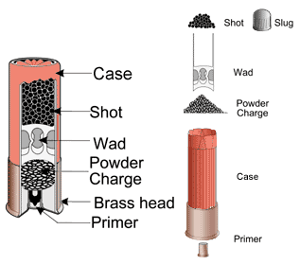
a b c d e f
Identify the parts of a shotgun shell and their function.

Part | Function
a.
b.
c.
d.
e.
f.

Identify and demonstrate the four fundamentals of shooting a shotgun safely.
1.
2.
3.
4.

Identify the various gauges of shotguns and explain which one you would pick for use and why.
Gauge |  | Use:
Why?

Gauge |  | Use:
Why?

Gauge |  | Use:
Why?

Gauge |  | Use:
Why?

Gauge |  | Use:
Why?

Gauge |  | Use:
Why?

RIFLE SHOOTING FIELD REQUIREMENTS:

Demonstrate how to clean a rifle properly and safely.
Demonstrate the knowledge, skills, and attitude necessary to safely shoot a rifle from the benchrest position while using the five fundamentals of rifle shooting.
Using a .22 caliber rimfire rifle and shooting from a benchrest position at 50 feet, fire five groups (three shots per group) that can be covered by a quarter. Using these targets, explain how to adjust sight to zero a rifle.
Fire five groups (five shots per group) that can be covered by or touch a quarter.

SHOTGUN SHOOTING FIELD REQUIREMENTS:

Demonstrate how to clean a shotgun safely.
Demonstrate the knowledge, skills, and attitude necessary to safely shoot moving targets, using the fundamentals of shotgun shooting.
Shooting score required:
Hit at least 12 out of 25 targets in two 25-target groups.
The two groups need not be shot in consecutive order.
A minimum of 50 shots must be fired.

Shooting skill rules:
- Targets may be thrown by a hand trap, manual mechanical, or on any trap or skeet field. Note: If using a hand trap or manual mechanical trap, the trap operator should be at least five feet to the right and three feet to the rear of the shooter. If throwing left-handed with a hand trap, the trap operator should be at least 5 feet to the left and 3 feet to the rear of the shooter
- All targets should be thrown at a reasonable speed and in the same direction.
- Targets should be generally thrown so as to climb in the air after leaving the trap.
- Scores may be fired at any time, either in formal competition or in practice.
- Any gauge shotgun not exceeding 12 gauge may be used.
- Only commercially manufactured ammunition may be used. Reloads may not be used in BSA shooting sports programs.
- Shooters must shoot in rounds of 25. Rounds need not be shot continuously or on the same day (the term "round" refers to a single series of 25 shots).
- If using a trap field, shoot station 3 with traps set to throw straightaway targets.
- If using a skeet field, shoot station 7 low house.

