
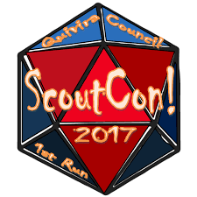
Participant Guide

SCOUTCON! 2026
November 6-8, 2026
Quivira Scout Ranch

BASIC INFO TO KNOW . . .



ScoutCon! is open to registered Scouts BSA, Ventures Scouts, Sea Scouts, and Registered BSA Adult Leaders. Note that BSA Adult Leaders must be current in YPT.

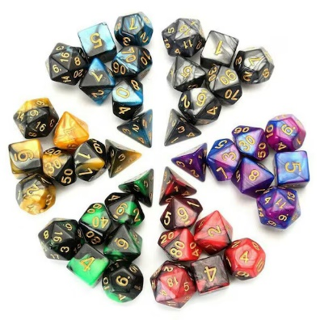
COSPLAY COSTUME CONTEST: No actual firearms allowed for this event.
Weapons for cosplay must be clearly manufactured costume props and rated PG-13, represent a game/story lore.

TOURNAMENTS: everyone must demonstrate excellent sportsmanship, befitting a Scout, and win or lose gracefully.

Fees – NOTE the reduction in registration fees & NOTE the earlier dates:
- Early-bird Registration $30.00 before October 12th (3 weeks prior to week of event)
- Regular Registration $40.00 between October 12th and October 18th
- Late Registration $50.00 between October 19th and October 25th
- Minions Registration $25.00 - requires 4 hours of event service; capped at 35 minions (committee + 25 volunteers); sign up via Signup Genius;
- All event fees are due by October 25th, no exceptions. No registrations after October 25th or day of event registrations will be accepted.

BSA Health Form: BSA Health Form Parts A & B are required by ALL attending.

Dietary & Special Needs: Please complete the Dietary Needs Request Form and submit to Lauryn Gaines no later than noon, Tuesday, October 27th.

Weather Conditions: ScoutCon is primarily an indoor activities event and will happen whether there is rain, shine, or snow. Please bring your own tent and be prepared for cold weather camping. Be Prepared! Think Trappers’ Rendezvous conditions, but still bring short sleeves, just in case. If you are attending as an individual, please make sure you bring your own tent and other camping supplies. The Scout Field Uniform is not required; however, wearing them to and from the event is always a good practice.

IMPORTANT INFORMATION TO KNOW: Every unit and individual registrant must bring their own water for in their campsites. For 2023, Chautauqua County was in a Stage 3 Emergency water supply with limited water usage by all. We should plan for this contingency again in 2026, unless otherwise notified.

NEW in 2023/2024/2025/2026: All games will be put up and cleared from the tables for meals. There will be NO Drinks or Food allowed on any table that has a game on it, even if it is your own game. No Exceptions. Also, a challenge card will be given to each Scout and Scouter, to engage in playing games with individuals from other units. Turn in your challenge card by 7pm on Saturday for the prize drawing.

ScoutCon Support Provided by




ScoutCon! 2026 Schedule

Friday Night: Registration and Check-in starts 4:30pm
Nov 6 Game Library open hours 6:30pm - 12:45am
Trading Post open hours 6:30pm - 12:00am
Adult Wingspan Tournament Friday Night, time TBD
Welcome and Announcements 9:00pm
Cracker Barrel 9:30pm

Game Library final call 12:45pm
Game Floor closed, Lights out 1:00am

Saturday: Flags (optional) 7:20am
Nov 7 Breakfast 7:30am
Announcements 8:30am
Game Library open hours 9:00am – 11:45pm
1:00pm – 5:30pm
6:30pm – 12:30pm
Magic Tournament 9:00am
Trading Post open hours 9:00 – 11:45pm
1:00pm – 5:30pm
6:30pm – 12:30am
DCC or D&D 9:00am – 11:30am, 2:00-5:00pm, 8:30pm-12:00
Dominion 9:00am – 11:30am
2:00pm – 5:30pm

8:30pm – 11:30pm
Chess Tournament 10:00am –11:30pm
Branding 9:00am – 10:30am
2:00pm – 4:00pm
Checkers Tournament 1:00pm – 3:30pm
Adult Chess Tournament 1:00pm – 3:30pm
Corn Hole Tournament 1:30pm – 3:30pm
Catan Tournament 3:00pm – 5:30pm
Retire Flags (volunteers requested) 5:15pm
Rubik’s Cube Tournament 7:00pm
Cosplay 7:30 - 8:30pm
Game Library final call 12:45pm
Game Floor closed, Lights out 1:00am
We’ll see you again at ScoutCon! 2027

Sunday: Breakfast 7:30am
Nov 8 Check Out & Turn-in Reviews 8:00am
Clean up and go home (Help requested) 8:30am – 10:00am
ScoutCon! 2026 is Closed

