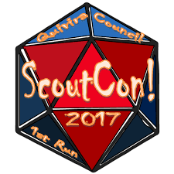
SCOUTCON! 2026
Nov. 6-8
@ QSR

BASIC INFO TO KNOW . . .




EVENT PURPOSE: ScoutCon! brings Boy Scouts together for a weekend of camping & tabletop gaming at Quivira Scout Ranch, near Sedan, Kansas. Boardgames, card games, role-playing games, and so much more are played and shared!

COSPLAY COSTUME CONTEST: No actual fire-arms allowed for this event. Weapons for cosplay must be clearly manufactured costume props and rated PG-13, represent a game/story lore.

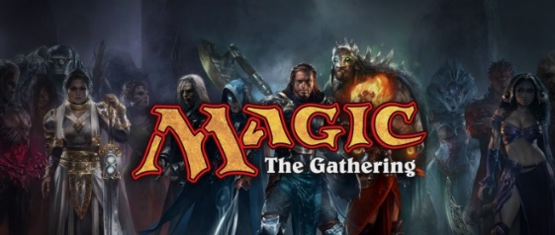
TOURNAMENTS: everyone must demonstrate excellent sportsmanship, befitting a Scout, and win or lose gracefully.
GAMES, GAMES, GAMES: From popular role-playing games like Dungeons & Dragons ™, Dungeon Crawl Classics ™ (“DCC”), Shadowrun ™, and Star Wars RPG ™
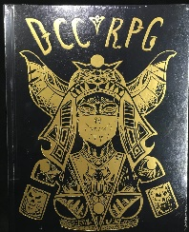
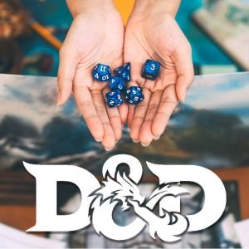

to boardgames such as Settlers of Catan ™, Ticket to Ride ™, RISK ™, and Monopoly ™
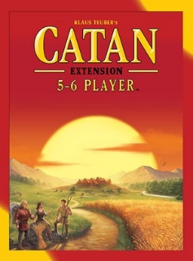
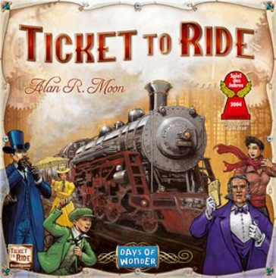

to Magic the Gathering ™, UNO ™, and simple card games…ScoutCon! is where the fun happens, year after year!



ScoutCon! is open to registered Scouts BSA, Ventures Scouts, Sea Scouts, and Registered BSA Adult Leaders. Note that BSA Adult Leaders must be current in YPT.

Weather Conditions: ScoutCon is primarily an indoor activities event and will happen whether there is rain, shine, or snow. Please bring your own tent and be prepared for cold weather camping. Be Prepared! Think Trappers’ Rendezvous conditions, but still bring short sleeves, just in case. If you are attending as an individual, please make sure you bring your own tent and other camping supplies. The Scout Field Uniform is not required; however, wearing them to and from the event is always a good practice.

Dietary & Special Needs: Please complete the Dietary Needs Request Form and submit to Lauryn Gaines no later than noon, Tuesday, November 3rd.

BSA Health Form: BSA Health Form Parts A & B are required by ALL attending.

Fees – NOTE the reduced registration fees:
- Early-bird Registration $30.00 before October 12th (3 weeks prior to event week)
- Regular Registration $40.00 between October 12th and October 18th
- Late Registration $50.00 between October 19th and October 25th
- Minions Registration $25.00 - requires 4 hours of event service; capped at 35 minions (committee + 25 volunteers); sign up via Signup Genius;
- All event fees are due by October 25th, no exceptions. No registrations after October 25th or day of event registrations will be accepted.

IMPORTANT INFORMATION TO KNOW:
Every unit and individual registrant must bring their own water for in their campsites. For 2023, Chautauqua County was in a Stage 3 Emergency water supply with limited water usage by all. We should plan for this contingency again in 2026, unless otherwise notified.

ScoutCon! support
provided by:







SCOUTCON! 2026
SCHEDULE

Friday Night (Nov 6):
Registration & Check-in starts 4:30pm
Game Library open hours 6:30pm - 12:45am
Trading Post open hours 6:30pm - 12:00am
Adult Wingspan Tournament Friday - TBD
Welcome & Announcements 9:00pm
Cracker Barrel 9:30pm
Game Library final call 12:45pm
Game Floor closed, lights out 1:00am

Saturday (Nov 7):
Flags (optional) 7:20am
Breakfast 7:30am
Announcements 8:30am
Game Library open hours 9:00am – 11:45pm
1:00pm – 5:30pm
6:30pm – 12:30pm
Trading Post open hours 9:00 – 11:45pm
1:00pm – 5:30pm
6:30pm – 12:30am
Throughout the day:
Magic the Gathering tournament
Dungeons & Dragons
Dominion
Dungeon Crawl Classics RPG
Chess & Checkers tournaments
Corn Hole tournament
Settlers of Catan tournament
Retire Flags 5:15pm
Rubix Cube & Cosplay contest 7:30 - 8:30pm
Game Library final call 12:45pm
Game Floor closed, Lights out 1:00am

Sunday (Nov 8):
Breakfast 7:30am
Check Out & turn-in Reviews 8:00am
Clean up and
go home (Help needed) 8:30am – 10:00am
SCOUTCON! 2026
November 6-8, 2026
Quivira Scout Ranch



ScoutCon! Is a weekend of fellowship with other Scouts, playing boardgames, card games, role-playing games, and other fun activities!

Early-bird registration open thru 10/11
Regular registration open 10/12 - 10/18
Late registration open 10/19 – 10/25
All registration fees due by 10/25/26

