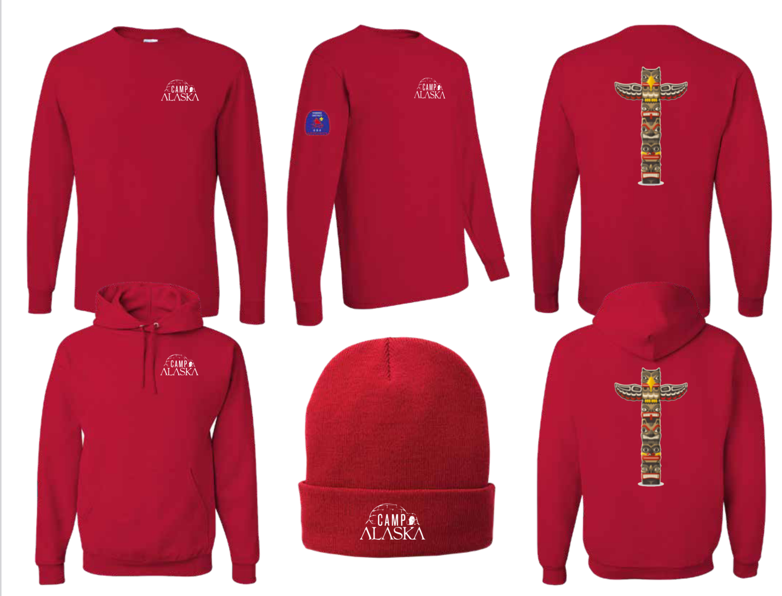

Item | Adult Size | Cost | Adult Size | Cost | Adult Size | Cost
Long Sleeve Tee | S-XL | $19 | 2XL | $24 | 3XL | $24
Hoodie | S-XL | $28 | 2XL | $29 | 3XL | $30
Stocking Cap | NA | $16

