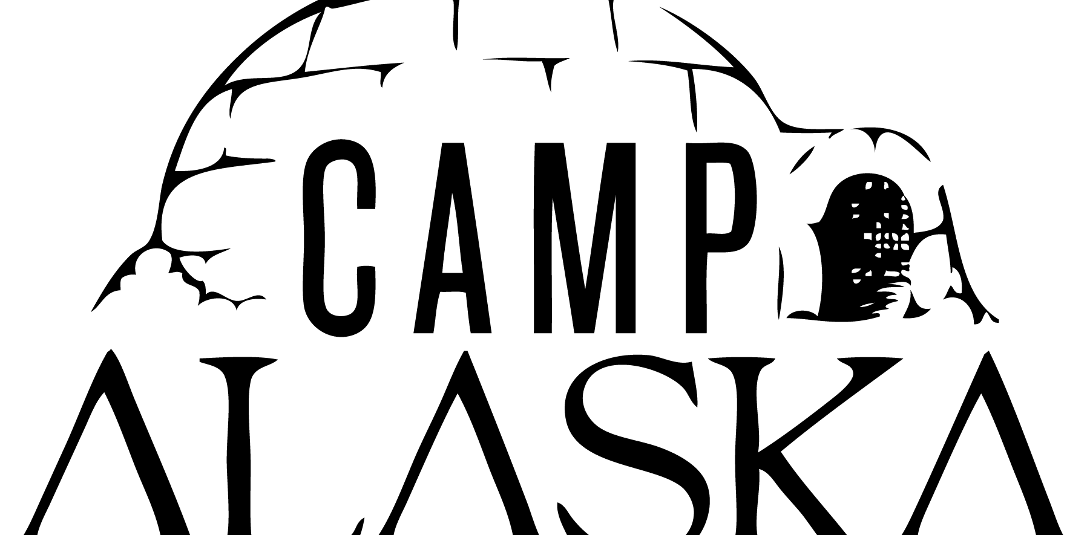

Camp Alaska 2026

WHAT IS CAMP ALASKA? Camp Alaska is a Winter Camporee and Scout skills competition consisting of stations named after Alaskan cities each with its own contest. Camp Alaska is open to Scout BSA Troops, Venturing Crews, Sea Scout Ships, and AoL Dens. Adults are allowed to be observers only! Some of the Scout skills that will be tested throughout the day are: First Aid, Communication, Fire Building, Teamwork, and, Pioneering.
In addition to a specific task, at each station the patrols (den/crew/ship) will be asked a question based on their general scouting knowledge that if answered correctly earns the patrol points. Additionally, each station will feature a scouting knot that must be identified and its use described. At Camp Alaska we abandon modern technology in favor of skill and ingenuity. Patrols will have to use their wits and skills they have learned through scouting.
1st, 2nd, and 3rd place awards for Scouts BSA and AOL are based on the patrol’s gold nugget count. Additional awards are for: Scout Spirit, Dutch Oven Dessert competition (youth), and Dutch Oven Dessert competition (adult)
BSA REQUIREMENTS: Youth and adults must be BSA registered to participate. Two-unit leaders (adults) are required to be responsible for all youth accompanying a unit. All leaders are required to be trained in youth protection. In accordance with June 2024 Guide to Safe Scouting changes Webelos dens may not attend. AoLs must participate as a Den with 2 deep leadership or individually with their parent/guardian.
SCOUT SPIRIT: Camp Alaska staff will be looking for and rewarding “Scout Spirit” throughout the day. Scout spirit applies to how a Scout lives and conducts his or her 'daily' life. Scouts show Scout spirit by being a role model to their peers, being a good leader and living by the Scout Oath and Law. Scout spirit is based on how a scout helps bring out the best in others as a reflection of their own character and attitude in their 'daily' life.
HEADQUARTERS and FIRST AID: Located at the North Pole. This area is manned throughout the day. Also, there is a warm area for your "EMERGENCY" use.
CAMPING: Troops may select their campsites as they arrive at Camp. Webelos may camp with a Troop or may camp on their own. Camping is permitted anyway in the park except for marked off program areas. One vehicle & trailer per campsite.
MEALS: Meals will be cooked in your troop / patrol campsite. Some patrols choose a Saturday sack lunches to maximize time available for competition. Bring your own cooking gear and food, camp staff will not provide cooking or camping gear to units. Open fires are only allowed in fire rings or other burning vessels that contain the coals and guard against the wind.
PATROLS: Camp Alaska is a Scout patrol-based event. Let the patrol succeed or fail on the strength of its members. Scout leaders may accompany their Scouts only as observers and may not lend assistance or offer advice. Patrol members must work together to navigate the course and complete the events. The ideal patrol size is six (6) to eight (8) scouts. The Patrol Leader should ensure that all members of their Patrol participate and contribute throughout the day.
BE PREPARED: It is the responsibility of each scout and adult scouter to be fully prepared for a wide range of winter weather conditions. Each person attending Camp Alaska MUST be prepared for extreme cold, high winds, rain, sleet, snow and just about any other weather you can think of. It is the duty and responsibility of each unit leader to see to it that all participants have received adequate cold weather training and are properly equipped including but not limited to proper clothing, shelter, food, water and first aid. Closed toe shoes must be worn at Camp Alaska; crocs don’t offer much protection from Polar Bears
PATCHES: Registered / paid camp participants will receive a Camp Alaska 2026 patch.
VOLUNTEERS: Like Klondike events all over the USA, Camp Alaska is a traditional camporee format. Each unit is asked to provide adults or older scouts who have mastered Camp Alaska to assist with some of the event stations during the competition. Several Units are “sponsoring” a station. All volunteers are very much appreciated.

SCHEDULE:
Friday, February 20th
6:00pm Check-in begins at the North Pole
9:00pm SPL / Scoutmaster meeting at the North Pole
Saturday, February 21st
7am: rise and shine
9am-12:00 Camps Open for Competition
12:00-1pm Lunch
1pm-4pm Camps Open for Competition
4-5pm: Patrol Leaders turn in gold nuggets at the North Pole
5:30pm-7:45pm Dinner
7:45pm Dutch Oven Dessert Competition. Each Patrol / Den send your contest entry with a representative to the North Pole. After judging, everyone eats!
8:00pm Everyone gathers at North Pole to eat dessert
8:15pm Awards Presentation
Sunday, February 22nd
8-10:00am Checkout at the North Pole. A leader from each Troop / Ship/Crew/Den will need to check out before leaving camp. A staff member will inspect your campsite before you leave. After staff has inspected your site you are free to leave.

SLEDS: Each patrol must have a sled or wagon for transporting their Patrol gear from one town to the next.

PATROL EQUIPMENT (Must be on your sled throughout the day):
- Compass
- Patrol First Aid Kit, equipped for Wilderness First Aid
- Scout Handbook or Scout Field Guide
- Passport (will be given at Friday night check-in)
- Fire building material, tinder
- Multiple means to light fire
- Tarp, minimum size 8’ x 8’
- 5’ –10’ length of knot rope for each Scout, need at least 40’ total per Patrol
- Handkerchiefs (1 per scout), will be used as blindfold, Scout neckerchiefs work
- Water bottle or canteen for each Scout
- Garbage bag – pack out your own trash
- Raingear for each Scout
- Frying pan, spatula; suitable for use on open fire
- Bag for carrying gold nuggets

SCORING: Patrols will have the chance to win gold nuggets at each station that will be counted at the end of the day to determine the event winners. Nuggets will be awarded for a variety of activities such as those listed below. Nuggets will be awarded to each patrol at each station and the patrol is responsible for turning them in at the North Pole at the end of the day

1 Nugget: Patrol answers the Scout Knowledge question correctly
1 Nugget: Patrol correctly identifies knots (knots limited to those needed for 1st class and figure eight); 1 Nugget: Patrol names use of knot
1 Nugget: Patrol sled/wagon is being used, and gear is properly secure

Gold Spikes are awarded for outstanding embodiment of the Scout Oath and Law showing outstanding leadership and teamwork during the activities or performing an extraordinary act of kindness.
Gold Washers are awarded to patrols for exceptional spirit such as helping fellow scouts during the event, showing perseverance, enthusiasm and a positive attitude. Washers rank heavily for the Scout Sprit Award.

DUTCH OVEN DESSERT COOKING COMPETITION: Each Patrol is encouraged to participate. Patrols may prepare whatever dessert they desire but it must be made in a DUTCH OVEN. There will also be an Adult Leader competition. Entries will be judged separate from the Scouts. Adult entries must also be made in a DUTCH OVEN.

CAMP ALASKA STAFF: the North Pole will be staffed 24/7. If you have questions in advance, please contact:

Joseph Heil, Program Director, 919-413-1632, scoutsbsa@blessedsacramentwichita.com
Shane Koranda, Program Assistant, skoranda@hotmail.com
Jamie Cruz, District Executive, Jamie.Cruz@scouting.org

