***All Districts Quivira Council***

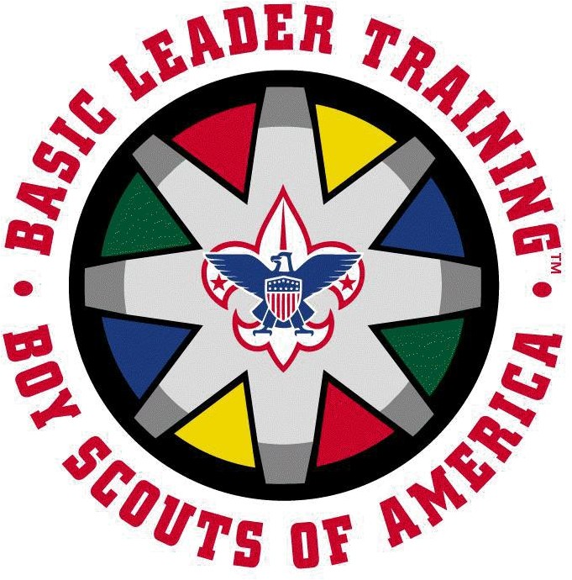

# Cub Scout

# Den Leader Training

***October11th, 2025***

**What is it?** Cub Scout Den Leader Position-Specific Training has been developed to give **new leaders** the knowledge, skills, tools, and enthusiasm that they need to be successful. The course is designed to provide Cub Scout leaders with the basic information they need to successfully carry out the duties of their position.

**Why?** To **make your life easier**, help you succeed in your role, and provide our youth a great Scouting experience!

**Who?** This training is for BSA adults who are registered with a Cub Scout pack. ***Participants MUST have completed current “Youth Protection Training” prior to course*.**

**When?** October 11th, 2024. Training will start at 8:00 am and will conclude by noon.

**Where? Quivira Council Service Center**, 3247 N. Oliver, Wichita, Kansas 67220.

**Cost? FREE, FREE, FREE!!! Did we mention this is a free training?!**

**We can accommodate 50 Scouters. Please register online at the link below to ensure we have adequate space.**

**Registration:** Registration is **NOW OPEN**, online on Black Pug: [**https://scoutingevent.com/198-92509**](https://scoutingevent.com/198-92509)

**Insurance:** Liability insurance is provided for all BSA registered adult members.

**Bring:** This is a uniformed event, please wear your Class A (Field) Uniform. Bring something to take notes with and any questions you have!

**Contact for Course Director Kat Bruce** [**kbruce01@gmail.com**](mailto:kbruce01@gmail.com) **620-242-3629 Dist. Training Chair Kelley DeGraffenreid jdegraffenreid@cox.net 316-209-1972 More Info.** Council Staff Advisor Lauryn Gaines [**lauryn.gaines@scouting.org**](mailto:lauryn.gaines@scouting.org) **316-369-0671**