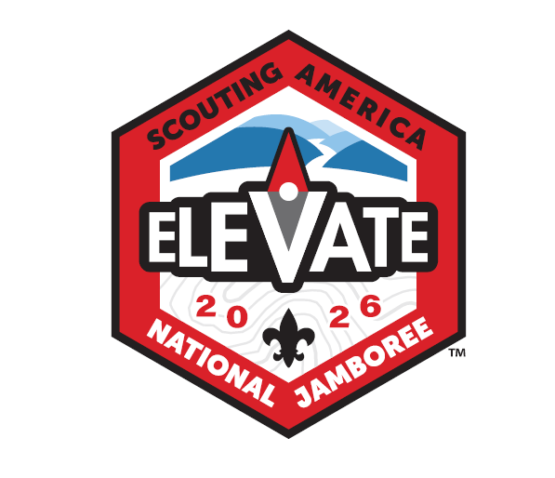
Quivira Council
2026 National Jamobree Information
- When: July 18-31, 2026
  - Fly out of Wichita July 18th. Tour DC until July 21 and then travel to the Jamboree on July 22.
- Where: Summit Betchel Reserve, Bleckley, WV
- Who: Any registered Scout, 12yrs old, by July 22, 2026, but not yet 18 yrs old by July 31, 2026
- Cost: $3,350 per person
- Availabiltiy: 18 youth males, 18 youth females
What is Scouting America National Jamboree?
Overall it’s an experince you can’t get anywhere else in the Scouting program. Thousands of Scouts from across the country and the world all gather at Summit Bechtel in West Virgina for ten days of pure scouting adventure and fun. All major activites can be found there from shooting sports, moutain biking, rock climbing, swimming, zip lines and most merit badges can be worked on during the Jamboree. The list contiues with conservation projects, OA activites, Amature Radio, STEM, stage shows at various times and finally patch trading and socializing with other Scouts too. If you can think of it in Scouting then you’ll most likely find it at Scouting America National Jamboree.
Quivira travel plan:
Current travel plan is to depart Wichita July 18th to tour Washington DC July 18th – 21st. Travel to Jamboree site to attend the Jamboree, July 22-31, and return to Wichita on July 31st. The DC tour normally includes tours of US Capitol, various Smithsonian muesums, Holocoust Muesum, National Library, National Archives, Ford’s theatre, the National Mall Monuments, Arlington National Cemetary and other atrractions in the area.
What does the $3350 cover?
The $3350 covers the Once-in-the-lifetime opportunity to attend Scouting America’s premier event, which will likely not happen again until 2030! Participants will be provided the chance to interact with Scouts from all across the US, as well as international Scouts!
Specifically: ALL travel (airfare, Metro pass & bus to-and-from the Jamboree), ALL food, Jamboree Registration Fee ($1560), travel lodging, Jamboree day pack, Jamboree Council strips (two uniforms and five for trading), Paid OA members will get 2 Jamboree-themed Lodge flaps, three Council Jamboree t-shirts, large travel duffle bag (about 120-140L).
More or less once the scout arrives at the airport they are covered until they return home except for snack and souviener money.

Contingent Size and Leadership:
Quivira Council’s is committed to send a contingent of 18 youth males plus two adult leaders and 18 youth females plus two adult leaders to the 2026 National Jamboree.
Linette Koranda & Jennifer Archer will be the leaders for the female contingent, while Shane Koranda and Aaron Archer will lead the male contingent leaders.
National Scholarship Program:
National Scholarships will cover up to half of the $1,560 Natoinal Fee which is a max scholarhip of $780 from National. To apply go to this site and follow the scholarship instructions: https://jamboree.scouting.org/participants/
Quivira Council Popcorn sales commision for Jamboree:
Quivira Council is offering a special Jamboree popcorn commision. If you sign up for Jamboree before August 31, 2025 you can, at your election, sell for the Jamboree contingent. If you make this election then you will get 50% commission towards Jamboree fees. For example you sell $1,000 in popcorn you will get $500 paid towards Jamboree fees. However, you are selling strictly for the Jamboree therefore you will not get any reduciton in council fees as you would selling for you troop.
Click here to sign up for Jamboree!
Yours in Scouting,
Patrick Reilly – Quivira Council Jamboree Chairman
Linette Koranda & Jennifer Archer, Quivira Female Contingent Leaders
Shane Koranda and Aaron Archer, Quivira Male Contingent Leaders

