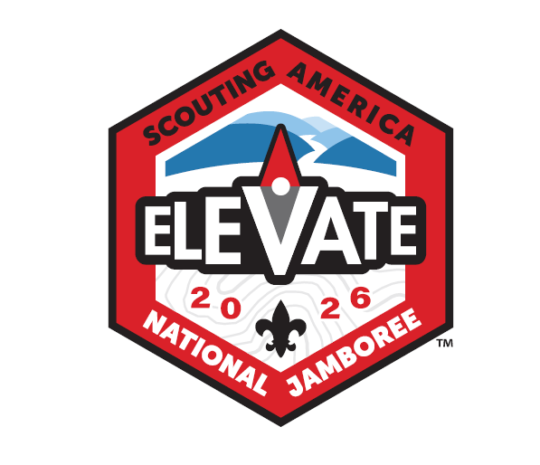
Quivira Council
2026 National Jamobree Information
- When: July 19-31, 2026
- Where: National Jamobree Site Betchel Summit, WV
- Who: Any registered 12yrs old but not yet 18yrs old Scouting America BSA Troop member may attend
- Cost: $3,350 per person
- Availabiltiy: 18 youth males, 18 youth females and 4 adults.
What is Scouting America National Jamboree?
Overall it’s an experince you can’t get anywhere else in the Scouting program. Thousands of Scouts from across the country and the world all gather at Summit Bechtel in West Virgina for ten days of pure scouting adventure and fun. All major activites can be found there from shooting sports, moutain biking, rock climbing, swimming, zip lines and most merit badges can be worked on during the Jamboree. The list contiues with conservation projects, OA activites, Amature Radio, STEM, stage shows at various times and finally patch trading and socializing with other Scouts too. If you can think of it in Scouting then you’ll most likely find it at Scouting America National Jamboree.
Quivira travel plan:
Current travel plan is to depart Wichita July 19th to tour Washington DC July 19th – 21st. July 22-31 travel to Jamboree site to attend the Jamboree and return to Wichita on July 31st. The DC tour normally includes tours of US Capitol, various Smithsonian muesums, Holocoust Muesum, National Library, National Archives, Ford’s theatre, the National Mall Monuments, Arlington National Cemetary and other atrractions in the area.

What does the cost cover?
The cost covers all travel, food, entrance fees, tent, cot, travel lodging, day pack, Jamboree Council strip for two uniforms and five for trading, two council Jamboree t-shirts, large travel duffle bag (about 120-140L). More or less once the scout arrives at the airport they are covered until they return home excpet for snack and souviener money.
Contingent Size and Leadership:
Quivira Council’s goal is to send a contingent of 18 youth males plus two adult leaders and 18 youth females plus two adult leaders to the 2026 National Jamboree. Shane and Linette Koranda will lead the male contingent. The leaders for the female contingent are still being determined.
National Scholarship Program:
National Scholarships will cover up to half of the $1,560 Natoinal Fee which is a max scholarhip of $780 from National. To apply go to this site and follow the scholarship instructions: https://jamboree.scouting.org/participants/
Quivira Council Popcorn sales commision for Jamboree:
Quivira Council is offering a special Jamboree popcorn commision. If you sign up for Jamboree before July 31, 2025 you can, at your election, sell for the Jamboree contingent. If you make this election then you will get 50% commission towards Jamboree fees. For example you sell $1,000 in popcorn you will get $500 paid towards Jamboree fees. However, you are selling strictly for the Jamboree therefore you will not get any reduciton in council fees as you would selling for you troop.
How to sign up for Jamboree:
NEED TO FILL THIS IN FOR BLACK PUG INFO…

National Jamboree promotional videos to view for fun:
Videos about Jamboree: https://scouting.webdamdb.com/bp/#/folder/13318879/

Yours in Scouting,
Patrick Reilly – Quivira Council Jamboree Chairman

