
EASTSIDE FALL CAMPORAMA
WOOD LAKE SCOUT RESERVATION
AUGUST 28-30, 2026

REN FAIRE

Attention all Scouts, Leaders, and Volunteers! You are hereby invited to test your fitness, knowledge, skills, leadership abilities, fun, fellowship, and more during the Eastside Fall Camporama. Does your Patrol have what it takes to win Tough Scout? Does your Cub Pack enjoy camping and outdoor activities? Will your Soapbox car make it to the end of the hill?

Cost:
Scouts BSA: The cost for Camporama is $10.00 per Youth Scout. Adults are $5.00 each. It does not matter if your unit does one or all the following: Tough Scout, Camp, Soapbox, Archery.

Cub Scouts: The cost for Camporama is $10.00 per Youth Scout. Adults are $5.00 each. It does not matter if your unit does one or all the following: Camp, Range Activities, Cub Scout Challenge.

Staff: If you are strictly staffing this event, contact Creasy McKinzie BEFORE registering on the Council website.

Camping:
The event has reserved the entirety of Camp Tamarack. Event staff will assign units to campsites. You may be sharing a site with another unit. Campsite locations will NOT be given out prior to Friday night check-in. The cost for camping is included in the registration fee.

Parking:
Cub Packs are allowed one (1) vehicle attached to a trailer to stay parked at their campsite. ALL other vehicles must be parked in the main parking lot. We will be enforcing parking passes to prevent too many vehicles driving through camp at one time.

Fires:
The camp has a no ground fire policy. Campsites have available fire rings for use. Additional above ground fire pits are okay. All fires & fire-building must adhere to the Guide to Safe Scouting.

Health Forms:
All persons MUST have the BSA Health Form A, B1, & B2 filled out and presented to the Health Officer upon arrival at camp. Everyone must turn in the Health Forms to the Health Officer, who will secure them for the entire event. Any health concerns that could result in a health and safety issue must be disclosed to the Health Officer upon check-in. You are responsible for collecting your Health Forms during check-out. If you do NOT want to turn in your original Health Form, it is YOUR responsibility to bring a photocopy (not a digital copy) for the Health Officer.

Awards:
Awards for the individual events will be given out at Fire Bowl on Saturday night. Remember, if you have a traveling trophy, bring it with you!

Fire Bowl:
Units should prepare a song, skit, or story for the Fire Bowl. At some point during the day on Saturday, units interested in participating in Firebowl programs should turn in their song, skit, or story to Rotary Cabin. There will be a limited numbers of slots for each type. The deadline for approval to be added to the program is 5:00pm on Saturday.

Events:
The following events will be going on all weekend. Please see further in this Leader Guide for more details on each event.

- Tough Scout Challenge – Scouts BSA/Venturing
- Soapbox Derby – Scouts BSA/Venturing
- Cub Scout Challenge – Cub Scouts
- Conservation Hour at Camp – All Scouts and Volunteers
- Fire Bowl – All Scouts and Volunteers

Contacts:
Contact your District Program Chair with any questions you have on this event in general. Or you can contact the specific event chairs as needed.

Pioneer Trails: Creasy McKinzie at 574-350-0480 or froggyxrs@gmail.com

Tough Scout / Soapbox Derby: Creasy McKinzie at 574-350-0480 or froggyxrs@gmail.com

Cub Scout Challenge: Shawn Hile at 574-333-6662 or shile3000@gmail.com

Pioneer Trails District: Sierra Seventy at 812-243-7862 or sierra.seventy@scouting.org

TOUGH SCOUT CHALLENGE
SCOUTS BSA/VENTURING

Tough Scout Challenge Details:
Tough Scout Challenge is a series of stations that are mentally and physically demanding and are designed to test a Patrol's skills and leadership abilities as you compete head-to-head with another Patrol.
- Patrols will be backpacking everything that you need into camp.
- There is a packing list of items this year. Packs WILL be inspected at check-in Friday night to make sure they do not contain additional items. The Pack List is in this document.
- You will need to haul water to your campsite.
- Per camp rules, do NOT bring any firewood. It will be available as cut wood or downed limbs. Do NOT cut down any trees, shrubs, etc.
- When your Patrol checks in on Friday night, you will be given instructions on how to get to your campsite. It will NOT be the shortest or easiest route to your campsite. Expect to hike with your gear.
- Your Patrol Leader (PL) will need to register your patrol at 8am Saturday morning where you will be assigned the order in which you will do the stations and which patrol(s) you are competing against at each one.
- Patrols should consist of at least 4 Scouts but no more than 8 Scouts.
- Immediately after the opening at the Parade Grounds, there will be an air horn style start in which you will head directly to your first station.
- You will need to carry with you what you think you need and be prepared to travel all over Wood Lake camp to go from one station to another.
- At the end of the time allotment, the station judges will send you to the next station. You have a limited amount of time to travel between stations, and you are NOT allowed to leave early for a jump start on traveling across camp.

Scoring:

- You will earn points at each station for how well you complete the challenge and how quickly you finish. Any ties based on points will be determined by which patrol finished in the fastest time. There may be opportunities for individuals to earn bonus points or individual awards, depending on the station.
- The top patrols with the highest points and the fastest times will win prizes at the Fire Bowl Saturday night, with the top patrol earning the traveling trophy.
- If a challenge involves a “head-to-head” competition, the Patrol numbers will be balanced. For example: For a tug-o-war competition if one Patrol has 5 Scouts and the other has 8, then 5 Scouts will be randomly picked from the larger patrol.
- There is a maximum of 50 points earnable at each station, for a total of 300 points.
- However, there will be other challenges and bonus point opportunities all weekend long.
- Some of the bonus points available are listed below. There may be other mini challenges that pop-up over the course of the weekend.
Examples of Basic Bonus Points Available:
Meal Planning: No cooler or refrigerated foods (See packing list)
Campsite Inspections: Staff WILL be doing campsite inspections and will award bonus points. A copy of the inspection guideline sheet is attached.
Early Registration: Any unit that registers online prior to April’s Round Table, Wednesday, April 9, 2025, will be awarded bonus points.

Suggestions for Patrols:

- Bring Patrol Spirit! Your Patrol is like a Team competing in a Tournament. Have your yells, flags, “Class B” or activity Shirts just as a sports team would. Class A or Regular uniforms are not required.
- Plan for this event like it is a backcountry hiking and camping trip. If you forgot something at home or in your vehicle, you WILL NOT be allowed to go back for it once you have started hiking. Plan on a ONE MILE or longer hike to get to your campsite.

REQUIRED - Registered Adult Volunteers:
You will need to provide one adult volunteer, per patrol entered, to act as station judge. That leader will be in charge with another adult for that station for the entire day. The stations will be setup in advance, and you will receive complete instructions on Friday evening/Saturday morning in an adult leader only meeting. Instructions will include how the station is run, how points and scoring is done, and a score sheet. You will need to bring your own chairs, rain gear, snacks, water etc. Be Prepared! Each station will have a minimum of two adult leaders acting as judge together.

All other adults are not permitted on the Course at all. There shall be no physical or verbal assistance given by any adult during the competition. Adult Station Leaders may clarify instructions to the Patrol Leader if needed at their station. But “teaching” or guiding the Patrols on how to do the station is not allowed.

Failure to provide a leader to assist could be cause for disqualification. If there are any questions regarding this policy, please contact me. I would rather discuss this in advance than not have a patrol participate.

Stations:

- As a rule, we do not reveal what the stations will be in advance.
- This year, we are themeing the stations around Steampunk.
- As a general rule, Scouts should be knowledgeable in the following areas: Knot-Tying, Lashings, Fire Building, First Aid, Cooking, and Orienteering. They may use all or some of these skills, in addition to ones that are not listed.

REQUIRED - Packing List:
It is the responsibility of each Patrol to pack their own gear, using the following packing list below. If any additional items that are not on the list are found during check-in inspection, you will be asked to lock them in your vehicle.

Each Scout Must Have: Each Patrol Must Have:
Pocket Knife (1) Hatchet (>24” overall) or Folding Saw
Shelter Fire Starting kit = ½ Number of Scouts (min.)
Water Bottle No Matches or Lighters Allowed ***
Mess Kit Cooking Equipment
Cordage Backcountry Style Meals *
Candling - Light Source (1) Roll of Cargo/Duct Tape
Bandana (1) Copy of Scout Handbook (min.)
Compass
Sleeping Bag
Spare Clothes
Sewing Kit **

* The intention of this event is to survive a several miles/days hike in wilderness. For that purpose, meals should consist of those used for backcountry hiking and camping. Any unit can bring “refrigerated” food as long as all such food for the entire patrol fits inside a small, insulated lunch bag. Any unit that does a full weekend of meal planning without using an insulated bag will earn bonus points.
** For each Scout in the Patrol with a small, emergency sewing kit, the Patrol will earn bonus points.
*** For fire starting kits, use the Scouts BSA Handbook for ideas on alternative methods and materials to start a fire (e.g. flint and steel, bow drill, ferro rod).

NEW THIS YEAR:
SCOUTS BSA YOUTH MUST BRING AN EXTRA SET OF CLOTHING SPECIFICALLY FOR EVENTS IN TOUGH SCOUT. EXPECT TO GET YOUR CLOTHES WET AT SOME POINT. NO, YOU ARE NOT GOING TO THE WATERFRONT / LAKE. SWIMMING TEST NOT NEEDED.

THANKS!

CUB SCOUT CHALLENGE
CUB SCOUTS

Cub Scout Challenge Details:
Cub Scout Challenge is a fun weekend of camping, outdoor adventure, shooting sports, and activities for Lion to AOL Scouts. It is a whole day of fun activities for all ages, followed by an evening Fire Bowl, and church services on Sunday morning. This is a great time to work on final rank requirements, advancements, Leave No Trace, and more.
Camping:
Campsites will be assigned during check-in. One vehicle with a trailer attached is allowed at the campsite. All other vehicles must be parked in the main parking lot after unloading gear. The number of vehicles driving through camp will be limited to provide a layer of safety for those that are walking around Camp Tamarack. Just as a reminder, at least one (1) adult leader must be BALOO trained.
Food:
All Units must bring their own food to prepare at their campsites. The event will not be providing food.
Activities Could Include:
Obstacle Course, Treasure Hunt, Games, Hiking, STEM, Space Derby, Crafts, Handiworks, Service, and More!
Shooting Sports Activities Could Include:
BB Gun Range and Slingshot Range
Staffing:
Cub Scout Challenge requires that all registered Packs provide a minimum of (1) adult volunteer. One additional volunteer is needed for every additional 10 participating youth to staff the event. Volunteer names will be taken down at time of check in. Volunteers will receive event identification and instruction packages on the morning of the event (see schedule).
Packing:
Remember to bring your Cub Scout Six Essentials
We have provided a sample Cub Scout Packing List for a Pack Overnight Campout. Feel free to use this as an example to help plan your campout with your leaders and adults. We recommend that your leaders checkbox the appropriate items your Scouts need for this specific campout and give a copy to your parents. For example, the waterfront is closed, so there is no need for swimwear.

PLEASE READ ALL OF THE FALL CAMPORAMA RULES AND POLICIES THROUGHOUT THIS GUIDE. THERE MAY BE OTHER INFORMATION YOU NEED LOCATED UNDER A DIFFERENT HEADING OR SECTION.
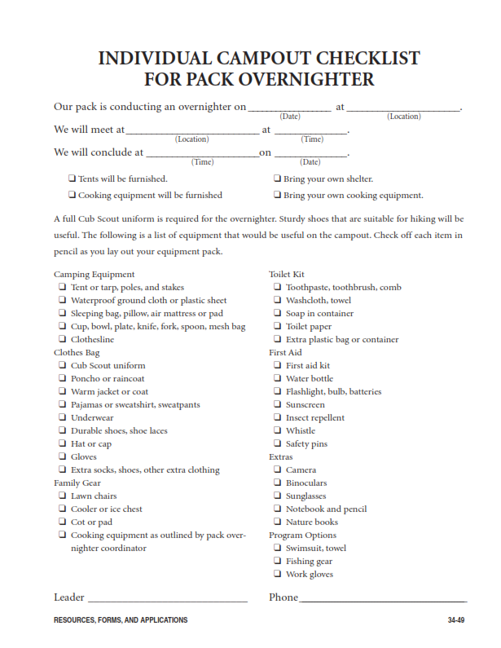
SOAPBOX DERBY
SCOUTS BSA/VENTURING

OVERVIEW
It is that time of year again to brush off and clean up those Soapbox derby cars. It’s time to go racing. First off, cars do not have to be Official Soapbox Derby Racers or another kit-type car to compete. On the BUILD a CAR page, a very simple car is outlined that will work for the race and meet all the safety and “size” limitations. The top priority is SAFETY, but we want as many youths to participate as there is interest – we do not want this to get too expensive for youth, teams, and parents, and units.

With that said, here are the rules and requirements for all downhill racing cars. See rules for drivers on a separate page.
BUILD A CAR
These are the requirements for a Soapbox Derby Race Car at this event.

CAR SIZE
A car must be appropriately sized for All drivers on the team, so that all drivers can sit in, steer, and brake safely, without too much stretching, or without cramping up.

CAR SEAT
All cars are required to have a seat. The car must have an attached or incorporated seat and fixed backrest allowing the driver to sit upright with feet forward (no head-first or laying-down driving positions).

BRAKING
All cars are required to have a brake. It must be easily operated while steering the car. Brakes that drag on the road surface MUST be faced with rubber (old tire tread works great).
The braking mechanism must be repeatable by the driver. No weight-based or “anchor-type” single-use braking systems are allowed.

STEERING
All cars are required to have a means to steer, such as steering with the feet and/or with the hands holding a rope or a mechanical steering device attached securely to the front axle support.

WHEELS
All cars are required to have 4 wheels that touch the ground.

THE RACE

GENERAL RULES ABOUT RACING
- No power/drive/assisting devices are allowed
  - A pre-marked man pushed zoned is the only power is allowed
- Cars are deemed to have crossed the finish line when the front nose crosses the line.
- Going off course or interfering with the other car in any way during the race will result in a DNF disqualification.
- The race will be a double elimination tournament.

DECORATION
Teams are encouraged to decorate their cars. Decorations cannot interfere with the proper operation of the car or of the race and must fit within the size of the car.

ADDED WEIGHT
Adding weight to a car is strictly prohibited.
All components of the car must contribute to the frame, function, or safety features of the car. Superfluous or decorative elements will be allowed at the discretion of race officials. Any components of the car deemed to be “added weight” by the race officials must be removed in order for the car to pass inspection.
- It is strongly encouraged that teams work together to build and decorate their cars.
- Inherited cars and legacy cars (from previous races) are allowed.
- Parent/leader-built cars are allowed, but come on, this is for the kids - have them help as much as they can to help make the car. It is part of the fun.
- If your unit does NOT own a soapbox derby car, the District does own a few cars. If you want to borrow one of these cars for the race, please contact Cliff or Creasy in advance. Be prepared to make minor repairs if needed the day of the race.
- Soapbox derby cars, extra parts, and repair kits are NOT required to be hiked into campsites as part of Tough Scout and should be left in vehicles/trailers at the main parking lot.

THE DRIVER
For the safety of the driver, all drivers MUST be wearing a helmet when racing.

WINNING
- The winner, as always, will receive the coveted traveling trophy.
- Tough Scout bonus points could be issued for:
  - Best camporama-themed looking car
  - And more

Schedule of 2026 Camporama Events:
Day  1 | 5:00PM: Units arrive for Check-in and Instructions at Trading Post Porch  8:00PM: Check-In ends (After hours check-in is available at Rotary Lodge)  9:00PM-9:30PM: Leader Meeting for Scouts BSA at Rotary Lodge  10:00PM: Lights out in camp
Day  2 | 8:00AM: Open Registration for Cub Scouts Packs and Scouts BSA Troops at Trading Post Porch  8:30AM: Flags, Opening, and Announcements at Parade Field  10:00AM-12:00PM: Cub Scout Shooting Sports  9:00AM: Tough Scout Challenge Air Horn Start from Parade Field  9:15AM-9:45AM: Tough Scout Station One  9:50AM-10:20AM: Tough Scout Station Two  10:25AM-10:55AM: Tough Scout Station Three  11:00AM-11:30AM: Tough Scout Station Four  11:30AM-1:00PM: Lunch Break  1:00PM-2:00PM: Conservation Service Projects  1:00PM-4:00PM: Cub Scout Challenge Activities  2:15PM-2:45PM: Tough Scout Station Five  2:50PM-3:20PM: Tough Scout Station Six  3:30PM-4:00PM: Soapbox Derby Registration  4:00PM-5:00PM: Soapbox Derby Race Starts  5:00PM-6:30PM: Scouts BSA Individual Shooting Sports Competition  Dinner Break after Races and Cub Scout Challenge ends  8:00PM: Fire Bowl Event: Event Awards, Fellowship, Eagle Scout Recognition, Flag Retirement, Skits/Songs, Cracker Barrel (Bring your own snacks!)  *Units/patrols attending the Fire Bowl Event should plan a skit/song/story to present.  11:00PM: Lights out in camp
Day  3 | 9:00AM: Church Service at the Chapel  11:00AM: Hike Out time  12:00PM: Everyone out of camp, including vehicles
Schedule is subject to change. Any changes will be announced as soon as possible and a final copy will be available during check-in at the event.

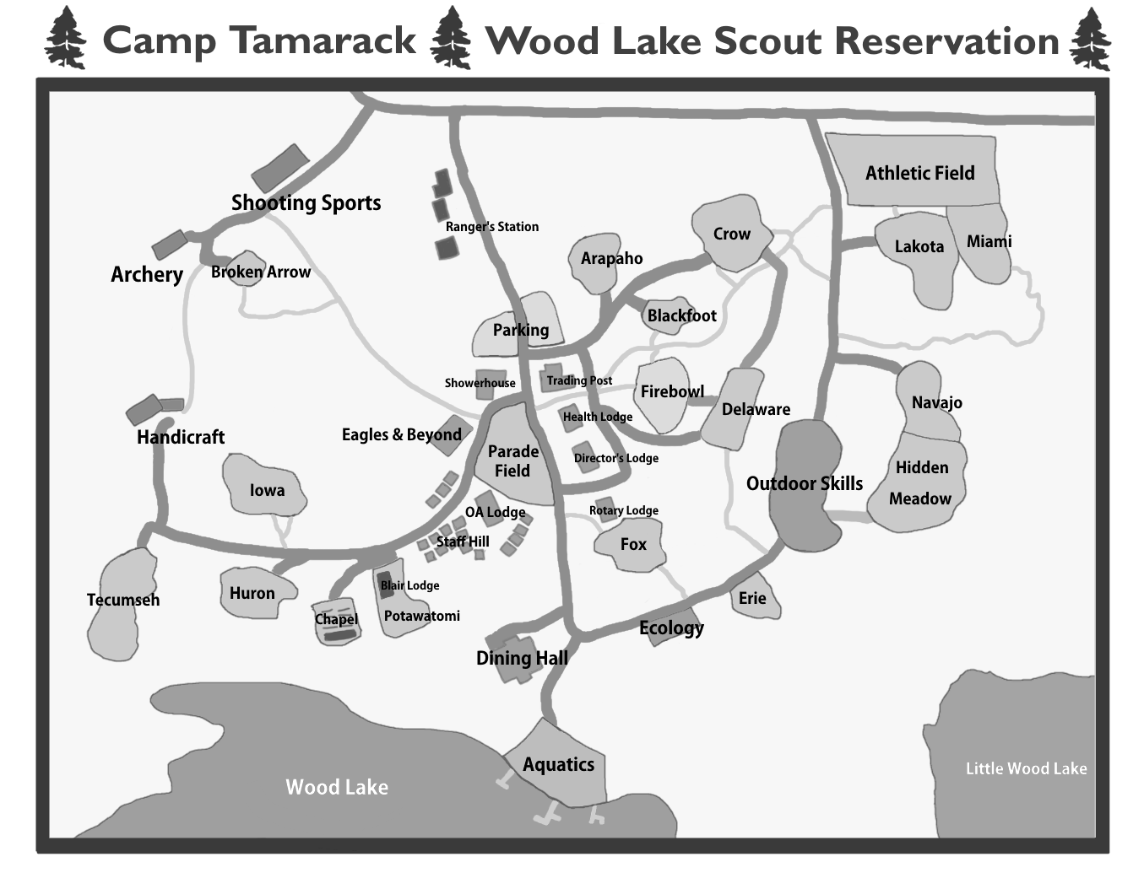

CAMPSITE INSPECTION CHECKLIST

Campsite: ___________________ ___ Unit #: ___________________________

SPL: __________________________ Unit Leader: ________________________

HEALTH AND SAFETY: Max 12 Points
RESTROOM SANITATION
UNIT EQUIPMENT
CAMPSITE CLEANLINESS
SAFETY HAZARDS
FIRST AID KIT
FIRE PLAN
TOTAL
CAMP ORGANIZATION: Max 6 Points
ENVIRONMENTAL IMPACT
DUTY ROSTERS POSTED
TENTS/HAMMOCKS/SHELTER
TOTAL
SCOUTING METHOD: Max 8 Points
UNIFORM(ITY) INSPECTION
UNIT SCHEDULE PLANNED & POSTED
PATROL/DEN METHOD
PROMPTNESS (FLAGS, EVENTS, ETC)
TOTAL
SCOUT SPIRIT: Max 8 Points
FELLOWSHIP
YELLS OR SONG
MORALE
FLAGS
TOTAL
GRAND TOTAL | OF 34 POINTS
INSPECTORS:
____________________________________________________________________________

____________________________________________________________________________
NOTES

