
Cub Scout Day Camp
Staff Manual
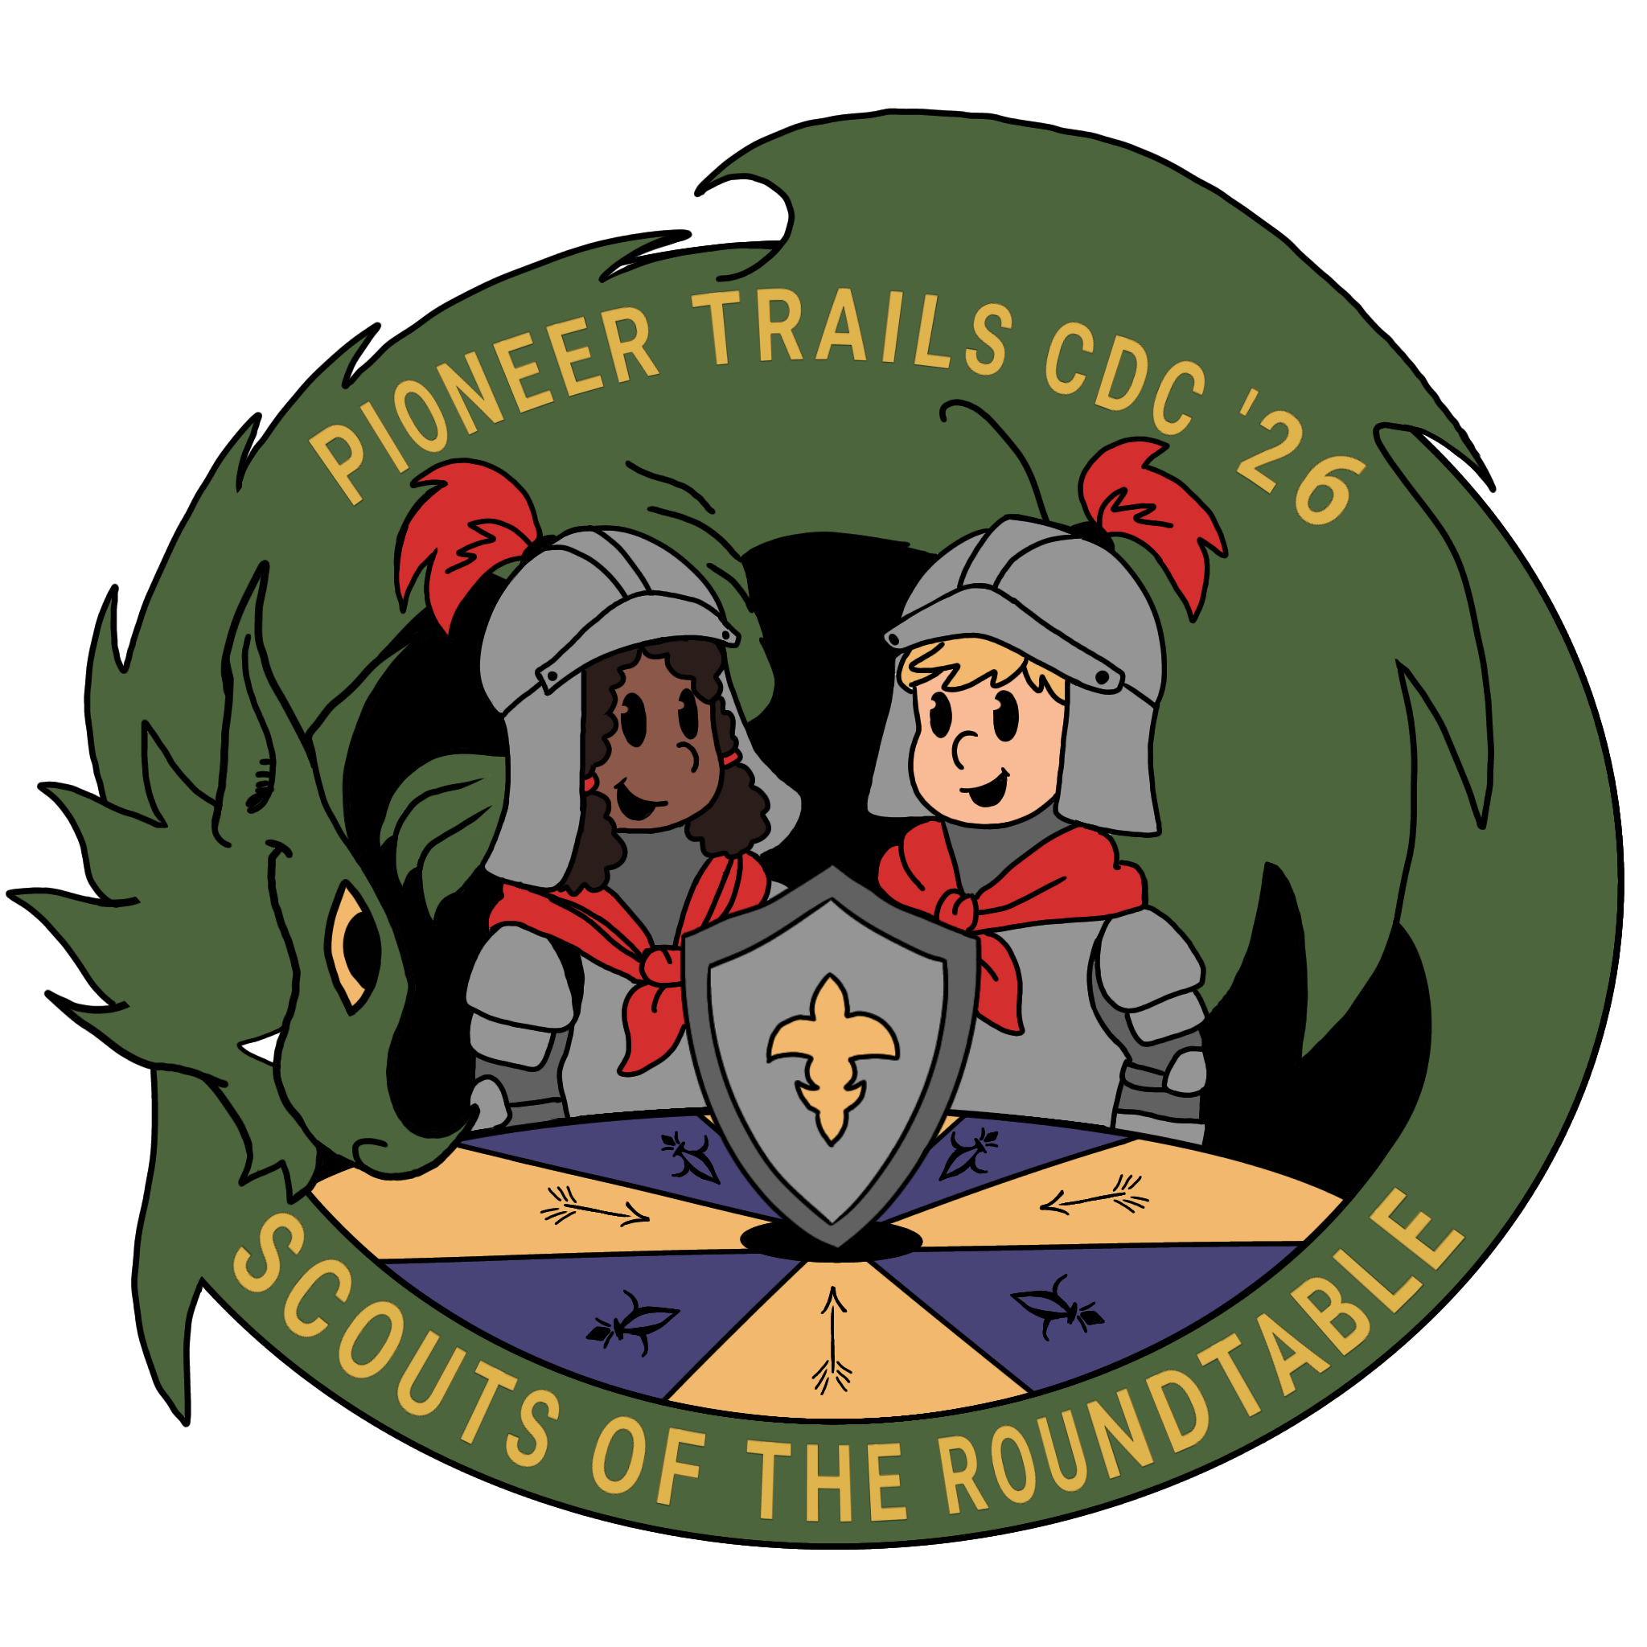
Pioneer Trails

Ob Bow Park
Elkhart, IN
Table of Contents
Camp Director Message p. 1 Smoking Policy p. 18
Goals of Day Camp p. 2 Lost and Found p. 18
Staff Organization Chart p. 3 Trading Post p. 18
Minimum Staff Requirements p. 4 Camp Evaluation Surveys p. 18
Key Staff Positions p. 5 Pixie Camp p. 19
Staff Training Plan p. 9 Meals p. 19
Daily Schedule & Program Overview p. 10 Safety and Security p. 20
Staff Arrivals and Departures p. 11 Severe Weather p. 20
Vehicles and Parking p. 11 Missing Camper p. 22
Program Stations p. 12 Fires and Emergency Drill p. 22
Rainy Day Alternatives p. 13 Water Accidents p. 23
Program Safety p. 13A Serious Injury p. 23
Purchasing of Camp Supplies p. 13A First Aid p. 23
Communication p. 14 Heat Risks p. 24
Uniforms p. 14 Medications Policy p. 24
Personal Conduct of Staff p. 14 Youth Protection p. 24
Reporting Daily Attendance p. 15 Outdoor Campfire Safety p. 25
End of Day Dismissal p. 15 Sweet 16 of BSA Safety p. 26
Early Dismissal p. 15 BSA Policy on Drugs & Alcohol p. 27
Two-Deep Leadership p. 15 Serious Illness/Injury p. 28
Discipline p. 16 Time Fillers p. 29
Wildlife p. 17
Contraband p. 17

A Word from your Day Camp Director

Thank-you for being a part of this year’s Pioneer Trails Day Camp. We could not hold a Day Camp without volunteers willing to give of their time and talents. Your participation will help ensure that the Cub Scouts of Pioneer Trails have a great outdoor experience that they will remember for many years to come.

In 1975, the National Council added Cub Scout Day Camp to the National Camping School program. Since then councils have been offering a wide variety of Day Camps across the nation. Day Camp is of particular value to those Cubs who may not have the finances or family support to attend resident camps. In Pioneer Trails, Day Camp offers a great, in-expensive option for our district Cub and Webelos scouts. Our purpose is to provide meaningful, advancement-related and fun activities in the outdoors. We want to provide activities for our scouts that they cannot experience in the regular den setting.

The purpose of this manual is to provide you with the information you need to help us in our goal to ensure that our scouts are kept safe and that Day Camp is a wonderful experience for them. Please take time to familiarize yourself with the information on the following pages. It will be of great value in making your Day Camp experiences positive ones for you and for the scouts you serve.
Thank-you
Jonathan Kime
Pioneer Trails Day Camp Director

< 1 >
Goals of Cub Scout Day Camp

To provide an outdoor program which will deliver adventure, challenge, teamwork opportunities, confidence building, and fun as well as skills development and advancement opportunities.

To provide an outdoor program which will lead to self-reliance, self-confidence and leadership and which will enhance the traditional aims of Scouting: citizenship, character development, and mental and physical fitness.
(goals adapted from the Camping and Outdoor Program Committee Guide, p. 2)

Fulfill the Promise

Youth join a unit because Scouting provides the excitement and adventure of camping in the
great outdoors. They want to share that excitement with friends. The key to fulfillment is in the hands of council and district Scouters like yourself. You can unlock the door to adventure so that one day they will say: “It was all that I hoped for and more!”
Day Camp Administration Guide

The Scout Oath
On my honor, I will do my best to do my duty to God and my country and to obey the scout law; to help other people at all times; to keep myself physically strong, mentally awake and morally straight

The Scout Law
A scout is trustworthy, loyal, helpful, friendly, courteous, kind, obedient, cheerful, thrifty, brave, clean and reverent.
The Outdoor Code
As an American, I will do my best to - Be clean in my outdoor manners,
Be careful with fire
Be considerate in the outdoors, and
Be conservation minded
< 2 >
Staff Organization Chart
Council Day Camp Advisor:  Sierra Seventy  sierra.seventy@scouting.org  812-243-7862 | Council Short Term Camp Advisor:  Creasy McKensie  Froggyxrs@gmail.com  574-350-0480
Day Camp Director:  Jonatthan Kime  eaglescout1205@yahoo.com  574-352-4411 | Program Director:  Andrew Christophel  trumpetguy13189@gmail.com  574-215-9253
Health Officer  Libby Stout | Rangemaster  Shawn Hile | Quarter Master
Youth Staff | Station Leaders | Asst Quarter Master

Minimum Key Staff- Either the Health Officer or the Assistant Health Officer must be in camp at all times that youth are present. During set-up and tear-down, another key staff member who is Red Cross Certified must be present. At all times, at least two National Camp School Trained staff must be present at camp. Ranges must always be attended by Range Trained Staff.
< 3 >
Pioneer Trails Cub Scout Day Camp
Minimum Staff Requirements Policy (See Standard SQ-401)

Minimum Key Staff: Day Camp Director - 1
Program Director - 1
Health Officer – 1
Trading Post Manager – 1
Youth Staff Leader – 1
Quarter Master – 1

Minimum Program Staff: One adult leader per station
One trained range master per range – per 8 boys shooting

Minimum Den Walkers: One den walker per 4 scouts
Minimum of one walker per participating unit

All staff are registered members of BSA.
Visiting staff are all trained in BSA Youth Protection Policies

< 4 >
Key Staff Positions at Day Camp
Day Camp Administrator:
The day camp administrator is the professional on the council staff responsible for the planning, promoting, presenting and reporting of Day Camp.

Day Camp Director:
The day camp director is the volunteer on the site conducting the Cub Scout Day Camp. Her responsibilities include: Supervise the personnel and operating details of the day camp.
Recruit, interview and train day camp staff.
Conduct, in co-operation with the program director, a camp staff training course prior to the opening of camp.
See that standards for leadership, program activities and health and safety are maintained. Evaluate and report to Camp Administrator.
Keep accurate records of income and expenses.
Set-up and maintain the petty-cash account.
Be a free-lance person at the day camp.
Program Director:
The program director is the volunteer on site responsible for the day camp program. Her responsibilities include: Report to the camp director.
Help staff carry out a successful day camp through the use of personal coaching, training and program aides.
Be responsible for program planning, supplies and of camp.
Supervise activity stations during camp, keeping everyone supplied with the resources and help required.
Promote day camp attendance at roundtables, pack meetings and activities
< 5 >
Health Officer:
The on-site health officer is a responsible adult holding a current certification required to the position including a current certification in C.P.R.
Responsibilities include: Maintain first aid logs.
Be available at the First Aid Station located at headquarters through-out the hours of day camp.
Store and dispense prescription/over-the-counter medication.
Designate a vehicle to be placed in reserve for emergency transportation.
Oversee and restock camp first aid kits.
Quartermaster:
The Quartermaster is responsible for physical arrangements and camp safety. His responsibilities include: Supervise and assist with camp set-up and closing.
Transport equipment stored overnight.
Supervise traffic during daily opening and closing of camp.
Be on hand to deal with any supply and set-up needs during the hours of camp operation.
Be responsible for camp water and ice.
Youth Staff Leader:
His responsibilities include: Supervise the youth staff, delegate jobs and guide them in their responsibilities
Keep a daily record of on-site youth staff.
Conduct a youth staff training prior to the opening of camp.
Trading Post Manager:
Responsibilities include Manage set-up and operation of camp Trading Post
Oversee stock control by a daily record of all merchandise purchased, received and sold.
< 6 >
Program Station Leaders
Station Leaders will: Be responsible to the program director.
Carry out a constructive program with the help of the program director, youth assistants and program aides.
Supervise housekeeping, sanitation and camper health and safety at individual stations.
See page 19 for detailed description of responsibilities.
Walk-Along Leaders
The Walk-Along Leader must be a man or woman, 21 years of age or older, of well-known good
Character and ability. Walk-along leaders serve as den leaders during camp.
Responsibilities of walkers include: Be responsible to the program director
Supervise the boys in the den.
Assist in program areas as needed
Be concerned for camper safety and security.

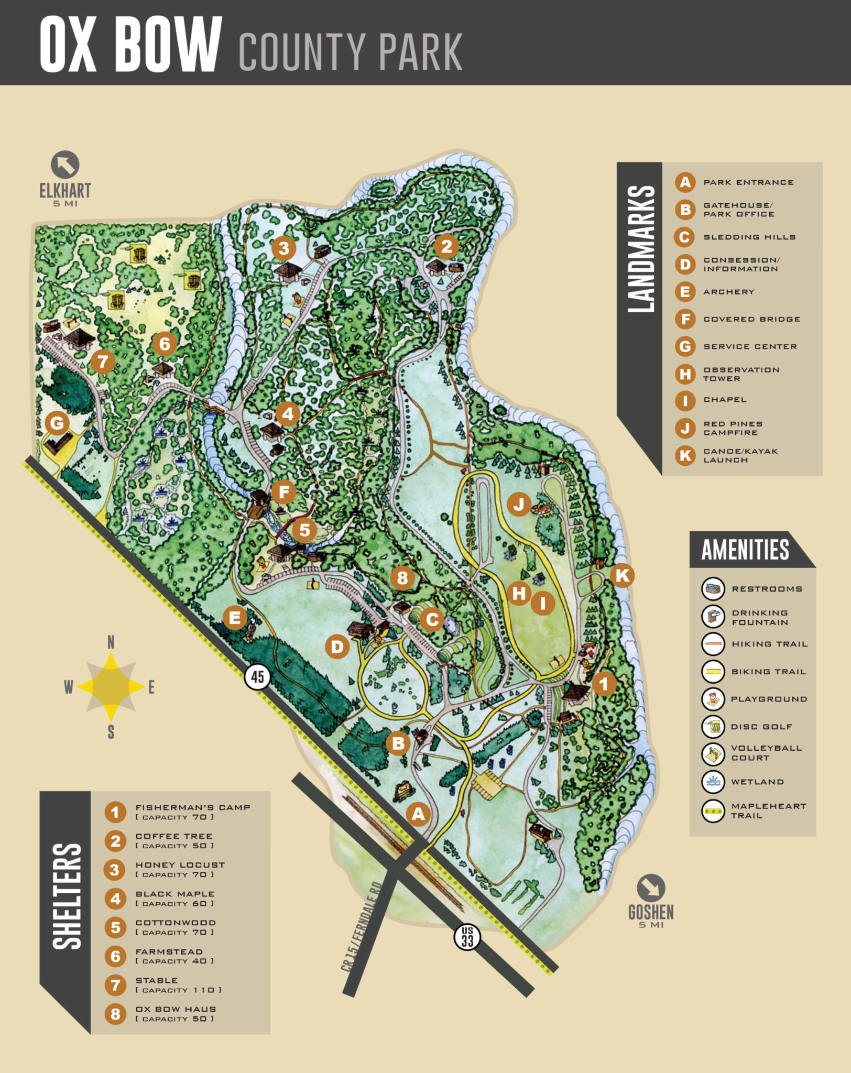
Pioneer Trails Cub Scout Day Camp
Staff Training Plan
- All staff to complete Safeguarding Youth Training
- All staff to complete Seasonal Camp Staff Youth Protection and Personal Safety Training – Staff Training Day
- All staff to complete Weather Hazards Training
- Each Range Master to complete Range Training every 2 years.
- Camp Health Officer to complete the one-time self-study Camp
Health Officer’s Training Course
- Camp Director and Program Director to complete National Camping School Training
- Professional staff adviser to complete National Camping School training.
- All new staff, and others as designated by Camp Director, to attend Staff Training Day –which includes Security and Stress Management Sessions.
- Key Staff, as designated in camp standards, to complete Unlawful Harassment Prevention Training.
- Red Cross Basic First Aid and CPR Training offered to key staff – to be renewed every two years.
Staff are requested to bring completed training cards to Staff Training Day. If any required training has not been completed, this will be offered at the Training Day.
The Day Camp Director is responsible for keeping copies of completed training cards and for keeping copies of training rosters.

< 9 >

Daily Schedule and Overview of Program
Tuesday -Thursday,
8:00 a.m. – 8:30 a.m. Arrival and Check-in
8:30 a.m. – 8:45 a.m. Opening Ceremony
8:55 a.m. – 11:30 a.m. Stations
11:45 a.m. – 12:30 p.m. Lunch
12:30 p.m. – 3:05 p.m. Stations
3:15 p.m. – 3:30 p.m. Closing Ceremony
Friday:
12:00 p.m. – 12:15 p.m. Arrival and Check-in
12:15 p.m. – 12:25 p.m. Opening Ceremony
1:15 p.m. – 4:55 p.m. Field Day /Snack
5:00 p.m. - 5:45 p.m. Awards/Skits / Closing
5:30 p.m. - 6:30 p.m. Cleanup

Camp Program
The focus of our program is to provide activities which are not easily completed in a den setting, activities that cannot be completed without a large number of participants and advancement oriented activities.
The range of activities include those that focus on: Physical fitness
Nature Appreciation
Team Spirit
Care for our World and Environment
Life Skills and Knowledge
< 10 >
Staff Arrivals and Departures
All staff members are asked to check in at headquarters as you arrive each day.
- Sign in – we need to know who is present each day of camp
- Pick up your daily schedule
- Get a daily up-date for any changes
On Tuesday through Thursday, camp begins with an Opening Ceremony at 8.30 a.m. with activity sessions starting at 8.45 a.m. All staff members are to arrive at least ½ hour before camp starts to help get everything ready for the scouts. Station leaders will need this time to set up their stations.
Attend the Opening and Closing ceremonies if time allows.
Report if you will be a late arrival or absent to the Camp Director as soon as possible.
Please have a watch or cell phone so that you can keep track of time and release scouts from your station in a timely manner.
Station supplies will be delivered to the station areas each day, and picked-up at the end of each day. If a station leader desires to keep the station supplies with them, please let the Quarter Master and Program Director know.
At the end of day, please pack-up your station supplies and leave them on a table to be picked up. If you have a large quantity of trash, leave it with the supplies, for staff to take to the dumpster.
Vehicles and Parking
Please do not drive on the grass areas at camp. If you have a large quantity of supplies to unload, please talk to the Camp Director and we will make arrangements. You must park in a designated parking area. Please observe all speed limit signs while driving in the park.

< 11 >

Thank you for volunteering to be a Station Leader
1. All Camp activities should reflect the Core Values of the Scouting Program. Use your station time to reinforce these values and principles.
2. As a station Leader- you are in charge of your station. You determine when anyone can enter your area, and when / how the activity will go. Maintain control and the Scouts won't lose interest. Scouts should ask permission to your area.
3. Use other adults/walkers to make the station go. Ask them to help the Scouts, and/or perform a task. Lions and Tigers require adult accompaniment to help.
4. Encourage the Scouts to put their names on all papers, materials, and stuff they will keep after the activity. Pencils and/or markers will be provided.
5. Clearly indicate what the rules for your station are, when/how each task will be done, and any safety concerns.
6. Explain what the station is about. Give history, reasons of importance, and how the station applies to Scouting. Use visual aids, such as posters. Engage the Scouts to promote interest and learning.
7. Splitting a large group is helpful for many stations. 2 groups of 6 boys is easier to work with than 1 group of 12. Have one group work on one part of the activity while the other does another part, then switch. Watch your time-so each group has time for each part.
8. A station instruction sheet will be provided to give the purpose of the station, helpful suggestions, and key elements to keep the station relevant to Scouting.
9. If the station goes too quickly- use time to sing a song, play a simple game, have Scouts practice their skit for the campfire program. Each walker will be given a folder with time filling games and ideas – some are also included in the staff manual.
10. Most important…have FUN! If you are having fun, so will the Scouts.
< 12 >
Station Leaders and Staff
Station Leaders who register early receive a free t-shirt that should be worn each day of camp. If you are unable to wear the camp t-shirt, you must be issued a camp lanyard with identification indicating you are part of the camp staff.
A water cooler and some kind of shelter will be provided at each station. Encourage the scouts to drink some water while at your station. If you need refills, call headquarters on your radio.
You will have youth staff to help at your station – let the Youth Staff Leader know if you need more than one helper. You may involve the den walkers as helpers also.
Let the Program Director know if you are running short on supplies or have any other supply problems.
Among your supplies will be a container of beads. These are recognition beads for completing the activity at your station. Give these to one of the adult walkers for distributing to the scouts. Necklaces to display the beads are issued to each scout.
Keep your station clean and orderly. If you are painting or gluing, please cover the picnic tables with plastic tablecloths. We are responsible for leaving the park shelters and tables in pristine condition. If you have an excess of trash, leave it for collection at the end of day.
Archery and BB ranges are to be secured before being left unattended. No one is allowed into the Archery or BB ranges unless there is a range trained staff member present.
Fires are to be attended at all times. Ask permission to enter or pass through program areas other than your own.
Make sure you have a way of keeping track of time – you are responsible for starting on time and for finishing on time. Be ready with some time fillers if your group gets done early – some suggestions are included.
Dress for the weather, most activities will go on regardless of weather. Alternate activities are available for stations that do not have shelter or would be at risk during lightning/heavy winds/… Alternatives will be provided by the Program Director.

< 13 >

Rainy Day Alternatives
Cooking should be able to continue by using the fire pit in the shelter. If the rain is really bad then the cooking project will change to preparing a food item that does not need to be cooked and completing the discussion part of the activity.
Stations on the field–scouts will remain under the field shelter and play games or complete a craft from those available –Please note the time filler activities in the back of the staff manual – some of these can be used as rainy day alternatives.
Archery – will remain under shelter and go through the safety and demonstration part of the activity. If the weather has not improved, they can play games or do a craft.
BBs – will remain under shelter and go through the safety and demonstration part of the activity. If the weather has not improved they can stay under shelter and play games
Nature Hike – this activity can continue in light rain if everyone has protection. If the rain is too heavy, then the scouts will be re-directed to a craft or under-cover games activity.
Station leaders are directed to the Rainy Day Alternatives section of the manual for activities they can do with their dens if their planned program cannot be completed due to the weather.

< 14 >
Communication
Our primary communication platform is discord. Discord is a free app that allows texting, calling, and file sharing within a closed server. All adult staff as well as youth staff over the age of 13 with parent permission are encouraged to join the server at staff training day or upon first arriving at camp. This allows us to share information quickly and efficiently through camp. There will be separate channels for discipline first aid and supply issues to make sure the right staff have easy access to the information they need to see,
Uniforms
All staff will receive a camp T-shirt and/or lanyard. It is important that you wear this uniform every day – it is how you are recognized as being on staff. “Proper clothing for activities is required” (Guide to Safe Scouting p.1) Please wear sturdy shoes – no sandals, flip flops or bare feet are not allowed. Bring rain gear. ‘Belts not Boxers’. If wearing shorts, please wear modest shorts – at least finger-tip length as per most local school dress codes.
Walkers must wear a lanyard with a name tag, identifying them as a walker.

Personal Conduct of Staff
All staff members must act in accordance with the Cub Scout Promise and the Scout Law – to do your best and to be “trustworthy, loyal, helpful, friendly, courteous, kind, obedient, cheerful, thrifty, brave, clean and reverent”
All staff members are to keep pranks, practical jokes, and horsing around to a minimum. Youth Staff members are expected to do what they are asked promptly and cheerfully. Under no circumstances are junior staffers to interact physically with the campers.

< 15 >
Reporting Daily Attendance – Den Walker Responsibilities
All dens will be issued a copy of their den roster each morning. Each den leader/parent walker shall conduct den attendance each morning before departing for their first station. Please leave this clipped to your den board
End of Day Dismissal – Den Walker Responsibilities
Each den leader/parent walker will check off end-of-day attendance by signing the den record sheet to indicate that each scout has been picked up by one of those people indicated on the scout’s registration form. Names of those authorized to take scouts home will be listed on the back of the sign-out sheets. If there is a problem with an unauthorized person wishing to take a child with them, this should be immediately brought to the attention of the Camp Director. She will contact the parent/guardian listed on the registration form to verify pick-up procedures for the child. If the parent cannot be contacted, the child will not be released. If the problem accelerates the Day Camp Director will contact the scout executive for advice.
Early Dismissal
All scouts will be released only from camp headquarters. Parents that need to pick up their scouts early must report to camp headquarters for a release slip. The parent will then go to the activity area and give the slip to the den leader before the child is released. On the Cub Scout registration forms, each parent/guardian is to indicate which individuals the scout can leave camp with. This will be verified in the case of early dismissal by the camp director. Those parents coming to a station to pick-up their children will be identified with a name tag. Staff at headquarters will call field staff on the radio to notify them that an adult is coming to pick up a child. Field staff must not release a child unless they get a call from headquarters and they see a release slip.
Two-Deep Leadership
The Guide to Safe Scouting states “Two registered adult leaders or one registered leader and a parent of a participant, one of whom must be 21 years of age or older, are required on all trips and outings” (p.1) Day Camp follows the policy of 2-deep leadership. Each den must have 2 walkers – the minimum is 1 adult for every 4 scouts – one of whom is 21 years of age or older.
Each station will have a minimum of 1 leader, plus at least one parent helper.

< 16 >
Discipline
The walkers are in charge of the scouts from station to station. Station Leaders are in charge of the activity at their stations. Discipline problems should be handled by walkers first, station leaders second. “Discipline used in scouting should be constructive and reflect Scouting’s values. Corporal punishment is never permitted’ (Guide to Safe Scouting p. 1)
If you are having a problem with a scout not paying attention or being disruptive at your station, you may ask an adult walker to sit that child out for a time – keep it to a minimum – no longer than 5-7 minutes.
The Camp Director is responsible for camp discipline. If there is a problem that you cannot handle easily, contact the director and she will deal with the situation.
If you are having a problem with a walker, contact the camp director immediately and they will handle it.
Remember – swearing and abusive, ‘put-down’ language is not permitted. Raised voices (yelling) is discouraged. No physical punishment is to be used.
Youth staff members are not to administer any form of discipline.
Suggestions for Reducing Discipline Problems
Initial impression – welcome the boys to your station, be enthusiastic and organized.
Use the scout sign – the boys know that this means be quiet and listen. It works very well!
Give instructions for the activity before you hand out materials – it will be easier to keep their attention.
Keep the boys busy – use your Youth Staff helper and walkers to make sure each scout gets the individual assistance he needs to complete the task without getting frustrated.
If the weather is hot and the boys are uncomfortable, make sure they get a chance to drink water and to cool down a little before commencing their activity.
For the scout who doesn’t want to participate in the activity - make it clear that the expectation is to participate (in an encouraging way). Ask why? What can I do to help? Give them a special responsibility or offer an incentive – “If we all get this done we can …… play a game, have a treat, earn a special bead” etc.
< 17 >
Spirit
Young scouts are very serious about things being fair. To them most situations are black and white. Something that you might say in fun, they may take seriously, and may not think it is funny. Something that we may say with a hint of sarcasm, no matter how innocently meant, can hurt feelings. Practical jokes should be approached cautiously. Some people are genuinely fearful of snakes, spiders and other bugs. To ensure the best experience for all – think twice.
Wildlife
Have the scouts respect the wildlife while at camp. Remind them that they are the visitors. They are not to chase, pick-up or throw stones or sticks at any living thing.
If you see an animal that could present a possible problem, please bring it to the director’s attention immediately.
Minimizing Threats from Dangerous Wildlife
1. Take precautions to avoid interfering with normal wildlife behaviors.
2. Prevent attracting or unintentionally creating wildlife conflicts or encounters.
3. Know what to do when you encounter wildlife.
The only dangerous wildlife that could possibly be encountered at Oxbow Park is the Eastern Massasauga Rattlesnake. Campers should stay on the paths. If a snake is encountered, Stop, allow the snake to escape or walk around it. If bitten, get medical attention immediately. The Health Officer should be called by radio from the closest station or called on her cell phone for assistance. Also note the dangers posed by insect borne diseases (Guide to Safe Scouting p.47)
Contraband
Alcohol, pornography, controlled substances, fireworks, firearms and ammunition including BB guns, bows and arrows and slingshots are not allowed. Any violation should be reported to the camp directors.
Anyone caught with contraband will be asked to leave the property immediately.
Scouts are not to bring their pocket knives to day camp. If a scout does, please confiscate the knife, give it to a walker to return to the parent at day’s end.

< 18 >
Smoking
The Guide to Safe Scouting states “Adult leaders should support the attitude that young adults are better off without tobacco and may not allow the use of tobacco products at any BSA activity involving youth participants. All scouting functions, meetings and activities should be conducted on a smoke-free basis, with smoking areas located away from all participants” p. 23 Elkhart County Parks and Recreation Department rules state “smoking in buildings or within 8' of an entrance is prohibited”
At Pioneer Trails Day Camp the smoking policy is:
- No smoking by Youth Staff under the age of 18
- No smoking in front of the scouts including in front of Youth Staff
- If you must smoke, please go to an area of the park not being used for Day Camp – a suggestion is Fisherman’s shelter.
Lost and Found
Everyone is encouraged to put a name and unit number on all personal belongings.
There will be a lost property area located at Headquarters. An announcement will be made at the end of each day to check for lost items. At the end of Day Camp, lost property will be taken to Roundtable through October. After that, it will be donated to Goodwill.
Trading Post
A Trading Post may operate at Headquarters throughout the duration of camp. It will be open during camp time for dens that have free time to stop by. Parents will be notified of the hours of operation and a list of items for sale will be sent home with the scouts on the first day of camp. The Trading Post will have snacks, drinks, scouting items and theme related items. It will be open Monday evening for the sale of camp T-shirts, water bottles, backpacks etc.
Camp Evaluation Surveys
Both campers and staff have the opportunity to give feed-back on their experiences at Day Camp. Surveys will be distributed to dens and staff members. Please complete these and place them in the box located at headquarters or clipped to your den board.

< 19 >
Pixie Camp
Pixie Campers are any unregistered youth Lion age or younger belonging to our staff or walkers. These youth are not eligible for activities such as shooting sports and wood working, but will have other parts of camp available to them to enjoy. The remainder of their time will be spent with simple craft projects and games overseen by a member of our staff.

Meals
Everyone should come with a lunch for each day. If you forget your lunch or are aware of a scout that has forgotten his lunch, please bring it to the Camp Director’s attention
Leaving camp for food is not allowed.
Station Leaders are encouraged to return to headquarters to eat lunch with the scouts and other leaders. This is in case of any lunch time announcements.
We have no means of refrigeration so plan accordingly. We encourage dens and leaders to bring coolers for storing lunches.

< 20 >
Safety and Security
Camp operates on the buddy system – buddies always stay together. If you see a scout without a buddy, send him back to his den to get one.
Scouts are not to engage in activities that would lessen the fun or endanger themselves or others such as – hitting, teasing, name calling, foul language, tackling, tree climbing, hitting trees with sticks, throwing stones etc.
While at camp, everyone on staff must wear the name tag and uniform provided. This lets us know you are supposed to be at camp. Scouts are also to wear their camp T-shirt every day to distinguish them from other visitors to the park.
All visitors to camp must check in at headquarters to receive a special name tag. At no stage should there be adults interacting with scouts who are not wearing camp identification
Day Camp is held at a public park which is open to other people during camp. Because there are predators in our community, we must be on guard to protect the scouts entrusted to our care. Be observant and report any suspicious activity to the Camp Director over the radio or by cell. Provide a location and a description. Do not attempt to make contact with someone you think is dangerous. The Camp Director or Park Rangers will deal with the situation.
Under no circumstances are youth to be carried in the bed of or towed behind a pickup. The beds of trucks or trailers must never be used for carrying youth.
Please remind the scouts to follow the ‘Leave No Trace” guidelines, particularly the need to stay on the marked trails. Poison ivy is prevalent in the park.

Severe Weather & Emergency Procedures
Severe Weather
The National Weather service uses the following terms to describe weather conditions:
Watch – weather conditions are right to form severe weather
Warning – severe weather is moving toward your area.
Signal: Series of constant short honks on a car or truck horn or air horn.
< 21 >
If severe weather approaches, such as heavy rain or wind, take your den to the Headquarters Pavillion. Have the station leader advise the Camp Director via discord. Take a headcount and report to the Camp or Program Director.
For very severe weather, the Camp Director will advise staff, via discord, to evacuate the camp. In such a case after a head count we will proceed to the nearest modern bathrooms and await parent pick ups.
A weather emergency radio is kept at headquarters and monitored by the camp nurse or delegate. If sufficient warning is received, all campers should gather in their dens in the modern bathroom structures. Before leaving your station and after arriving confirm your attendance.
The camp director will take charge of attendance records. The health officer will bring all health records. Depending on the time of day, families will be called to pick up campers.
Missing Camper
Signal: Long honk while driving through the park.
When notified of a missing camper, den leaders will immediately take a head count and report to the shelter leader. If you are missing anyone or unassigned scouts are present, notify the camp director. Staff not assigned to an activity will report to camp headquarters for assignment to search camp. The camp director will make the decision to notify the local authorities. Once found, staff will be assigned to give the all-clear signal.

<22>
Fires
Signal: Series of four short honks.
If a cub scout discovers a fire, they should immediately seek adult help, sound the alarm by yelling “Fire!” and stay away from attempting to fight any fire. If a major fire breaks out, all campers and staff will move by road to the parking area at camp headquarters. The Camp Director will contact the nearest fire department. The den leaders will keep their dens together and not permit scouts to help with firefighting.
Emergency Drill In accordance with National Camp Standard FA-703, a camp wide fire drill will be held within 24 hours of arrival at camp. The procedure for this drill will be as follows:
The Program Director and the Youth Staff Director will travel through the program areas, giving the signal for Fire – a series of 4 short honks. Den leaders will immediately gather their dens and march them to the nearest edge of the parking lot. A head count will be taken. Station leaders will take their radios and walk with the dens from their station. In the event of a real fire, the groups would march back to headquarters and assemble there. For the purpose of the drill, once the dens have assembled, they will wait for the Program Director or Youth Staff Director to drive by and give the all clear signal – this will be 2 short honks from their vehicle. Then everyone may return to their activity stations.
< 23 >

Water Accidents
The Pioneer Trails District Day Camp does not include aquatic activities. At no time should a scout or leader enter the rivers at Day Camp. If a scout or leader should fall in the water, rescue should be attempted first by reaching for the person or throwing something to them. Only as a last resort should a rescuer go into the water to aid the person.
Serious Injury
Campers should report the injury to the nearest adult leader who can contact the Camp Health Officer. All stations will be able to contact headquarters. The decision to call local Emergency Services rests with the Camp Director and Camp Health Officer. The injured person is only to be moved under supervision of emergency personnel or the health officer.
In the event of a fatality during camp, the camp director will contact the Scout Executive – James Hulgan (574-289-0337) and follow the procedure outlined in the Report of Fatal or Serious Accident or Illness. See p. 11 of Camp Health and Safety manual.
Newspapers, TV or radio station reporters will be directed to contact the LaSalle Council Service Center at 800-822-3867. No one on-site is to give reports of the event to anyone but Scouting professionals or local authorities.
First Aid
A competent, currently certified health officer will be available for injuries at camp.
Report all injuries to the health officer. She will determine if it is necessary for her to attend to the victim or if it can be handled by the den leader, using the provided first aid supplies.
In accordance with Camp Standard HS-510, First Aid Kits will be supplied at all on-site program areas. The Camp Health Officer will supervise these kits and restock them as necessary.
Seriously injured or ill persons are not to be moved until assessed by the health officer. Call her by radio from the closest station.
A licensed physician is responsible for medical care and health supervision of the camp as per National Standard HS-505 2013 Camp Health Supervisor – Dr. James P Mack Jr M.D.

< 24 >
If there is an emergency where 911 is needed, call the Camp Director. They will consult with the health officer and take action following the procedures outlined in the Camp Health and Safety manual.
Emergency vehicles will be located at headquarters. These vehicles will have a sign in the window. Do not park them in.
Heat Risks
Make sure the scouts drink water at your station. Even if it is not particularly warm, everyone will be more active than usual and can easily become dehydrated. Headache complaints are usually the first sign of dehydration.
Be observant for the signs of heat exhaustion – dizziness and headache, pale skin, shallow breathing, nausea and cold sweat. Anyone exhibiting signs of heat problems should be taken immediately to the health officer. Call headquarters to arrange a vehicle for transportation.
Medications
All scouts and staff under 18 are to turn in all medications, except asthma inhalers, epi-pens, and bee sting kits, to the health officer, located at headquarters. Medications will be available from the health officer as needed during the day. Scouts should see the health officer at lunch time for their mid-day medications. Others will be delivered by the health officer to the scout when needed.
Youth Protection
All leaders and parents have a responsibility to report any incidents of child abuse. Report any incident to: Scout Executive: James Hulgan 574-289-0337
Day Camp Director: Jonathan Kime 574-352-4411
Child Protective Services: Elkhart County 574-293-6551
Cass County 616-831-1577
Remember, just a reasonable suspicion is enough for you to make a report. Let the professionals do the investigation.

< 25 >
Outdoor Campfire Safety Rules

1. Follow all the rules of your campsite - At Oxbow Park the fire should only be built in the fire pit provided at the shelter

2. Appropriate equipment must be used – long handled utensils and pots, hot pads etc.

3. Have a clearly marked boundary around the fire. Allow no one to walk inside that area.

4. Once a stick is placed in the fire it must STAY in the fire!

5. NEVER leave your fire unattended. A responsible adult must be present at all times.
For the younger scouts, an adult leader is in charge of the fire at all times. For the Webelos scouts, a Youth Staff scout who has his Firem’n Chip may be in charge of the fire. Again, the fire must never be left attended.

6. Clear all combustibles away from the fire – at least 5 feet. This includes lighter fluid.

7. Have a pot or bucket of water nearby in case sparks start a fire away from the fire circle.

8. Have a bucket of sand and a shovel near the fire to extinguish it.

9. When you are finished cooking, make sure the fire is DEAD OUT. Spread the coals and ashes and sprinkle them with water. Stir and sprinkle until the site is cold. Feel it with your hand to make sure the fire is completely cold.

10. Store all uneaten food in a safe manner. Keep raw meats separated from other items. Keep all food items stored at appropriate temperatures – coolers and ice should be used for items which need refrigeration.

11. A first aid kit will be kept at the cooking station.

12. Hand sanitizer and/or anti-bacterial wipes will be kept at the cooking station. Hand washing facilities are within easy access.

13. An SDS Sheet for lighter fluid will be kept at the site if lighter fluid is being used.

< 26 >

Scouts and their parents expect all Boy Scouts of America activities to be conducted safely. To ensure the safety of participants, the Boy Scouts of America expects leaders to use the four points of SAFE when delivering the Scouting program.
Supervision
Youth are supervised by qualified and trustworthy adults who set the example for safety.
• Accepting responsibility for the well-being and safety of youth under their care.
• Ensuring that adults are adequately trained, experienced, and skilled to lead the activity, including the ability to prevent and
respond to likely problems and potential emergencies.
• Knowing and delivering the program of the Boy Scouts of America with integrity.
• Using qualified instructors, guides, or safety personnel as needed to provide additional guidance.
• Maintaining engagement with participants during activities to ensure compliance with established rules and procedures.
Assessment
Activities are assessed for risks during planning. Leaders have reviewed applicable program guidance or standards and
have verified the activity is not prohibited. Risk avoidance or mitigation is incorporated into the activity.
• Predetermining what guidance and standards are typically applied to the activity, including those specific to the Boy Scouts of
America program.
• Planning for safe travel to and from the activity site.
• Validating the activity is age-appropriate for the Boy Scouts of America program level.
• Determining whether the unit has sufficient training, resources, and experience to meet the identified standards and, if not,
modifying the activity accordingly.
• Developing contingency plans for changes in weather and environment and arranging for communication with participants,
parents, and emergency services.
Fitness and skill
Participants’ Annual Health and Medical Records are reviewed, and leaders have confirmed that prerequisite fitness and
skill levels exist for participants to take part safely.
• Confirming the activity is right for the age, maturity, and physical abilities of participants.
• Considering as risk factors temporary or chronic health conditions of participants.
• Validating minimum skill requirements identified during planning and ensuring participants stay within the limits of their abilities.
• Providing training to participants with limited skills and assessing their skills before they attempt more advanced skills.
Equipment and environment
Safe and appropriately sized equipment, courses, camps, campsites, trails, or playing fields are used properly. Leaders
periodically check gear use and the environment for changing conditions that could affect safety.
• Confirming participants’ clothing is appropriate for expected temperatures, sun exposure, weather events, and terrain.
• Providing equipment that is appropriately sized for participants, is in good repair, and is used properly.
• Ensuring personal and group safety equipment is available, properly fitted, and used consistently and in accordance with training.
• Reviewing the activity area for suitability during planning and immediately before use, and monitoring the area during the activity
through supervision.
• Adjusting the activity for changing conditions or ending it if safety cannot be maintained.
Guide to Safe Scouting 680-114
May 2021 Revision
BSA Policy on Alcohol, Tobacco, and Drug Use and Abuse
Alcohol: The following statement was approved by the National Executive Board of the Boy Scouts of America:
It is the policy of the Boy Scouts of America that the use of alcoholic beverages and controlled substances is not permitted at encampments or activities on property owned and/or operated by the Boy Scouts of America or at any activity involving participation of youth members.

Tobacco: Adult leaders should support the attitude that they, as well as youth, are better off without tobacco in any form and may not allow the use of tobacco products at any BSA activity involving youth participants. This includes the use of electronic cigarettes, personal vaporizers, or electronic nicotine delivery systems that simulate tobacco smoking.

All Scouting functions, meetings, and activities should be conducted on a smoke-free basis, with smoking areas located away from all participants.
References: Scoutmaster Handbook, No. 33009, and Boy Scout Handbook, No. 34554

Drugs: The misuse of drugs happens in all levels of our society. We may be confronted with the problem at any time; therefore, we need to understand the misuse of drugs and what can be done about the situation. See the Drug Enforcement Administration website (http://www.justice.gov/dea/index.htm) for detailed information on controlled substances and their effects.

< 28 >
SERIOUS INJURIES OR ILLNESS
The following steps are recommended in the event of a serious
injury or illness on the camp property:

Step One: Immediate Action
A. Of utmost importance is the proper care of the injured or
ailing individual. Immediately contact a licensed medical
practitioner to supervise the care, treatment, and/or transportation of the injured party.
B. In cases involving lack of breathing or shortness of breath,
severe bleeding, or internal poisoning, capable and trained
first-aiders should apply their skills to control or assist in
the immediate recovery process.
C. Contact camp licensed medical practitioner or local
licensed medical practitioner as appropriate.
D. Alert local hospital—provide them with essential information
related to injury or illness.
E. Arrange transportation to the hospital.

Step Two: Local Notification
A. As quickly as possible, parents or other next of kin should
be notified by the Scout executive, camp director, or the
Scout executive’s or camp director’s representative
about the injury or illness and what steps have been taken
to aid the injured or ailing individual. This should be done
by a telephone call whenever possible. Be careful not to
frighten or excite parents or other next of kin, but rather to
reassure them that everything possible is being done.
1. Contact the family licensed medical practitioner if such is
the desire of the parent or guardian and be sure that the
practitioner’s satisfied with the medical arrangements.
2. Provide transportation, if necessary, for parents or other
next of kin to the location of the injured or ailing person.

B. In case of serious injury:
1. Collect all facts, including names of witnesses.
2. Notify authorities—police, sheriff, etc.
3. Notify Scout executive. (The Scout executive notifies
the council president and the chairman of the health
and safety committee.)

C. In case of serious illness:
1. Notify health authorities if contagion is suspected.
Follow their instructions.
2. Notify Scout executive. (The Scout executive notifies
the council president and the chairman of the health
and safety committee.)

Special Note: If either a serious injury or illness might result
in death, the camp director should obtain help as necessary
from the camp chaplain or other religious leader.
Check instructions for follow-up steps as described in the
folder Report of Fatal or Serious Injury or Illness, No. 19-147A,
using form No. 19-148A, Preliminary Report of Fatal or Serious
Injury or Illness. Send a facsimile within 24 hours of the incident
(sample wording is inside the cover of the pink accident folder,
No. 19-147A). Follow up with a hard copy of the Preliminary
Report, No. 19-148A, within four days of the incident.

Camp Health and Safety Manual p. 11

FATAL INJURY OR ILLNESS
In the event a fatal injury or illness occurs on the camp property
the following steps should be followed:
Step One: Immediate Notification
A. Camp director, event chairman, or Scout executive must immediately notify local authorities. The police and coroner must institute an inquiry to determine the cause of death—whether responsible precautions were taken to prevent the accident. This will also include a decision as to whether or not standard practices were followed at the time of the accident.
B. Get all the facts, including names and statements of all witnesses.
C. If a person other than the Scout executive is the first to receive the information, contact the Scout executive before any further steps are taken. Give the Scout executive as much of the following information as you can:
• Who? Name and age of subject, Scouting unit and number, name and address of parents, guardians, or other next of kin.
• When? Date and time of day.
• Where? Give specific location, including address and
community if possible.
• What? Nature of injury or illness.
• How? If known—for example, swimming, boating, hiking.

Step Two: Immediate Action
The Scout executive, council president, and family
religious leader or council chaplain arrange a place
to meet and jointly proceed to the home of the family
of the deceased. No phone call is made to the family.
A personal visit is the only acceptable way.
A. The Scout executive contacts the following by telephone:
• Regional director
• Council president
• Council health and safety committee chairman
• Attorney
• Local insurance claims office
• Director of external communications at the national office
(Refer to Crisis Communication from the pink folder, No.
19-147B.) Prompt attention is necessary. Establish one
“pipeline” to news media.
Be sure parents and/or other next of kin are informed by personal contacts before any release is made to the public.
• National director of health and safety
B. Check procedures for follow up steps described in the folder
Report of Fatal or Serious Injury or Illness, No. 19-147B.
< 29 >

Time fillers
To help you insure every moment at camp is an opportunity for fun, friendship and activity: it is suggested to use time fillers when needed:
Some helpful time fillers include:
  - Practice den cheer
  - Practice den skit for campfire program
  - Use markers to decorate walking sticks
  - Tell jokes
  - Do a scavenger hunt
  - Play on a playground if close
  - Take a bathroom break
  - Take time to fill water bottles and get a drink
  - Use time to attach beads.
  - Reapply sunscreen and/or bug spray.
  - Sing songs (see some enclosed suggestions)
  - Play games (see some enclosed suggestions)
Have Fun! If you are having fun, so will the Scouts.

< 30 >
SONGS
The Star-Spangled Banner
(The National Anthem of the United States of America)
Oh, say can you see - By the dawn’s early light
What so proudly we hailed - at the twilight’s last gleaming?
Whose broad stripes and bright stars - through the perilous fight,
O’er the ramparts we watched - were so gallantly streaming?
And the rocket’s red glare, - the bombs bursting in air,
Gave proof through the night - that our flag was still there.
Oh, say does that star-spangled banner yet wave
O’er the land of the free - and the home of the brave?

Make New Friends
Make new friends, but keep the old.
One is silver, the other is gold.

A circle is round, it has no end.
That’s how long, I will be your friend.

A fire burns bright, it warms the heart.
We’ve been friends, from the very start.

You have one hand, I have the other.
Put them together, We have each other.

You help me, and I’ll help you
And together-we will see it through.

The sky is blue- The Earth is green
I can help – to keep it clean

Across the land – Across the sea
Friends forever - We will always be.

< 31 >
I’ve Got That Cub Scout Spirit (Tune: Joy in My Heart)
I’ve got that Cub Scout spirit
Up in my head, up in my head, up in my head;
I‘ve got that Cub Scout spirit,
Up in my head, up in my head to stay.

(replace “up in my head” with other words for the next verses).
Second verse: Deep in my heart
Third verse: Down in my feet
Forth verse: All over me

Fifth verse: I’ve got that Cub Scout spirit
up in my head, deep in my heart, down in my feet:
I’ve got that Cub Scout spirit
All over me, all over me to stay.

Train Song (Tune: “Yankee Doodle”)
I met an engine on a hill
All hot and broke-hearted,
and this is what he said to me
As up the hill he started.
(slowly)
I think I can, I think I can, At any rate, I’ll try.
I think I can, I think I can, At any rate, I’ll try.
(faster)
I knew I could, I knew I could,
I never should have doubted.
I knew I could, I knew I could,
I never should have doubted!

Do Your Best (Tune: Jingle Bells)
Do your best, do your best.
In everything you do.
Keep the Promise and the Law.
Be a Cub Scout true.
Do your best, do your best.
Be a loyal Scout.
Do your duty to God
And help your country out. < 32 >
GAMES
Buddy Tag
Also called “Elbow Tag”. In this game, you have to hold on to a buddy to avoid being tagged.
Need: 6 or more players in an open area.
Instructions:
- One person is “it”, and one person in the runner.
- Everyone else finds a partner/buddy and links arms. The pairs of buddies scatter around the playing area.
- The person who is “it” tries to tag the runner.
- To avoid being caught, the runner has to link up with a pair of buddies before “it” can tag him.
- When the runner finds a buddy, he links arms and is safe…but now the biddy on the other side of the pair becomes the runner.
- If the runner is tagger before he can link up with a pair of buddies, he is now “it”, and “it” becomes the runner.
The game can go on forever, So stop playing when you are out of breath.
Land, River, Mountain
Need: Two lines on the ground (or use two pieces of rope) long enough for all the players to stand along and about 2ft. apart.
Land
------------------------
River
------------------------
Mountain
Instructions:
- The leader calls land, river or mountain.
- The players jump to the appropriate place between the lines.
- If they jump to the wrong place or jump on the lines they are eliminated.
The winner is the last one in.

Eat the Fish Tail
The longer the fish the better.
Directions:
- Players line up in single file, hold each other around the waist. The first player is the fish head, the last player is the tail.
- On signal from leader, the head tires to catch the tail while the tail tries to avoid being caught.
- All must continue to hold on to each other.
< 33 >
Cowboy, Bear, Lady
Played along the lines of rock, paper, scissors.
- Lady – one hand on hip, one hand behind head.
- Bear – two hands raised in threatening bear position
- Cowboy - two hands raised pretending to shoot guns.
Instructions:
Players all pair up standing back to back.
The leader calls 1, 2, 3. On 3 the players quickly turn to face each other making the action for one on the three characters.
- Lady defeats the cowboy
- Cowboy defeats the bear
- Bear defeats the lady

The one defeated is eliminated. Winner is the last one playing.

Caterpillar Race
Directions:
- Divide players in to even groups forming a line.
- The first player in each line places his hands on the ground.
- Each teammate behind him bends forward and grasps the ankles of the player in front of him.
- On a signal, the “caterpillars” move forward with everyone holding tight to the ankles.
- The first team that crosses the finish line still intact wins.

Chain Tag
Directions:
- Players are scatter over the playing area.
- One player is “it” and tries to tag another player.
- The first player he tags joins hands with “it” and helps in tagging others. They can only use their free hand to tag others.
- Each player tagged joins hand with the one tagging him. The line grows longer as more players are tagged, but only the players at the two ends of the chain may do the tagging.
- Tagging doesn’t count if the chain in broken.
- The game continues until all boys have been tagged.

< 34 >
Back to Back
Need: Odd number of players.
Directions:
- All players except one, “it”, stand back to back in pairs with their elbows locked.
- Pairs should scatter randomly over the playing area.
- When “it” calls “all change!”, each player must find a new partner and hook elbows with them. At that same time, “it’ tries to find a partner also.
- The player left without a partner becomes the next “it”.

Blast off
Similar to the traditional game of Duck, Duck, Goose!
Directions:
- Players sit in a circle.
- Leader chooses on player to start by saying “10”.
- The next player to the left says “9” and so on until you get to “1”.
- The players who comes after “1” is the astronaut and should get up when everyone else yells “Blast Off!”.
- The astronaut walks around the outside of the circle and taps each seated player on the head, saying “star” with each tap until he randomly decided to tap someone and say “comet”.
- The player tapped as “comet” chases the astronaut around the circle, while the astronaut tries to get to his space and be safe.
- If caught, the chaser(comet) becomes the new astronaut. If not caught, they repeat the countdown 10,9,8, etc. to select a new astronaut.
Steal the Bacon
Materials: an object to represent the bacon (bean bag, sock, whatever can be grabbed with one hand)
Directions:
- Players divided into two teams and sit in rows on the ground about 6 feet apart.
- Players are numbered 1, 2, 3, etc. down the row. Sitting as below.
1 2 3 4 5 6
*
6 5 4 3 2 1
- In the center between the two rows of players is an object- the bacon.
- The leader calls a number and the two players (one from each team) with that number have to race to pick up the ‘bacon’ and return to their spot without being tagged by the other runner.
- Points are added up each time a team wins. Winners are the team with the most points.
< 35 >

