Walkers Helper Book
LaSalle Council
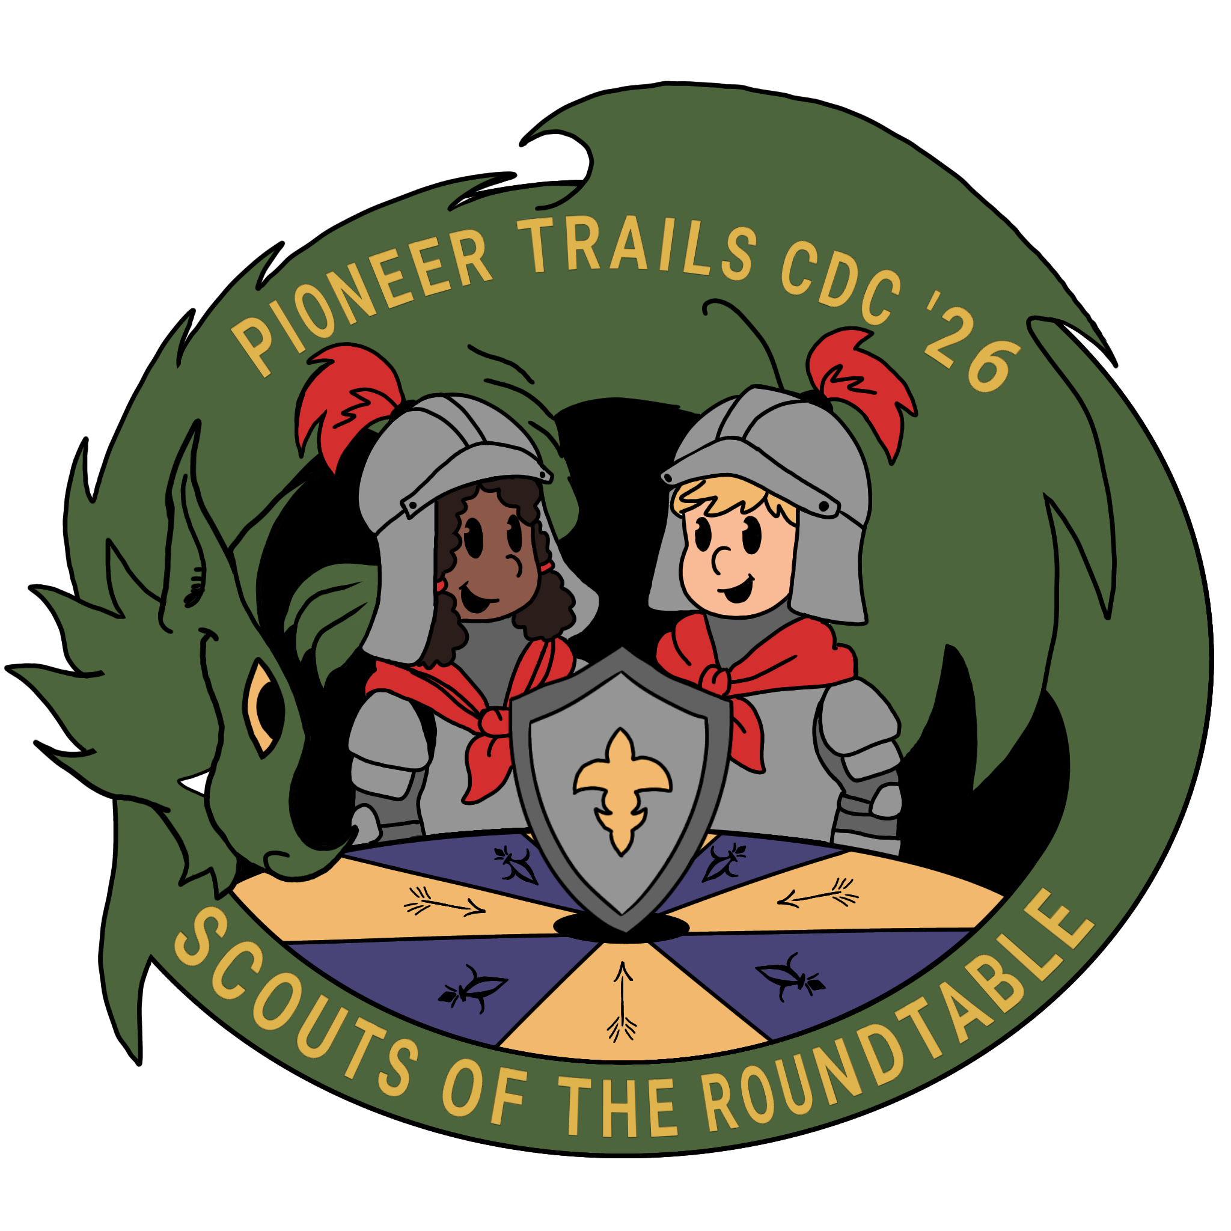

Pioneer Trials
Cub Scout Day Camp

Oxbow Park, Elkhart, IN
What to Bring

Scouts/Youth participants
- Closed-toe shoes (good for walking) & socks recommended
- Packed lunch (lunch will NOT be provided)
- Dress for the weather
- Sunscreen (no sprays)
- Bug repellent (no sprays)
- Rain gear (jacket or poncho – no umbrellas)
- Hat (optional)
- NO knives
- Masks (optional)

Adults
- All the above
- Cooler for group to keep sack lunches in at Den boards
- Wear lanyard everyday

Scouts/Youth Participants receive*
- Red Vest to be worn each day of camp

*we cannot guarantee supplies for late registrations.

Cub Scout Day Camp

Day Camp Contacts

Council Day Camp Advisor:  Sierra Seventy  sierra.seventy@scouting.org  812-243-7862 | Council Short Term Camp Advisor:  Creasy McKensie  Froggyxrs@gmail.com  574-350-0480
Day Camp Director:  Jonatthan Kime  eaglescout1205@yahoo.com  574-352-4411 | Program Director:  Andrew Christophel  trumpetguy13189@gmail.com  574-215-9253
There will always be a key staff member at headquarters during the hours of camp.

Walkers are responsible for supervising the Scouts in the den, insuring safety and security, and promoting fun. A Den at camp may include Scouts from different Packs – as a Scouting community- it is important for the Den to work together as one unit.
Each den should have a minimum of 2 walkers each day. If your den needs more walkers, speak to the Camp Director. Walkers are required to wear a Walker Lanyard or camp t-shirt to identify them as a Walker. (Please leave the lanyards at camp each day). Camp t-shirts are not provided but may be purchased before camp through the portal. If there are not enough lanyards for your walkers, please get more from headquarters.
Morning Responsibilities- Mare sure each scout wears the camp t-shirt and has a water cup. Write names on the cups with the marker provided. Take daily attendance and leave the attendance sheet clipped to the den board. Assign buddies – each scout should have a buddy that he stays with at all times. If you have an odd number of boys, make a threesome.
Walkers supervise the scouts as they move from station to station. Ensure that they stay on trails and follow camp rules. Please make sure that the boys drink plenty of water during the day to avoid dehydration. Scouts should always use the buddy system.
Dens should not enter a station without requesting permission from the Station Leader. Sometimes the Station Leader will ask the scouts to do a cheer before entering. Once inside a Station area, the station leader is in charge but may require the use of the Walker as additional hands and helpers- especially for the newer Scouts.
Walkers are responsible for supervising the scouts during the lunch session. Please ensure your eating area is left tidy. Encourage the boys to wash hands at the sanitation station before eating lunch.
At the end of the day, a walker is responsible for having the scouts signed out. The person collecting the scout must sign the form in a legible manner so that we can identify who took the scout home. Walkers should not leave until each of the scouts in their den has left. If no one comes to collect a scout bring him/her to headquarters. Please leave your den area tidy at the end of the day.

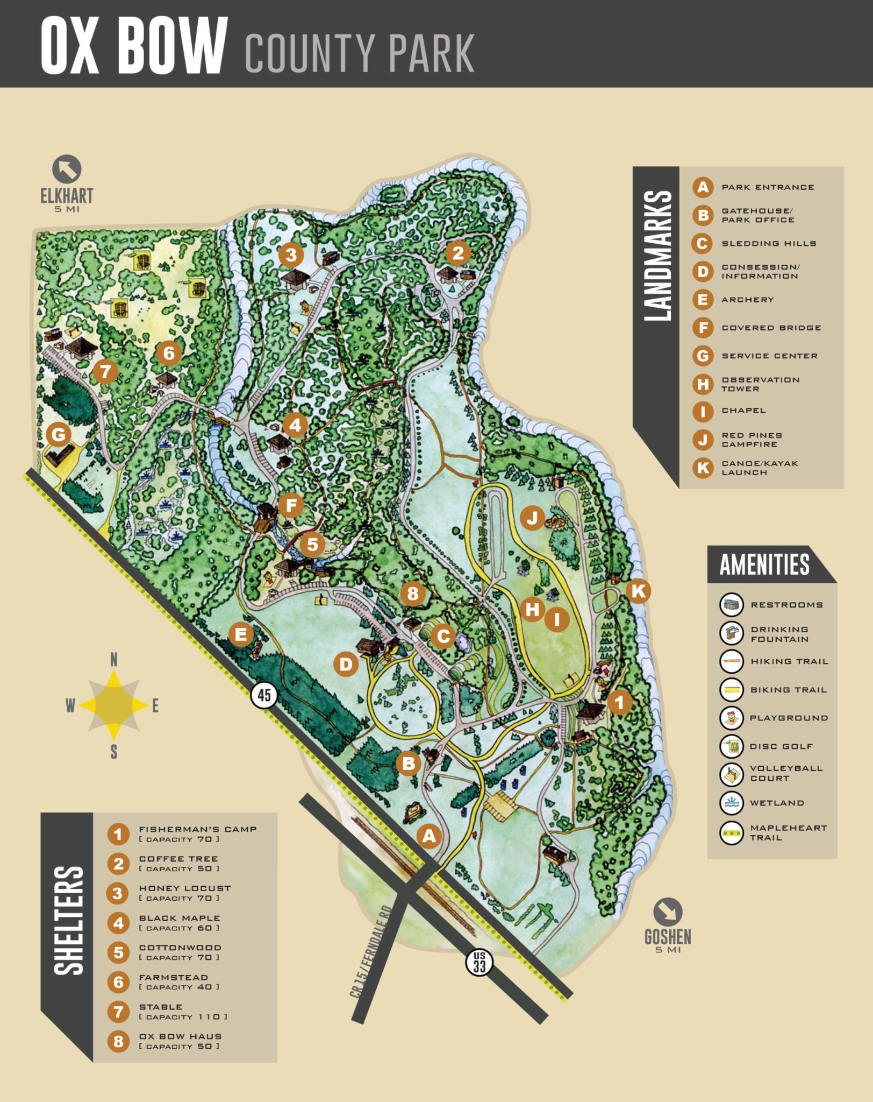
Basic Camp Rules
- All late arrivals and early dismissals should check –in/out at headquarters. As a walker, do not let anyone leave with an adult unless they have a signed release form from headquarters.
- Please park in designated parking spaces only! Do NOT park on the grass.
- BSA Youth Protection standards are to be followed by all person in camp- see brochure.
- Respect wildlife and nature – following the Leave No Trace Guidelines at camp.
- Alcohol, pornography, controlled substances, fireworks, firearms, and ammunition are not allowed at camp.
- Scouts are not to bring pocket knives – Walkers should confiscate and give to parents at pick-up.
- Smoking for adults (18 and over) is only permitted out of view of scouts.
- Buddy system should be followed at all times in camp.
- No activities that would lessen the fun or endanger anyone are permitted (hitting, teasing, tree climbing, etc. )
- All visitors must check in at headquarters and obtain a visitor lanyard- do not allow anyone without a camp uniform/t-shirt or camp lanyard to interact with the scouts.
- Report suspicious activity or persons to the camp director.
- While at headquarters, please keep the scouts inside the fenced area. They should only be outside the fence, if they are with an adult.
- Keep scouts out of the woods and off the fences. You make take your den along a trail.

First Aid
In the event of an accident or injury, simple first aid kits are available at the stations. If needed, have the nearest station leader radio the health officer at headquarters for directions and assistance. Only emergency personnel should move an injured person. Please let the health officer know about the incident so it can be recorded in the camp medical logs.
Weather Emergency
In the event of severe weather, take your den to the nearest shelter with a hard roof. Directions will be broadcast to the station leaders via radio. If conditions worsen, the camp director will advise staff via radio to evacuate the camp. Move the scouts as quickly and safely as possible. Leave gear behind if necessary. Follow camp station directions.
Emergency Drill Procedures
A Staff member will travel through the program areas, giving the signal for Fire = a series of 4 short honks.
Den leaders (walkers) will immediately gather their dens and march them to the nearest road edge or the parking lot. A head count will be taken.
Station leaders will walk with the dens from their station.
In the event of a real fire, groups would receive evacuation directions by radio from the camp director. For the purpose of the drill, once the dens have assembled., they will wait for the program Director or Quartermaster to drive by and give the all clear signal – this will be 2 short honks from their vehicle. Then everyone may return to their activity stations.
Photography
If you are taking pictures of your scout(s) please be cognizant of other scouts that may be in frame. Not every scout is okay being photographed for any number of reasons. Please make sure that you have permission to photograph or film any scout(s) you are photographing or filming.

Time fillers
To help you insure every moment at camp is an opportunity for fun, friendship and activity: it is suggested to use time fillers when needed:
Some helpful time fillers include:
  - Practice den cheer
  - Practice den skit for campfire program
  - Tell jokes
  - Do a scavenger hunt
  - Play on a playground if close
  - Take a bathroom break
  - Take time to fill water bottles and get a drink
  - Use time to attach beads.
  - Reapply sunscreen and/or bug repellent.
  - Sing songs (see some enclosed suggestions)
  - Play games (see some enclosed suggestions)
Have Fun! If you are having fun, so will the Scouts.

SONGS
Make New Friends
Make new friends, but keep the old.
One is silver, the other is gold.

A circle is round, it has no end.
That’s how long, I will be your friend.

A fire burns bright, it warms the heart.
We’ve been friends, from the very start.

You have one hand, I have the other.
Put them together, We have each other.

You help me, and I’ll help you
And together-we will see it through.

The sky is blue- The Earth is green
I can help – to keep it clean

Across the land – Across the sea
Friends forever - We will always be.

I’ve Got That Cub Scout Spirit (Tune: Joy in My Heart)
I’ve got that Cub Scout spirit
Up in my head, up in my head, up in my head;
I‘ve got that Cub Scout spirit,
Up in my head, up in my head to stay.

(replace “up in my head” with other words for the next verses).
Second verse: Deep in my heart
Third verse: Down in my feet
Forth verse: All over me

Fifth verse: I’ve got that Cub Scout spirit
up in my head, deep in my heart, down in my feet:
I’ve got that Cub Scout spirit
All over me, all over me to stay.

Row Row Row Your Boat
Row row row your boat,
Gently down the stream,
Merrily merrily merrily merrily,
Life is such a dream.
Row row row your boat,
Gently down the stream,
If you see a crocodile,
Don’t forget to scream.

ANIMALS IN THE OCEAN (sung to the tune of The Wheels on the Bus)
The sharks in the ocean go chomp, chomp, chomp
Chomp, chomp, chomp,
Chomp, chomp, chomp
The sharks in the ocean go chomp, chomp, chomp
All day long…
The turtles on the ocean go snap, snap, snap,
Snap, snap, snap,
Snap, snap, snap.
The turtles in the ocean go snap, snap, snap.
All day long…
The crabs in the ocean go click, click, click,
Click, click, click,
Click, click, click,
The crabs in the ocean go click, click, click,,
All day long…
The jellyfish in the ocean go wibble, wobble, wibble,
Wibble, wobble, wibble,
Wibble, wobble, wibble.
The jellyfish in the ocean go wibble, wobble, wibble,
All Day Long ...
The clams in the ocean go open and shut
Open and shut
Open and shut
The clams in the ocean go open and shut
All day long…
The seahorse in the ocean rocks back and forth
Back and forth
Back and forth
The seahorse in the ocean rocks back and forth
All day long…
I’m a Little Fish
(sung to the tune of I’m a Little Teapot)
I’m a little fish o, (hold up one hand with thumb facing upwards to represent a fish)
Watch me swim. (move hand back and forward)
Here is my tail, (wriggle fingers on fish hand)
And here is my fin. (wriggle thumb)
When I want to have fun,
With my friends,
I swish my tail and dive right in. (swish fish hand around)

GAMES
Buddy Tag
Also called “Elbow Tag”. In this game, you have to hold on to a buddy to avoid being tagged.
Need: 6 or more players in an open area.
Instructions:
- One person is “it”, and one person in the runner.
- Everyone else finds a partner/buddy and links arms. The pairs of buddies scatter around the playing area.
- The person who is “it” tries to tag the runner.
- To avoid being caught, the runner has to link up with a pair of buddies before “it” can tag him.
- When the runner finds a buddy, he links arms and is safe…but now the biddy on the other side of the pair becomes the runner.
- If the runner is tagger before he can link up with a pair of buddies, he is now “it”, and “it” becomes the runner.
The game can go on forever, So stop playing when you are out of breath.

Shark Tag
- Designate the Shark, And have the kids play tag. Whomever the Shark eats either is out or also transforms into a Shark.

Land, River, Mountain
Need: Two lines on the ground (or use two pieces of rope) long enough for all the players to stand along and about 2ft. apart.
Land
------------------------
River
------------------------
Mountain
Instructions:
- The leader calls land, river or mountain.
- The players jump to the appropriate place between the lines.
- If they jump to the wrong place or jump on the lines they are eliminated.
The winner is the last one in.

Eat the Fish Tail
The longer the fish the better.
Directions:
- Players line up in single file, hold each other around the waist. The first player is the fish head, the last player is the tail.
- On signal from leader, the head tires to catch the tail while the tail tries to avoid being caught.
- All must continue to hold on to each other.

Water- Fire - Earth
Played along the lines of rock, paper, scissors.
- Water – wavy side-way hand.
- Fire – fingers up wiggling
- Earth – hand flat.
Instructions:
Players all pair up standing back to back.
The leader calls 1, 2, 3. On 3 the players quickly turn to face each other making the action for one on the three characters.
- Water quenches Fire
- Fire burns Earth
- Earth absorbs Water.
The one defeated is eliminated. Winner is the last one playing.

Caterpillar Race
Directions:
- Divide players in to even groups forming a line.
- The first player in each line places his hands on the ground.
- Each teammate behind him bends forward and grasps the ankles of the player in front of him.
- On a signal, the “caterpillars” move forward with everyone holding tight to the ankles.
- The first team that crosses the finish line still intact wins.

Drip, Drip , Drop
Similar to the traditional game of Duck, Duck, Goose!
Directions:
- Players sit in a circle.
- The Fish walks around the outside of the circle and taps each seated player on the head, saying “drip” with each tap until he randomly decided to tap someone and say “drop”.
- The player tapped as “drop” chases the astronaut around the circle, while the fish tries to get to his space and be safe.
- If caught, the chaser(drop) becomes the new fish.
Capture the Crab
Materials: an object to represent the crab (bean bag, sock, whatever can be grabbed with one hand)
Directions:
- Players divided into two teams and sit in rows on the ground about 6 feet apart.
- Players are numbered 1, 2, 3, etc. down the row. Sitting as below.
1 2 3 4 5 6
*
6 5 4 3 2 1
- In the center between the two rows of players is an object- the crab.
- The leader calls a number and the two players (one from each team) with that number have to race to pick up the ‘crab’ and return to their spot without being tagged by the other runner.
- Points are added up each time a team wins. Winners are the team with the most points

