3rd Annual Buffalo Stampede
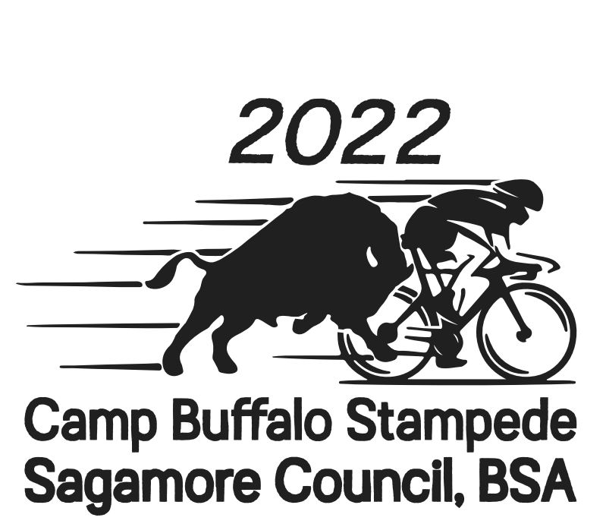
August 27, 2022

What is the Buffalo Stampede?
The 3rd Annual Buffalo Stampede is Cycling Event that is open to the public and all scouts and scouters. The Stampede will be held on Saturday August 27th at Camp Buffalo. Bicycle riders will depart Camp Buffalo beginning at 7:30 a.m. and will take routes exploring the Tippecanoe River Valley. Route distances include a 13 mile ride that is appropriate for cub scouts, younger scouts and families. The 13 mile route is $15 each or a family can register for $40. This cycling event offers route distance options for all members of your unit. The other distances are 28, 52, 63 and 100 miles and are $40 per rider. Early bird discounts ends on June 1st. Event T-Shirts can be purchased for $20 each.

All routes are fully supported with SAG Stops providing water, sports drinks and snacks. All riders can take part in a post ride meal served in the Camp Buffalo Dining Hall.

All participants must provide their own bicycle and wear a helmet at all times while riding.

Scouts wishing to earn Cycling Merit Badge can use the 50 mile ride as the final riding requirement for the road cycling option. By following the training guide posted on the registration page scouts will be able to get all of the rides in that are required.

For Scouts BSA and Venturing Crews that would like to camp, please reserve a Camp Buffalo site on your own, you will need to provide your own leadership.

We also need volunteers to help work the event. You will be appreciated and fed.
For more information please contact me or Mark Bradford.

BUFFALO STAMPEDE TRAINING GUIDE
The date of the Buffalo Stampede is August 27, 2022. The ride options are 13 miles, 28 miles, 52 miles, 100 km, 100 miles.
In order to have a positive cycling experience proper ride training is essential.
That training starts now! Ride training can also incorporate the other required rides for the Cycling MB done on your own or with your unit (but ride training should exceed those rides alone).
Recommended ride-training basics:
Start now!
June 1-30, be riding at least 15 miles per week. This equates to 60 miles by the end of June. As part of these miles, try two 10-mile rides in these weeks. Have as a goal riding at least 10 miles per hour over the length of these 10 mile rides. If doing the Cycling Merit Badge, these two 10-mile rides can be used to satisfy the ride requirements for such.
July 1-31, ride at least 20 miles per week. This equates to 80 miles by the end of July. As part of these miles, try two 15-mile rides in these weeks. Try to work up to 12 mph over the length of these 15 mile rides. If doing the Cycling Merit Badge, these two 15-mile rides can be used to satisfy the ride requirements for such.
August 1-20, ride 25-30 miles per week. This equates to 75-90 miles by August 20. Try a 25 mile-ride during this time span, which can count for one of the Cycling Merit Badge ride requirements for such. Keep advancing your pace to the goal of 13-15 mph under steady effort for the duration of this 25 mile ride.
If you are planning to ride the 100 km or the 100 mile ride – your training should be greater than listed above and you need to have done a single ride of 75 % of the distance 2 to 3 weeks prior to the event. Only experienced scouts with good physical stamina should be able to participate in the 100 km and 100 mile routes.
Before completing any requirements for Cycling Merit Badge – inform your scoutmaster of your desire to earn it and then contact a Cycling Merit Badge Counselor in Sagamore Council.
The 52 mile ride can be used to satisfy the Cycling Merit Badge requirement 7-A3 “Participate in an organized bike tour of at least 50 miles. Ride must be completed in a minimum of eight hours to satisfy the Merit Badge requirement. Afterward, use the tour’s cue sheet to make a map of the ride”.

Camping
For Scouts BSA and Venturing Crews that would like to camp, please reserve a Camp Buffalo site on your own.. You will need to provide your own leadership for camping.

TENTATIVE SCHEDULE

Saturday, August 27
6:30 am Registration begins

7:30 - 9:00 am - 52, 63, 100 mile rides launch
8:00 - 10:30 am - 13 and 28 mile rides launch

12:00 pm - 5:30 pm Post Ride Meal and All You Can Drink Slushies at Camp Buffalo Dining Hall

All riders should be off the course by 5:15 p.m.

ROUTE DESCRIPTIONS
Strava and MMR Route Links are available on the registration page
The date of the Buffalo Stampede is August 27, 2022. The ride options are 13 miles, 28 miles, 52 miles, 100 km, 100 miles.
13 & 28 mile routes launch from Camp Buffalo from 8:00 to 10:30 a.m.
13 mile
Family fun ride. Launching from Camp Buffalo, you’ll turn south when everyone else turns north. Roll by quiet farms, up and over some small hills. This route will have a SAG stop at White Oak UMC at 10 miles (White Oak UMC SAG will not open until 8:30 a.m.) Finishing up you will ride the winding approach as you come back into Camp Buffalo from the east. This friendly route will be enjoyable for kids of all ages. Bring the family out for this ride.
28 mile
The 28 mile route is sure to be a favorite of scouts, scouters and our friends. Launching from Camp Buffalo at 10:00 a.m., you will work your way north then shoot straight, rolling past woods and over sandhills ride then north rolling past fields and farms as you make your way to the sleepy little town of Pulaski for a SAG stop along the banks of the Tippecanoe River. Leaving Pulaski you will work your way back and forth across the river as you return to Camp Buffalo. This route will have a SAG stop at 17 miles and an optional SAG at 4 miles (White Oak UMC SAG will not open until 8:30 a.m.) 416 ft of elevation gain.
52, 100 k, 100 mile routes – Launch from Camp Buffalo between 7:30 - 9:00 a.m. All riders should plan to be off the course by 5:15 p.m.
52 mile
The 52 mile route is available to anyone wanting to check a half century off their list. This great route crosses Tippecanoe River 6 times! After a short exit roll to get you north and east of Camp Buffalo, you will head straight east, rolling past woods and over sandhills to meet up with the Panhandle Pathway and your first planned SAG Stop in Thornhope, IN. Shoot north up the Panhandle and enjoy a SAG Stop in Winamac and then a tour of the town that is capped off with a ride through the beautiful Winamac Town Park that lies in an oxbow of the Tippecanoe River. From there you will make your way east of Winamac traveling past farms and fields. Turning back west your return journey will be twisting and turning as you follow the Tippecanoe River valley to the sleepy little town of Pulaski for a SAG stop along the riverbanks. Leaving Pulaski you will work your way back and forth across the river as you return to Camp Buffalo. This route will have SAG stops at 14, 24, and 40 miles. 600 feet of elevation gain. Scouts BSA members working on Cycling Merit Badge - this ride will fulfill the final riding requirement.
63 mile - Metric Century 100k
Metric Century anyone? This 63 mile (100k) route is slightly more challenging than the 52 mile in both distance and a few more climbs. Like the 52 mile, the route crosses the Tippecanoe River 6 times! This route will begin by following the 13 mile and 100 mile routes before reaching an optional SAG Stop at 10 miles. Meeting up with the Panhandle Pathway you will have your first scheduled SAG at Thornhope at 21 miles. Ride north on the Panhandle Pathway for 10 miles and enjoy another SAG at the Depot in Winamac. A cycling tour of downtown Winamac, leads you east past the Town Park then a rolling tour through the countryside until you turn back west. You’ll meet up with the 52 and 100 mile routes and wind your way down the river to the sleepy little town of Pulaski for a SAG stop along the banks of the Tippecanoe River. Leaving Pulaski you will work your way back and forth across the river following the river valley back to Camp Buffalo. This route has planned SAG Stops at 20, 30, and 50 miles with an optional at 10 miles if needed (White Oak UMC SAG will not open until 8:30 a.m.) 773 feet of elevation gain.
100 mile
The Buffalo Stampede Century. This great route incorporates two rail trails, has the opportunity for an air conditioned SAG Stop at a Harley Davidson dealership and crosses the Tippecanoe River 7 times!
It's an easy start, rolling out of Camp Buffalo. East of Camp Buffalo, you will head north and cross the Tippecanoe River into the sleepy little town of Pulaski for your first scheduled SAG stop at 22 miles. You will make your way out of Pulaski and continue to head north through the farms and fields of Pulaski County and through the town of Ripley, you will then make your way toward Denham and over to Kerstings Cycle Center for your second SAG stop (44 miles) You will then head up to the North Judson Erie Trail. You will jump on the bike trail at the Big Blue Bike and take the trail southeast to the new terminal end. Head South and cross the Tippecanoe River another two times before arriving in downtown Winamac for your third scheduled SAG stop at the depot (70 miles). You will get to ride south on the Panhandle Pathway for 4 miles crossing the Tippecanoe River a 4th time, then a eastward hilly loop through more farms and fields, before joining the 52 and 100k routes for your return to Camp Buffalo. Wind your way down the river to the sleepy little town of Pulaski for a SAG stop along the banks of the Tippecanoe River. Leaving Pulaski you will work your way back and forth across the river following the river valley back to Camp Buffalo. This route has planned SAG Stops at 22, 44, and 70 miles with an optional at 10 miles if needed (White Oak UMC SAG will not open until 8:30 a.m.) . There will also be the option of stopping for a SAG or water refill when you return to Pualski at 90 miles. The Pulaski SAG will close at 3:00 p.m., water will be available until 5:00 p.m. 1073 feet of elevation gain.

