Ghost-Bust-o-ree

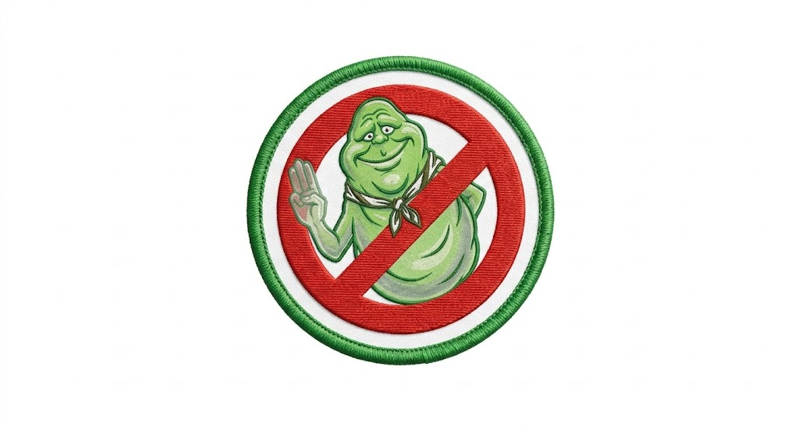

April 17th-19th 2026
Sagamore Council
Spring Camporee

Leaders
Check in at the Ranger Station at the Cary Camp parking lot for Troop Guide Packet. All participants will need completed permission slips (for troop use only), medical forms A, and B for this event. Each troop will keep medical forms for ICE purposes.
Vehicles:
Only troop trailers will be allowed at the campsite during the camporee. All vehicles must return to and be parked at the main parking lot. For the safety of all campers, please do not bring multiple vehicles into camp for setup and teardown.
Uniforms:
The uniform for this camporee is the BSA Field (Class A) Uniform. The Field Uniform is expected for all Scouts and Scouters for the opening Flags and closing ceremonies. The Activity (Class B) Uniforms can be worn during patrol activities and competition. Please stay aware of the weather for Camporee weekend. It is up to the Troops to have weather appropriate clothing on hand.
Campfires:
Campfires will only be allowed in designated campfire ring(s) at each campsite. Troops may request additional fire rings if needed.
Firewood:
Firewood will be provided to each campsite. Carrying in your own firewood
is allowed as well, as long as the firewood has been debarked or USDA approved for transport.
Water:
Each Campsite will have a designated water spigot located near the latrine.
Meals:
It is each troop’s responsibility to provide their own meals during the camporee.
Each troop is responsible for securing their food and trash. There is a dumpster available for trash in the drive near the camp store, packing trash out is not required.
Site Management:
Troops will observe Leave No Trace Principles and follow the Outdoor Code. We want to leave the camp better than we found it.
Facilities:
Each campsite has a designated latrine. There is also a flush restroom located across from the parking lot (See key J on the Cary Camp Map). All scouts and scouters must observe the buddy system and YPT protocols at all times.
Camp Rules:
Following Scouting America Policy, do not bring alcohol or firearms to Scouting America events.
Service dogs are ONLY allowed on Cary Camp property if absolutely necessary with proper documentation provided to Ranger Becky at Rebecca.Wellner@scouting.org BEFORE the event. Absolutely no personal pets on Cary Camp property.
Important Contact information:
Camp Ranger Becky: Rebecca.Wellner@scouting.org 317-442-4592
District Executive and Staff Advisor for event: Darwin Nunn darwin.nunn@scouting.org 865-282-9369
Questions?
Host Troop Contact - Tim Lacey at jtjlacey@yahoo.com 765-714-6218

Ghost-Bust-o-ree Itinerary
Friday – April 17, 2026
5:00 – 7:00pm Registration and “FireHouse” (campsite) set up
8:00pm Lead Ghostbuster meeting
10:00pm quiet time

Saturday – April 18, 2026
6:00 – 8:00am Breakfast
8:30 Opening assembly (dining hall)
9:00 – 9:50 1st activity
10:00 – 10:50 2nd activity
11:00 – 11:50 3rd activity
12:00pm lunch
1:30 – 2:20 4th Activity
2:30 – 3:20 5th activity
3:30 – 4:40 6th Activity
5:00 Dinner
7:30 closing camp fire
8:15 GhostBusters
10:00pm quiet time

Sunday – April 19, 2026
6:00 – 9:30 Breakfast and break down your firehouse

Troop Activities - Scouts

Activity 1: Cross the Streams
Patrols will build two fires 36 inches apart to melt the stay puft marshmallow man strung up 24 inches above the ground between the two fires.
Patrols will need to skewer and hang Stay Puft
Stay Puft is a Class VII Interedimensional Entity, so if he falls or you burn him you will have failed humanity. The only way out of this sticky situation is to melt him out of existence.

Proton pack Training
Patrols will start by training on the use of their proton packs. (Sling shots) Target practice will include ghosts, apparitions and Class 5 Free-Roaming Vapors.
A final test for the marksmen of the patrol will be setting off Ghost traps, both near and far. You might even get a shot at Slimer!

The Keymaster Escape Room
Your Patrol are "guests" at Louis Tully’s apartment. Louis has been possessed by Vinz Clortho (The Keymaster) and has locked the door to keep the Ghostbusters out. The Scouts must find the spare key, "short" the electrical possessed fridge, and escape before the Stay Puft Marshmallow Man steps on the building.

Ecto 1 Breakdown
Ecto 1 has broken down while the patrol was chasing down Gozer’s demon dogs. Your patrol must find their way to Gozer’s Temple using only a cryptic note and their PKE meter. Make your way quickly, but don’t miss any clues or the gate between dimensions will be forever open.

How to Build a Proton Pack
Each patrol must build a proton pack from items available at the You’ll be judged on appearance, functionality and originality. Just leave room for it’s main component, the nuclear accelerator (5 gallon water jug).
Oh, we almost forgot, the nuclear accelerator will need to be carried through an obstacle course without the nuclear accelerator falling out of the proton pack or leaking.

You’ve been Slimed!!
Slimer caught you by surprise and now all of your equipment and the ecto evidence you have collected is covered in slime. How quickly can you remember what you had? Is anything missing? There will be extra points if you can remember each item’s ghost hunting purpose!

Troop Activities – Leaders
If you are up for the challenge; the dining Hall refrigerator is on the fritz. Each time it is opened a mystery box appears; will your box contain items for one of slimer’s favorite dishes, will the Stay Puft Marshmallow man be your inspiration or will your dish require an ecto Plasma containment unit when served! Who knows, who cares, just make something delicious for our Ghostbuster judges to devour and you may walk away with Slimer’s seal of approval!
Rules

All Patrols will be scored on the “Venkman scale”
- 1–4 Points (Total Disaster): "Dogs and cats living together... mass hysteria!" The patrol struggled to function.
- 5–7 Points (Hired Help): "We’re ready to believe you!" Solid effort, basic skills mastered, but room for improvement.
- 8–10 Points (The Professionals): "We came, we saw, we kicked its butt!" Exceptional leadership and scouting skills.
Judges may award up to 10 discretionary points per patrol for:
- Themed Spirit: Does the patrol have a "Ghostbusters" yell or customized uniform pieces?
- Cheerful Service: Are they helping other patrols or keeping the "firehouse" (campsite) clean?
Questions:
Contact tim lacey jtjlacey@yahoo.com or 765-714-6218
Notes:
All the normal Scouting America rules and regulations apply for this campout. Also remember this is an April weekend in Indiana so it’s likely to snow, rain, frost overnight and be 75 degrees at 2pm. so prepare for any and every possibility.
Now on to the important items:
PLease do not bring any Class v or higher apparitions with you, there will be plenty at camp already.
If you are caught roasting a stay puft marshmallow man, you will be required to share. Please make sure you have plenty graham crackers and chocolate.
Also, Do not feed the demon dogs! They are very hard to clean up after.
Finally, Remember You’re a Ghostbuster! So dress and act the part or at least make a patrol flag that incorporates a ghost and maybe a spooky yell.

