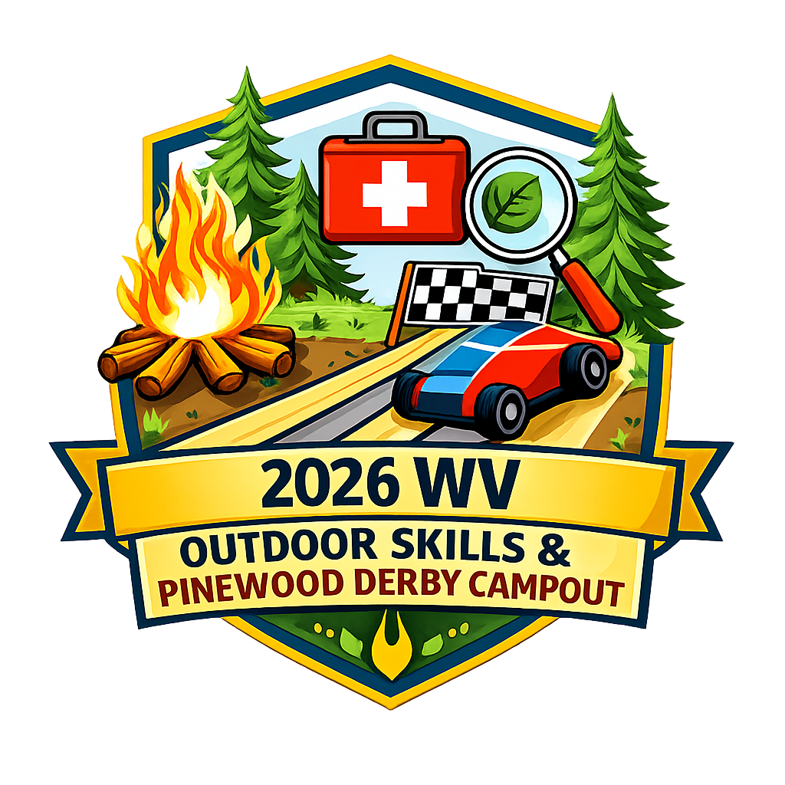

2026 Outdoor Skills & Pinewood Derby Handbook

Event Purpose 3
Communication 3
Adults & Siblings 3
Cub Scouts 3
Details 3
Activities 4
Campsite 4
Packing List – Label Everything 4
For the Day: 4
For the Evening: 4
For overnight: 4
Important Notes for Parent and Packs 5
Weather: 5
Handbooks and Record Keeping: 5
Guide to Safe Scouting: 5
Scouts 5
New Crossovers 5
Tenderfoot and Second Class 5
First Class and Above 5
Campsites 6
Packing List – Label Everything 6
Important Notes for Scouts, Parents, and Troops 6
Weather: 6
Handbooks and Record Keeping: 6
Guide to Safe Scouting: 7
Adult Opportunities 7
BLS CPR and First Aid 7
Adult Boot Camp 7
A Hands On Workshop: My AOL is Now a Scout: HELP! 7
Volunteers 8
Additional Details 8
Arrival and Check Out 8
Parking 8
BSA Health Forms Part A and B 8
Allergies Dietary Needs 8
Differing Abilities 9
Questions? 9

Event Purpose & Handbook Use

Cub Scouts often need repetition of skills. This event allows Cubs to practice those outdoor skills that are an important part of the Scouting program and have the opportunity to race their Pinewood Derby car again. For our Scouts BSA members, this is an opportunity to come and work on non-troop tied rank items, complete conservation service, and/or work on their leadership skills.

For our adults, this event will provide a fun environment to spend time with their Cub, participate in our Parent Boot Camp and/or our hands-on workshop, and/or earn their BLS CPR and First Aid certification.

This event also gives our units a break from having to plan and provide leadership. We of course would love any help adults would like to provide! Volunteers are essential to any event. We just did not want to overburden our units. All Guide to Safe Scouting rules will be observed. You can find details regarding how we are achieving this in the Cub Scout and Scouts BSA section of this handbook.

This handbook is a living document. When we receive questions that may pertain to everyone, we will send out an email or Group Me post and update this handbook. Regardless of which type of attendee you are, we strongly recommend reading the entire handbook and using the Table of Contents for guidance on finding specific information.

Communication

Families can expect to receive a couple of emails before the event reiterating important points. Quick or immediate information will be communicated through the Group Me App. Please join as soon as you register to keep abreast of the latest and greatest about this event.

Adults & Siblings

Cub Scouts and siblings must attend with an adult. If a parent is volunteering, they may ask another adult to assist their Cub or the District Team will arrange for two registered adults to rotate with volunteers’ children. We want to make volunteering as simple as possible, while ensuring the safety of all attending.

Siblings are welcome to participate in the same activities as their Cub siblings, including the Pinewood Derby. Cars must meet derby requirements. All cars and participants must be checked in by 8:30 am Those participating in the derby only will be finished by noon. Awards are at 11:30 am.

For Cub families spending the night, all adults must be either registered Scouting America Leaders or Safeguarding Youth Trained (SYT). It is free to take the training. Click here for simple directions on taking this online training. Of course we would love to have more registered adults! If you are interested, please contact your Cubmaster or Scoutmaster. They would be happy to assist you!

SYT unregistered adults spending the night may not under any circumstances enter the Scouts campsites even if they have a Scout attending the event. This is a BSA policy. Any adult who breaks this policy will be asked to leave. Thank you so much for your understanding! Scouts who are also in Cub families have the option of sleeping with their family in the Cub campsite or sleeping in the Scout campsites.

Unregistered and non-SYT trained adults may attend during the day; however, per Scouting America policy, they will not be able to supervise children other than their own. Thank you for your understanding!

All adults, registered and non-registered, and siblings must register and complete the Annual Health and Medical Form parts A&B.

We are offering several opportunities for attending adults! Please see adult opportunities below.

Cub Scouts

Details
All ranks are invited to attend! The activities are adjusted for each age group and adventures. Cubs must attend with an adult. The only exception is for our volunteers. Please see the Volunteer Section for more details. Cubs may spend the night, leave at 4pm after the day events, or leave after the Campfire Program (approximately 8pm). We need to know who is in camp at all times. It is a safety issue. Please help us by checking out when your family is leaving.

All Cubs must register and submit the BSA Health parts A&B.

Activities
Cubs will participate in a variety of activities. Examples include fire safety, knots, conservation service, campfire songs, knife safety and skills. Lions, Tigers, and Wolves make a wooden pocket knife to practice safety. Bears and Webelos will review safety and practice knife skills. At check-in all families will be given a map and schedule.

Campsite
All Cub families spending the night will be located in the Raisor Shelter field. We would love to add a second campsite! We have a fun evening planned with campfire songs, yummy food, and a relaxed evening with other Cub families. We hope you will consider spending the night. Please remember that all adults spending the night must be either registered or SYT trained. If you would like to try camping, but do not have a tent, please contact Melissa at scout.momma.6@gmail.com or (765) 337-7353. She may be able to help you borrow equipment.

Packing List – Label Everything

For the Day:
- Backpack
- Waterbottle – Please make sure you bring one for each member of the family.
- Pocket Knife (if you have one) – Bears and Webelos Only
- Appropriate clothing for the weather
- The remainder of the Six Essentials

For the Evening:
- Pie Irons if you have them
- Camp Chairs
- Mess Kits are not needed

For overnight:
- Tarp
- Tent
- Sleeping mats or cots
- Sleeping bags and extra blankets
- Pillows
- Toiletries
- PJ
- Change of Clothes
- Great tips for what to pack and rules to keeping warm

Important Notes for Parent and Packs

Weather:
April weather is unpredictable. Please be prepared. Raincoats and layered clothing may be necessary. This Aaron on Scouting article might be helpful. We will be keeping a good eye on the weather and communicating through the Group Me App.

Handbooks and Record Keeping:
Cub Scouts do not need to bring their handbooks. A report will be sent to each unit outlining the requirements and/or service the Cub completed. Each participant’s unit was asked at registration and will be verified at check-in. Cubs who have handbooks should ask their leaders to sign their books. If your Cub does not have a book, no worries! Your Cubmaster will enter all of the requirements that every Cub completed.

Guide to Safe Scouting:
We are committed to ensuring the safety of all participants. We ask that families help ensure that our event is successful. First, all families MUST check in and out. In case of an emergency, we need to know who is at camp. This is an individual registration, meaning it is not a pack registration. An adult is expected to attend with their Cubs. We will ensure that two deep leadership is present at every station. In addition, we will have BALOO trained leadership managing each campsite so that families will have an amazing experience and packs do not have to worry about supplying a BALOO trained leader.

Scouts BSA

New Crossovers
Congratulations on continuing your Scouting journey! We have a wonderful program planned for you. Crossovers will be placed in patrols led by an older and high ranked Scout and engage in non-troop tied rank requirements. There are some requirements that must be completed within your troop. However, there are many that can be accomplished in this event. Attending will be well worth your time. Come and gain experience, work on rank, and make friends.

Tenderfoot and Second Class
We are excited to help you achieve your rank goals. Scouts will be able to work on non-troop tied rank requirements. At this event, you will be placed in a patrol led by a First Class or higher ranked Scout. We will have programming set up so that you may work on requirements that may be completed outside of the troop. We want to help you achieve your goals! This event will be well worth your time.

First Class and Above
We would love for you to join our staff! We are seeking First Class rank Scouts and above to lead patrols of Crossovers and Tenderfoot and Second Class Scouts. We also are looking for two SPLs, one male and one female. There is no charge to you and all meals are provided. We appreciate your help. If your Scoutmaster approves this event for service hours, we will provide a written letter regarding your participation. You will need to register and submit your BSA Health Form Parts A&B. You will not be charged.

Campsites
There will be two different campsites for Scouts BSA. The male scouts will camp at Moser Field and the female scouts will camp by the Newell Shelter. Scouts will be asked to bring a tent. We will allow scouts to sleep alone or we will assign them to a tent mate that is within the two years of age required. Each Scout family will be contacted in advance to facilitate this process and ensure that all Scouts feel comfortable. The evening will be more laid back with a campfire program, skits, and yummy food. We want this to be a very positive experience for the Scouts.

Packing List – Label Everything

- Backpack
- Handbook secured in a container or baggie to protect it from the elements
- Waterbottle – Please make sure you bring one for each member of the family.
- Appropriate clothing for the weather. Check out this article about layering. April weather is unpredictable.
- The remainder of the 10 Basic Outdoor Essentials except the map. We will supply any maps needed.
- Pie Irons if you have them
- Mess Kits
- Camp Chair
- Tarp
- Tent – if you do not own one, please contact Melissa (scout.momma.6@gmail.com (765) 337-7353). She may be able to help you borrow one.
- Sleeping mats or cots
- Sleeping bags and extra blankets
- Pillows
- Toiletries
- PJ
- Change of Clothes
- Great tips for what to pack and rules to keeping warm

Important Notes for Scouts, Parents, and Troops

Weather:
April weather is unpredictable. Please be prepared. Raincoats and layered clothing may be necessary. This Aaron on Scouting article might be helpful. We will be keeping a good eye on the weather and communicating through the Group Me App.

Handbooks and Record Keeping:
Scouts must bring their handbooks. Our patrol leaders and SPLs will sign off on non-troop tied requirements. This is especially important for the Crossovers to get in the habit of asking for a signature and answering any questions the Scout leaders have. In addition, a report will be sent to each unit outlining the requirements each Scout completed. We will be offering conservation service as well. We will note any completed service as well. Each participant’s unit was asked at registration and will be verified at check-in.

Guide to Safe Scouting:
We are committed to ensuring the safety of all participants. We ask that all Scouts help ensure that our event is successful. First, all Scouts (participants and staff) MUST check in and out of camp. In case of an emergency, we need to know who is at camp.

This is an individual registration event, meaning it is not a troop registration. We will ensure that two deep leadership supervises every patrol. In addition, we will have IOLS trained leadership managing each activity area and the campsites so that Scouts will have an amazing experience and Scout troop leaders do not have to worry about providing adults for the event. Of course, we would welcome any help registered adults offer, but we are alleviating troops for this event with the responsibility of providing troop leadership at the event.

All Scouts attending the event at no cost, but they must register and submit a BSA Health Form Parts A&B.

Adult Opportunities
There is no additional cost for any of the adult opportunities except BLS CPR and First Aid.

BLS CPR and First Aid
Adults and First Class Scouts and above may take this course from 1:00-4:00 pm on Saturday. Attendees or volunteers may take the course for $30 in addition to event fees. So, adult attendees pay $40 total and volunteers pay $30 for the class. This is an amazing opportunity. Space is limited so register quickly.

Adult Boot Camp
Experienced Scouters will show you what it is like to be a scout. This event wonderfully provides insight into the Scouting America program. Reexperience your childhood camping and/or Scouting days or experience what it means to be a Scout for the first time. No experience necessary! Adults participating in this camp may also attend the hands-on workshop.

Adults attend Boot Camp should follow the Scout packing list above. If you do not own some of this equipment, please reach out to Melissa. She will help you borrow what you need. Please do not let supplies prevent you from joining this amazing experience!

A Hands On Workshop: My AOL is Now a Scout: HELP!
There is nothing worse than not knowing what to expect or feeling unsure how you can help your Scout! This hands-on and informative workshop will not disappoint. Learn the ins and out of becoming a Scout parent, gain confidence, and feel secure in how you can help your Scout and their unit. Crossover parents will not want to miss this opportunity! Webelo parents and any other Scout parent are also welcome. Maybe you want to get a head start or learn something new. All are welcome! There is no additional charge for this workshop.

Volunteers

We are so grateful for our volunteers! Without them this event would not be possible. If you can share an hour or the entire event, we have a role for you! No experience needed. BSA registered adults may help in any program area. Non-BSA registered adults are welcome to help in a non-program area. We would love your assistance! Contact Melissa at scout.momma.6@gmail.com or (765) 337-7353 for more information on how you can help.

All volunteers attending the event at no cost, but they must register and submit a BSA Health Form Parts A&B.

Additional Details

Arrival and Check Out
Checking in and out of camp is required. This is a safety issue. Check in will begin at 7:30 am and conclude at 8:30 am. All Pinewood Derby Cars must be checked in by 8:30 am. We will have signs directing attendees. Derby only participants may check out following awards at
11:30. Attendees remaining for the remainder of the event may check out at 4:00 pm following the Outdoor Skills, at approximately 8:00 pm following the Campfire Program, or at the conclusion of the Campout at 10:00 am. If you need to arrive or leave at a different time, please communicate those details to Melissa (scout.momma.6@gmail.com (765) 337-7353) as soon as possible. You will still need to check in and out.

Parking
Parking is available in the designated grass lot to the right of the drive into camp. There will be signs and cones to direct you.

BSA Health Forms Part A and B
All adults, registered and non-registered, and siblings must register and complete the Annual Health and Medical Form parts A&B.

Allergies Dietary Needs
The Wabash Valley District Committee firmly believes in ensuring that every attendee has a wonderful time. This includes making sure that meals are nutritious and allergies and dietary needs are honored to the best of our ability and in a manner that creates a positive meal experience. This also extends to children with Autism who have a limited number of foods they can eat.

In addition to noting this information in your registration, we ask that you also complete this short form to allow our kitchen staff to prepare adequately. We appreciate your help.

Differing Abilities
All Cub, Scouts, and all attendees and volunteers have the right to have a positive experience. Our team is committed to working with our attendees that have differing abilities whether they be physical, emotional, behavioral, intellectual, or a combination. Many of our staff have experience with those with differing abilities. In order to help us accommodate our attendees with differing abilities, please complete this form in addition to listing needs in your registration. The more information we have, the better we can assist our attendees. This information is kept confidential and is only shared with our volunteer staff on a need to know basis.

Questions?

If you have questions or concerns, please do not hesitate to reach out! This is the first year putting together a combined district event. We learn from all questions and constructive concerns and feedback! We want to make sure that every potential attendee has all of the information they need.

Melissa Young-Spillers Geoff Gooch Darwin Nunn
scout.momma.6@gmail.com wdwmedia@gmail.com darwin.nunn@scouting.org
(765) 337-7353

