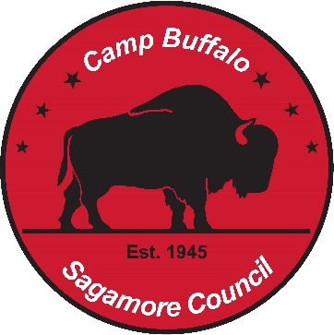

Camp Buffalo Summer Camp
2026 Class List, as of December 1, 2025

Aquatics
Swimming
Lifesaving
Snorkeling (Patch)
Instructional Swim
Brownsea Aquatics
Canoeing
Kayaking
Rowing
Stand-up Paddle Board (Patch)

Brownsea Island
Rank: Scout & Tenderfoot
Rank: Second Class
Rank: First Class, plus Fingerprinting MB
Fire Safety
Paul Bunyan Award
Totin’ & Firem’n Chits

Eagle Quest
Chemistry
Chess
Communications
Public Speaking
Disability Awareness
Emergency Preparedness
First Aid
Ecology
Bird Study
Environmental Science
Fish & Wildlife Management
Forestry
Mammal Study
Nature
Oceanography
Pul & Paper
Soil & Water Conservation
Space exploration
Astronomy
Sustainability
Weather

Handicrafts
Art
Leatherwork
Model Design & Building
Needlework (Test Lab)
Painting
Pottery
Sculpture
Textiles

Outdoor Skills
Camping
Cycling
Fishing
Geocaching
Orienteering
Pioneering
Search & Rescue
Wilderness Survival

Range & Target Sports
Archery
Rifle
Shotgun

Skilled Trades
Electricity
Metalwork
Plumbing
Surveying
Welding

Other
ATV Safety Course

Adult Training
Wilderness First Aid
(Week 2 only)

