Welcome to Scouting! Our mission is to prepare young people to make ethical and moral choices over their lifetime by instilling in them the values of the Scout Oath and Law. We know that kids don’t join Scouts for character building - they join because it’s fun. Your child will learn great life lessons, but they will be far too busy having fun to notice! This sheet gives a quick glimpse of how this works.

Cub Scouts is our program for boys and girls from Kindergarten to 5th grade (ages 5 -10). Cub Scouts are organized into Packs. Each Pack has a community organization that sponsors them and provides space for meetings to occur. Packs are made up of Dens. Each Den is a small group of Scouts that are the same grade/age.

Your Scout is a Member of An Arrow of Light Den...
The Arrow of Light (AOL) den is made up of no more than eight boys and/or girls who are in 5th grade. The den typically meets every week. Some den meetings may be a fun and educational field trip. Parents or guardians are encouraged to attend meetings to assist the Den Leader.

Your Scout is a Member of a Cub Scout Pack...
Dens meet together once a month for a pack meeting. The Cubmaster leads the meeting, but each den will have a part. Most months will be devoted to recognizing the Scouts for the projects they have completed, by presenting them with adventure pins or belt loops, or rank advancement patches. Some months, the pack meeting will have a special theme such as Pinewood Derby, Blue & Gold Banquet, or guest speakers.

REQUIRED  ADVENTURE TOPICS |  | ELECTIVE  ADVENTURE TOPICS
Scouting Basics |  | Science – Forestry
Outdoors |  | Technology – High Tech Outdoors
Personal Fitness |  | Engineering – Engineer
Citizenship |  | Math – Estimations
Personal Safety |  | Pinewood Derby Racing
Family/Reverence |  | Fishing
 |  | Cycling
 |  | Swimming
 |  | Camping
 |  | Conservation
 |  | BB Guns
 |  | Archery
 |  | Slingshot
 |  | Wildlife Studies
 |  | Canoeing
 |  | Knife Safety
Your Scout will earn the AOL badge of rank...
Adventures are a hallmark of every level of the Scouting program. But in Cub Scouting, the word takes on a special meaning. For each badge of rank, Cub Scouts must complete a series of Adventures, which are collections of themed activities on specific topics.

To earn the AOL Rank, your Scout will complete six required Adventures and two or more elective Adventures. Cub Scouts work on Adventures with their Den, Pack, and/or family.

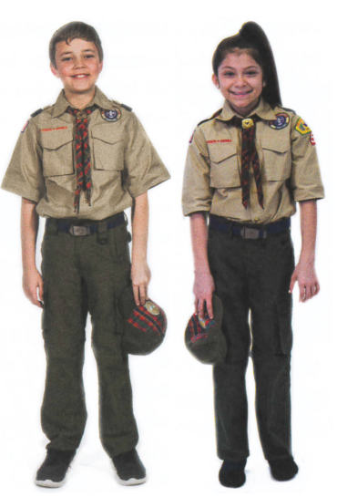
Your Scout may wear the AOL Cub Uniform…
The Boy Scouts of America has always been a uniformed body. Its uniforms help to create a sense of belonging. The formal AOL uniform is a tan Scouts BSA uniform with a checkered AOL hat and neckerchief.

THE SCOUT OATH
On my honor I will do my best
To do my duty to God and my country and to obey the Scout Law;
To help other people at all times;
To keep myself physically strong, mentally awake, and morally straight.

THE SCOUT LAW
A Scout is: Trustworthy, Loyal, Helpful, Friendly, Courteous, Kind, Obedient, Cheerful, Thrifty, Brave, Clean, and Reverent.

