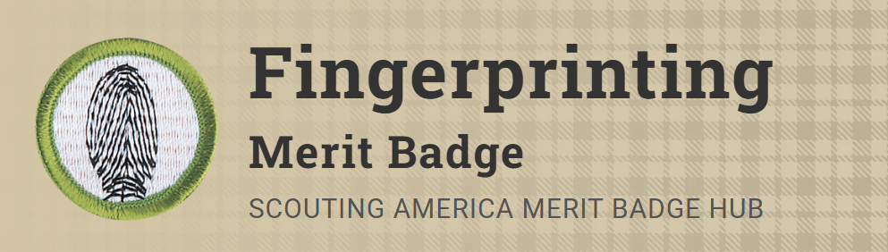
Merit Badge Counselor: Katrina Glass, katrina.glass@5creeks.org
Link: https://www.scouting.org/merit-badges/fingerprinting/
In earning the Fingerprinting merit badge, Scouts will learn about and use an important technique that is used by law enforcement officers, along with other materials like matching dental records and DNA sampling, to help identify amnesia victims, missing persons, abducted children, and others.
Pre-Requisites
None.

