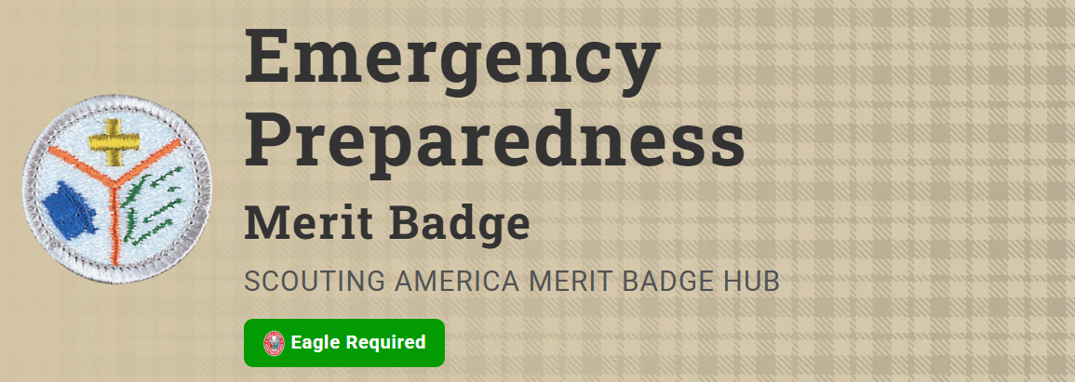
Merit Badge Counselor: Gavan Burke, gavan.burke@live.com
Link: https://www.scouting.org/merit-badges/emergency-preparedness/
Scouts are often called upon to help because they know first aid and they know about the discipline and planning needed to react to an emergency situation. Earning this merit badge helps a Scout to be prepared by learning the actions that can be helpful and needed before, during, and after an emergency.
Pre-Requisites
Earn the First Aid merit badge.
2. Planning for Family Emergencies. Do the following:
- (a) At a family meeting, discuss the situations on the chart you created for requirement 1(b) and make emergency plans for sheltering-in-place and for evacuation of your home. Discuss your family meeting and plans with your counselor.
Resources: How to Shelter in Place (video)
How to Evacuate From Wildfires (video)
- (b) Develop and practice a plan of escape for your family in case of fire in your home. Draw a floor plan with escape routes and a map with a safe meeting place. Discuss your family's home escape plan with your counselor.
Resources: Home Fire Safety Checklist (PDF)
Home Fire Escape Plan (PDF)
Plan Your Escape: High-Rise Apartment Fire (video)

