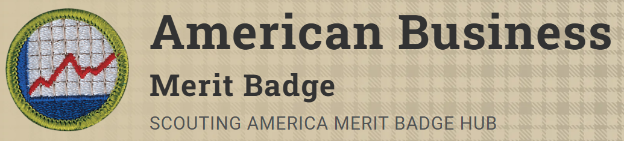
Merit Badge Counselor: Justin Clifton, jrclifton1@gmail.com
Link: https://www.scouting.org/merit-badges/american-business/
Earning the American Business merit badge can help Scouts learn practical business matters that will be useful throughout life. Learning how businesses function will help you understand society and uncover a number of career options.
Pre-Requisites
6. Do the following:
b. Select a business leader and interview this individual to learn more about his or her company and career path. Discuss the role ethics plays in making business decisions. Share what you have learned with your counselor.

