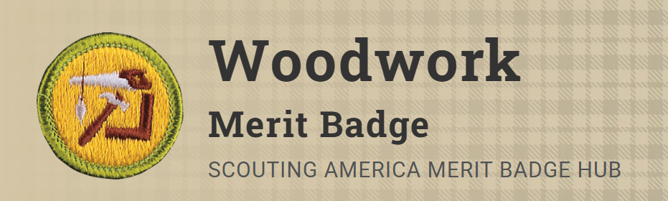
Merit Badge Counselor: Josh Shepherd, josh.shepherd@scouting.org
Link: https://www.scouting.org/merit-badges/woodwork/
Pre-Requisites:
6. Do ONE of the following:
(a) Make working drawings of a project needing beveled or rounded edges and build it.
Resources: Bevels- How to Make Beveled Panels on the Tablesaw (video)
Rounded Edges- How to Rout Round Corners (video)
(b) Make working drawings of a project needing curved or incised cuttings and build it.
Resource: Making Arcs & Curves the Easy Way (video)
(c) Make working drawings of a project needing miter, dowel, or mortise and tenon joints and build it.
Resource: Mitered Mortise & Tenon Joint (video)
(e) Help make wooden toys for underprivileged children OR help carry out a woodworking service project approved by your counselor for a charitable organization.
Resource: How To Make Wooden Toys for Kids | DIY | Great Home Ideas (video)

