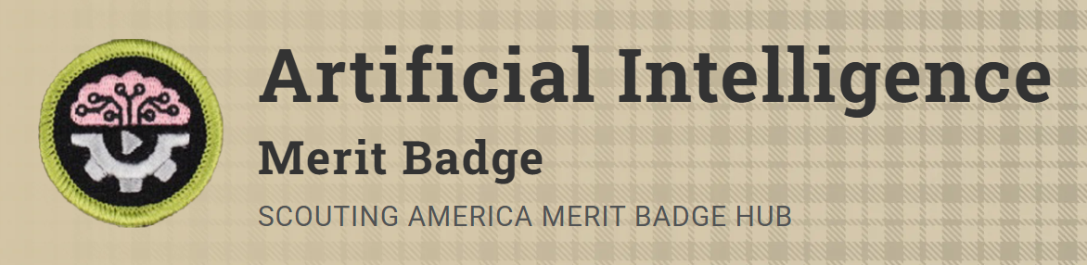
Merit Badge Counselor: Josh Shepherd, josh.shepherd@scouting.org
Link: https://www.scouting.org/merit-badges/artificial-intelligence/
Pre-Requisites:
7. Practical Application. Do ONE of the following:
(a) With your counselor's approval, choose an artificial intelligence project based on your personal interest or a community need. Develop a plan outlining the project's objectives, data requirements, and potential ethical considerations. Implement the project utilizing appropriate artificial intelligence tools, languages, or platforms. Share your project with your counselor. Discuss the steps you followed to create the project and your experience during the process.
(b) With your counselor's approval, design a short lesson plan on AI and teach it to your patrol or a group of Scouts. The lesson should include an AI-generated age-appropriate explanation of AI, examples of how AI is used in both everyday life as well as in the workplace, and an interactive demonstration of how Scouts could utilize AI to assist them with a school assignment, Scouting activity, or rank advancement. Share information on the development process and teaching experience with your counselor.

