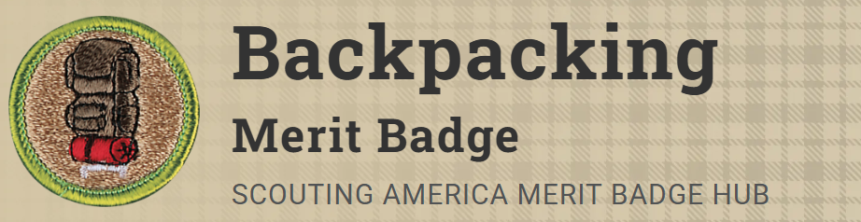
Merit Badge Counselor: Doug Waterfield, djw@iquest.net
Link: https://www.scouting.org/merit-badges/backpacking/
Earning the Backpacking merit badge will be demanding but rewarding. Scouts will learn what equipment to carry on their backs and what knowledge to have in their heads. In addition, Scouts will discover how to protect the environment by traveling and camping without leaving a trace. By mastering the basics of backpacking, Scouts will develop an even deeper respect for the outdoors.
Important: These are POST requisites. A completed MB will NOT be issued, unless proof of requirements is provided.
Pre-Requisites
1. Do the following:
(a) Write a plan for a backpacking trek of at least five days using at least three different campsites and covering at least 30 miles. Your plan must include a description of and route to the trek area, a schedule (including a daily schedule), a list of food and equipment needs, a safety and emergency plan, and a budget.
(b) Following the Leave No Trace Seven Principles and the Outdoor Code, take the trek as planned in requirement 11(a) that is at least five full days, covering at least 30 miles and utilizing at least three different campsites. While on trek, complete at least one service project approved by your counselor.
(c) Keep a daily journal during the trek that includes a day-by-day description of your activities, including notes about what worked well and thoughts about improvements that could be made for the next trek.
8. Do the following:
(c) Prepare three meals using a stove and fuel you can carry in a backpack.
9. Do the following:
(a) Write a plan that includes a schedule for a patrol/crew backpacking hike of at least 2 miles.
(b) Conduct a pre-hike inspection of the patrol and its equipment.
(c) Show that you know how to properly pack your personal gear and your share of the crew's gear and food.
(d) Show you can properly shoulder your pack and adjust it for proper wear.
(e) While using the plan you developed for requirement 9(a), carry your fully loaded pack to complete a hike of at least 2 miles.
10. Following the Leave No Trace Seven Principles and the Outdoor Code, participate in at least three backpacking treks of at least three days each and at least 15 miles each, and using at least two different campsites on each trek. Carry everything you will need throughout the trek.

