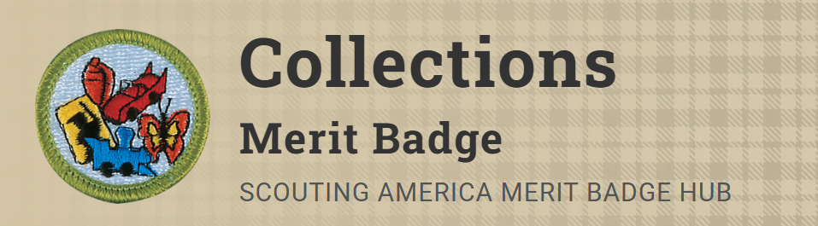
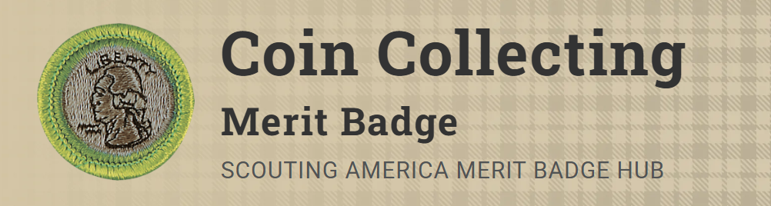
Merit Badge Counselor: Brian Forster, brian.n.forster@gmail.com
Links: https://www.scouting.org/merit-badges/collections/
https://www.scouting.org/merit-badges/coin-collecting/
Discover how collecting can be an educational and financially rewarding pastime with the Collections Merit Badge. Scouts will prepare a brief written report, give a detailed description, and explain the development of their collection while demonstrating the knowledge of preserving and displaying their most prized possessions.
Coin collecting is one of the oldest of all hobbies. Hoards of ancient coins found in excavations indicate that coins were one of the first collectibles. From earliest times, people valued coins not only as a means of trading and storing wealth, but also as miniature works of art.
*Collections – coin collecting and stamp collecting are excluded from eligibility for this merit badge.
Materials Needed:
Bring a part of your collection and include photos.
Bring full coin collection.
Pre-Requisites:
COLLECTIONS
- Prepare a short written report or outline for your counselor, giving a detailed description of your collection, including a short history, why you enjoy your collection, and what you have learned from collecting. Be sure to include why you chose that particular type of collection/collecting method.
Resources: The Invention of Collecting (video)
246 Cool Things to Collect (Collection Ideas) (website)
Meet Reece, King of the Fans | My Kid's Obsession (video)
4. Demonstrate your knowledge of collecting and investing. Discuss with your counselor (Research prior to):
Resources: 5 Smart Tips for Collecting Pokemon Cards on a Budget (video)
Contemplatiing Collectible Investments (website)
(a) How investing and speculation would apply to your collection
Resources: Find Investments to Meet Your Financial Goals (website)
Collecting Tips 101: Tip #48 Predicting Rare Games (video)
(b) What you would look for in purchasing other collections similar to yours
(c) What you would expect in return value if you decided to sell all or part of the collection
Resource: What's it Worth - Free Antiques & Collectables Price Guide (website)
5. Do the following (Research prior to):
(c) Explain the monetary value of your collection and where you learned about those values.
Resources: How to Find Out What It's Worth (website)
How Much Are My Collectibles Worth? Tips for Finding Values (website)
(d) Explain how your collection is graded for value, physical defects, size, and age. Show the various classifications or ratings used in your collection.
Resource: Understanding Museum Quality in Collectibles and Artifacts (website)
(e) List the national, state, or local association(s) related to or associated with your collection.
Resource: Antiques & Collectibles National Association Directory (website)

7. Find out about career opportunities in collecting. Pick one and find out the education, training, and experience required for this profession. Discuss this with your counselor, and explain why this profession might interest you.
Resources: Curators, Conservators, and Museum Workers Careers (video)
Dream Jobs: Antiquer (video)

COIN COLLECTING
4. Do the following and explain to your counselor the design features, designer name, designer initials, and where to find them for each item:
Resource: Coin Collecting 101 for Beginners: What You Need to Know to Start Coin Collecting (video)
(a) Collect a one-cent coin from the year group: 1959-2008 (that is, dated between 1959 and 2008) and a one-cent coin from the year group 2010-present. Explain how and why the one-cent coins issued in 2009 were different from either of the other two year groups.
(b) Collect two five-cent coins, one from each of these year groups: 1959-2003 and 2006-present. Explain how and why the five-cent coins issued in 2004-2005 were different from either of the other two year groups.
(c) Collect a ten-cent coin from 1965-present.
(d) Collect a twenty-five-cent coin from 1965-1998, two examples from the 50-State Quarter®/territories Program 1999-2009, two designs from the America the Beautiful® program 2010-2021 and two designs from the American Women Quarter® program (2022-2024). Explain the purpose of each of those programs.
Resources: Collecting State Quarters (video)
America the Beautiful Quarters® Program (video)
American Women Quarters® Program (video)
(e) Collect a half dollar coin from 1965-present.
7. Do ONE of the following:
(a) Collect and identify for your counselor 20 different world coins from at least seven different countries. Identify the country, major design elements, and denomination of each.
(b) Collect and identify for your counselor 20 different world paper money from at least seven different countries. Identify the country, major design elements, and denomination of each.
(c) Collect and identify for your counselor 20 different tokens and/or medals. Identify the issuer and use of each.
Resource: Exonumia (Tokens and Medals) (website)
(d) Complete one of the following and report to your counselor what you experienced:
(1) Attend a coin show
Resource: National and Regional Coin Shows for Collectors (website)
(2) Attend a coin club meeting
Resource: Local Coin Club Directory (website)
(3) Tour a U.S. Mint facility or museum
Resource: US Mint Locations in the US (website)
(4) Tour a virtual exhibit (with your parent or guardian's permission) approved by your counselor
Resources: Virtual Tours (website)
History of Money Exhibit (website)
Medal in America Exhibit (website)

