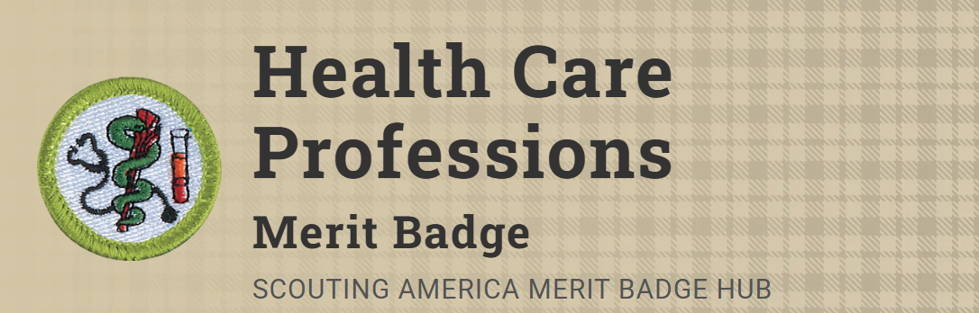
Merit Badge Counselor: Robert Allen, roberttoddallen2377@gmail.com
Link: https://www.scouting.org/merit-badges/health-care-professions/
Explore the different types of the healthcare fields and professions with the Health Care Professions Merit Badge. Scouts will learn how professionals in different health care fields work together to keep people healthy. The Health Care Professions Merit Badge generates excitement for a possible career in the healthcare industry.
Pre-Requisites
8. Identify a medical advancement or discovery that has been in the news recently. Discuss with your counselor how this can affect patient care.
Resources: Top Medical Breakthroughs of 2025 (video)
How AI Is Transforming Healthcare Across the Country (video)
Cutting-Edge Medical Advances To Come in 2026 (video)
9. With your parent or guardian's and counselor's approval, serve as a volunteer at a health-related event or facility in your community (e.g. blood drive, health fair, blood pressure screening event). Report to your counselor what you did and learned from the experience.

