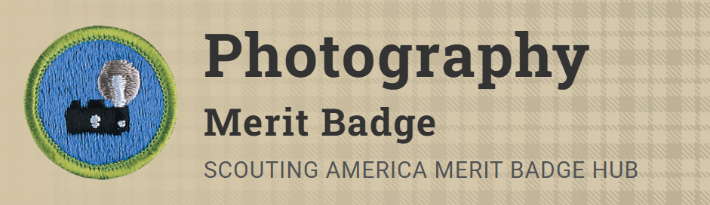
Merit Badge Counselor: Kris, Julius
Link: https://www.scouting.org/merit-badges/photography/
Beyond capturing family memories, photography offers a chance to be creative. Many photographers use photography to express their creativity, using lighting, composition, depth, color, and content to make their photographs into more than snapshots. Good photographs tell us about a person, a news event, a product, a place, a scientific breakthrough, an endangered animal, or a time in history.
Pre-Requisites
6. Describe how software allows you to enhance your photograph after it is taken. Select a photo you have taken, then do ONE of the following, and share what you have done with your counselor:
Resource: PHOTO EDITING FOR BEGINNERS - 9 Simple Steps to Improve Your Photos (video)
- (a) Crop your photograph.
- (b) Adjust the exposure or make a color correction.
- (c) Show another way you could improve your picture for impact.
7. Using images other than those created for requirements 4, 5, and 6, produce a visual story to document an event to photograph OR choose a topic that interests you to photograph. Do the following:
- (a) Plan the images you need to photograph for your photo story.
Resource: Storytelling in Photography (video)
- (b) Share your plan with your counselor, and get your counselor's input and approval before you proceed.
- (c) Select eight to 12 images that best tell your story. Arrange your images in order and mount the prints on a poster board OR create an electronic presentation. Share your visual story with your counselor.
Resource: How to Make a PowerPoint Photo Slideshow (video)
8. Identify three career opportunities in photography. Pick one and explain to your counselor how to prepare for such a career. Discuss what education and training are required, and why this profession might interest you.
Resources: Top 10 Careers For Photographers (video)
Indeed Career Guide (website)

