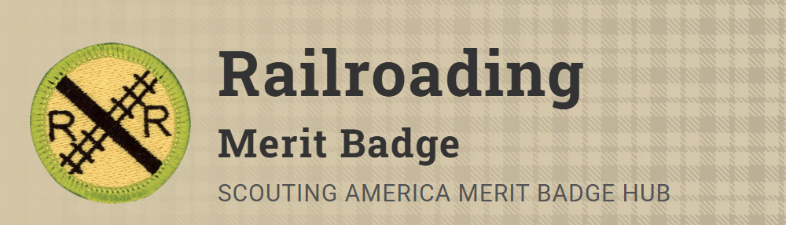
Merit Badge Counselor: Ashton Compton, 2003indyash@gmail.com
Link: https://www.scouting.org/merit-badges/railroading/
By earning this badge, Scouts can learn about the history of railroading, its place in modern society, careers in railroading, and hobbies related to railroading.
Pre-Requisites
7. Do ONE of the following special-interest options:
(a) Option A—Model Railroading. With your parent or guardian's and counselor's approval, do TWO of the following:
(1) Draw a layout of your own model railroad or one that could be built in your home. Design a point-to-point track or loop with different routings. Include one of the following: turnaround or terminal or yard or siding.
Resources: Layout Planning (website)
Model Railroad Layout Design for Beginners (video)
Five Starter Track Plans That Make Model Railroading Fun (website)
(2) Build one model railroad car kit or one locomotive kit.
Resources: Modeling Safety (website)
Model Railroading Safety and Etiquette (website)
Tools (website)
(3) Name the scale of four popular model railroad gauges. Identify the scale of four model cars or locomotives.
Resource: Comparing Model Train Scales: T, Z, N, Tt, Ho, S, O, G Scales (video)
(4) Locate the websites of four model railroad-related manufacturers or magazine publishers. Print information about their products and services, and discuss the information with your counselor.
(5) Build one railroad structure (from scratch or using a kit), paint and weather the structure, mount it on your layout or diorama, and make the surrounding area on the diorama scenic.
Resources: Weather Plastic Kit Buildings Easy—Detailed Guide DIY (video)
Structures (website)
Weathering (website)
(6) Alone or with others, build a model railroad or modular layout including ballast and scenery. Make electrical connections and operate a train. Describe what you enjoyed most.
Resources: How To Ballast Your Track—Model Railway Basics: Episode Six (video)
Scenery (website)
(7) Participate in a switching contest on a timesaver layout and record your time.
Resources: Fun With Model Train Switching Puzzles (video)
Switching Puzzle—Timesaver (Timelapse) (video)
Classic Switching Puzzles — John Allen's Timesaver (website)
(8) Explain the difference between powering and controlling a model railroad by using direct current, and powering and controlling a model railroad using digital command control.
Resources: Differences Between DC and DCC HO Locomotives (video)
DC vs. DCC: What's Best for Your Model Railroad?! (video)
Adding Power (website)
(b) Option B—Railfanning. With your parent or guardian's and counselor's approval, do TWO of the following:
(1) Visit a railroad museum, historical display, or a prototype railroad-sponsored public event. With permission, photograph, digitally record, or sketch items of interest. Explain what you saw and describe your photos, sketches, or video.
Resources: Railroading Museums in the US (website)
Railroad Museum Etiquette (video)
(2) Purchase tickets and ride a scenic or historic railroad. Under supervision, photograph the equipment and discuss with your counselor the historic significance of the operation.
(3) Locate the website of four rail historical groups, then find information on the history of the rail preservation operations and purpose of each group. Talk with a member of one of the groups and find out how you might help.
(4) Plan a trip by rail between two points. Obtain a schedule and explain when the train should arrive at two intermediate points. Purchase the tickets and make the trip. Explain to your counselor what you saw.

