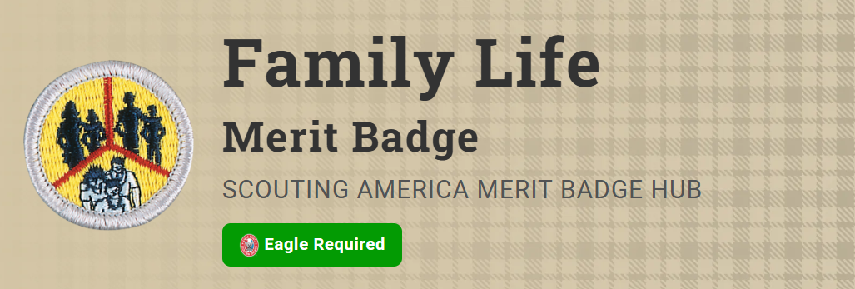
Merit Badge Counselor: Michael Hutton, michaelahutto@gmail.com
Link: https://www.scouting.org/merit-badges/family-life/
The family is the basic unit of society and is important to both individuals and communities. The world is rapidly changing, making today's society much more complex than ever before. As Scouts earn this merit badge, they will realize why it is important to know more about family life and how to strengthen their families.
Pre-Requisites
1. Prepare an outline on what a family is and discuss this with your counselor. Tell why families are important to individuals and to society. Discuss how the actions of one member can affect other members.
Resources: Why Family Matters in Shaping Teens' Passions and Identity (podcast)
Introduction to Family Life (video)
3. Prepare a list of your regular home duties or chores (at least five) and do them for 90 days. Keep a record of how often you do each of them*. Discuss with your counselor the effect your chores had on your family.
*Example - Page 8: http://usscouts.org/mb/worksheets/Family-Life.pdf
Resources: 10 Chores for Teens That Teach Them to Be Responsible Lifelong (video)
Family Chores (video)
Create a Household Chore Checklist in Word - Quick and Easy (video)
Family Chores App (app)
Chore and Allowance App (app)
4. With the approval of your parent or guardian and your counselor*, decide on and carry out an individual project that you would do around the home that would benefit your family. After completion, discuss the objective or goal and the results of the project with your family and then your counselor.
* You must document the project with before, during and after photographs.
Resources: Handy Teen Finishes House (video)
How to Start a Project (video)
5. Plan and carry out a project that involves the participation of your family. After completing the project, discuss the following with your counselor:
Resource: Time Management (video)
- (a) The objective or goal of the project
- (b) How individual members of your family participated
- (c) The results of the project
6. Do the following:
Note: Some of the issues surrounding requirement 6 for the family meeting could be considered of a personal nature. Use discretion when reviewing this requirement with the Scout.
Discussion of each of these subjects will very likely carry over to more than one family meeting.
(b) Prepare a meeting agenda that includes the following topics, review it with your parent or guardian, and then carry out one or more family meetings:
(1) How living the principles of the Scout Oath and Scout Law contributes to your family life
Resource: Scout Oath and Law (website)
(2) The greatest dangers and addictions facing youth in today's society (examples include mental health challenges, use of tobacco products, alcohol, or drugs and other items such as debts, social media, etc.)
Resources: What Causes Addiction, and Why Is It So Hard to Treat? (video)
Teens and Social Media (video)
Electronic Cigarettes and Vaping (video)
How to Identify the Signs of an Unhealthy Relationship (podcast)
How Do I Start a Conversation About Mental Health? (podcast)
Digital Safety and Online Scouting Activities (website)
Bullying Awareness (website)
(3) Discuss with a parent or guardian how bodily changes can affect the choices you make as you physically and mentally mature.
(4) Personal and family finances
Resources: Money Management (video)
The 50-30-20 Rule - Budgeting for Needs, Wants, and Savings (video)
(5) A crisis situation within your family and whom you can turn to for support during these situations.
Resource: Family Bonding (video)
(6) The effect of technology on your family
Resource: Evolving Technology: Will Family Life Ever Be the Same Again? (video)
(7) Good etiquette and manners
Resource: Etiquette (video)

