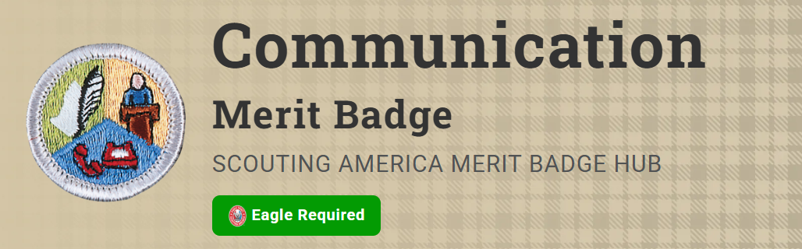
Merit Badge Counselor: Michael Hutto, michaelahutto@gmail.com
Link: https://www.scouting.org/merit-badges/communication/
This clear and concise definition comes from the U.S. Department of Education: "Communication focuses on how people use messages to generate meanings within and across various contexts, cultures, channels, and media. The field of communication promotes the effective and ethical practice of human communication."
Pre-Requisites
- Do ONE of the following:
(a) For one day, keep a log in which you describe your communication activities. Keep track of the time and different ways you spend communicating, such as talking person-to-person, listening to teachers, listening to the radio or podcasts, watching television, using social media, reading books and other print media, and using any electronic communication device. Discuss with your counselor what your log reveals about the importance of communication in your life. Think of ways to improve your communication skills.
Resources: Active Listening (video)
Download a Communication Log Template (PDF)
(b) For three days, keep a journal of your listening experiences. Identify one example of each of the following, and discuss with your counselor when you have listened to each: obtain information, be persuaded, appreciate or enjoy something, and understand someone's feelings.
Resources: Informative Speech (video)
What is Persuation (video)
Want to Add More Joy to Your Life? Here's How (video)
Listening Skills for Conflict Resolution (video)
How to Improve Your Listening Skills (video)
(c) In a small-group setting, meet with other Scouts or with friends. Have them share personal stories about significant events in their lives that affected them in some way. Take note of how each Scout participates in the group discussion and how effectively each Scout communicates their story. Report what you have learned to your counselor about the differences you observed in effective communication.
Resource: How to Ask Good Questions (video)
(d) List as many ways as you can think of to communicate with others (face-to-face, by telephone, letter, email, text messages, social media, and so on). For each type of communication, discuss with your counselor an instance when that method might not be appropriate or effective.
Resources: Communication Skills (video)
Communicating While Scuba Diving (website)
Communicating While Climbing (website)
2. Do ONE of the following:
(a) Think of a creative way to describe yourself using, for example, a collage, short story or autobiography, drawing or series of photographs, or a song or skit. Using the aid you created, make a presentation to your counselor about yourself.
Resources: Using Emojis To Communicate the Scout Law (website)
Writing With Your Audience in Mind (video)
How To Use Visual Aids for Public Speaking (video)
(b) Choose a concept, product, or service in which you have great confidence. Build a sales plan based on its good points. Try to persuade the counselor to agree with, use, or buy your concept, product, or service. After your sales talk, discuss with your counselor how persuasive you were.
Resource: Making a Speech Powerful & Persuasive (video)
3. Write a five-minute speech. Give it at a meeting of a group.
Resources: Types of Speeches (video)
3 Steps to Write Your Speech (video)
How to Overcome the Fear of Public Speaking: 3 Tips (video)
4. Interview someone you know fairly well, like, or respect because of his or her position, talent, career, or life experiences. Listen actively to learn as much as you can about the person. Then prepare and deliver to your counselor an introduction of the person as though this person were to be a guest speaker, and include reasons why the audience would want to hear this person speak. Show how you would call to invite this person to speak.
Resource: How to Introduce Your Guest Speaker (website)
IF YOU ARE UNABLE TO DO THIS PRIOR TO THE CLASS PLEASE BE PREPARED TO NAME THE PERSON THAT YOU PLAN TO INTERVIEW. WE CAN SCHEDULE A ZOOM CALL AFTERWARDS TO INCLUDE YOUR PARENTS OR TROOP LEADER.

5. Attend a public meeting (city council, school board, debate) approved by your counselor where several points of view are given on a single issue. Practice active listening skills and take careful notes of each point of view. Prepare an objective report that includes all points of view that were expressed and share this with your counselor.
IF YOU PLAN TO DO THIS BEFORE THE CLASS, PLEASE EMAIL YOUR COUNSELOR TO LET HIM KNOW WHAT PUBLIC MEETING YOU PLAN TO ATTEND FOR PRE-APPROVAL. BE PREPARED TO TURN IN YOUR REPORT IN CLASS OR BRIEFLY PRESENT. IF YOU ARE UNABLE TO ATTEND THE MEETING BEFORE CLASS, BE PREPARED TO LET YOUR COUNSELOR KNOW WHAT MEETING YOU PLAN TO ATTEND. WE CAN SCHEDULE A ZOOM CALL AFTERWARDS TO INCLUDE YOUR PARENTS OR TROOP LEADER.
6. With your counselor's approval, develop a plan to teach a skill or inform
someone about something. Prepare teaching aids for your plan. Carry out your
plan. With your counselor, determine whether the person has learned what
you intended.
PRIOR TO OR AFTER THE CLASS OBTAIN COUNSELOR’S APPROVAL
If completed prior to the class, be prepared to discuss what you taught in class. If you used any visual aids or materials in your plan, please bring them to class.
7. Do ONE of the following:
(a) Write to the editor of a magazine or your local newspaper to express your
opinion or share information on any subject you choose. Send your message
by fax, email, or regular mail.
(b) Create a webpage or blog of special interest to you (for instance, your
troop or crew, a hobby, or a sport). Include at least three articles or entries
and one photograph or illustration, and one link to some other webpage or
blog that would be helpful to someone who visits the webpage or blog you
have created. It is not necessary to post your webpage or blog to the internet,
but if you decide to do so, you must first share it with your parents and
counselor and get their permission.
(c) Use desktop publishing to produce a newsletter, brochure, flyer, or other
printed material for your troop or crew, class at school, or other group.
Include at least one article and one photograph or illustration.
8. Plan a troop or crew court of honor, campfire program, or interfaith worship
service. Have the patrol leaders' council approve it, then write the script and
prepare the program. Serve as master of ceremonies."

