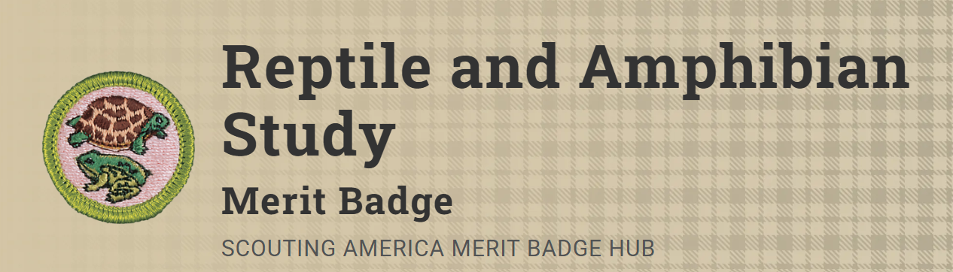
Merit Badge Counselor: Robin Blakley, robin.blakley3@gmail.com
Link: https://www.scouting.org/merit-badges/reptile-and-amphibian-study/
Kids always have been interested in snakes, turtles, lizards, and alligators, as well as frogs and salamanders. Developing knowledge about these captivating creatures leads to an appreciation for all native wildlife; understanding the life cycle of a reptile or amphibian and keeping one as a pet can be a good introduction to natural history; and knowing about venomous species can help Scouts to be prepared to help in case of an emergency.
NOTE: Scouts must remember to follow the Leave No Trace Seven Principles and the Outdoor Code while on field trips and when collecting specimens. Make sure you have permission of the land manager prior to taking any samples for your collections. Collecting is prohibited in most National and State Parks.
Scouts must not use venomous reptiles in fulfilling requirement 8(a). When you decide that keeping your specimen is no longer possible or desired, be sure to find another appropriate home for it or return it to the wild at the location of capture. Check with your counselor for those instances where the return of these specimens would not be appropriate.
Under the Endangered Species Act of 1973, some plants and animals are, or may be, protected by federal law. The same ones and/or others may be protected by state law. Be sure that you do not collect protected species.
Your state may require that you purchase and carry a license to collect certain species. Check with the wildlife and fish and game officials in your state regarding species regulations before you begin to collect.
Pre-Requisites
- (Be ready to discuss) Describe the identifying characteristics of six species of reptiles and four species of amphibians found in the United States. For any four of these, make sketches from your own observations or take photographs. Show markings, color patterns, or other characteristics that are important in the identification of each of the four species. Discuss the habits and habitats of all 10 species.
Resources: Reptiles of the United States (website)
Amphibians of the United States (website)
8. Do ONE of the following:
(a) Take custody of one or more reptiles or amphibians in a manner approved by your counselor. Maintain one or more reptiles or amphibians for at least a month. Record food accepted, eating methods, changes in coloration, shedding of skins, and general habits; or keep the eggs of a reptile from the time of laying until hatching; or keep the eggs of an amphibian from the time of laying until their transformation into tadpoles (frogs) or larvae (salamanders). Whichever you choose, keep records of and report to your counselor how you cared for your animal, eggs, or larvae, including lighting, habitat, temperature and humidity maintenance, and any veterinary care requirements. Unless you are the long-term owner, at the conclusion of this study, turn the animal(s) over to another responsible party approved by your counselor.
Resource: Pet Journaling: Track Your Pet's Needs and Your Time Efficiently (website)

(b) Choose a reptile or amphibian that you can observe or foster at a local zoo, aquarium, nature center, local rescue, or other such exhibit (such as your classroom or school). Study the specimen weekly for a period of three months. At each visit, sketch the specimen in its captive habitat and note any changes in its coloration, shedding of skins, and general habits and behavior. Discuss with your counselor how the animal you observed was cared for to include its housing and habitat, how the lighting, temperature, and humidity were maintained, and any veterinary care requirements.
Find out, either from information you locate on your own or by talking to the caretaker, what this species eats and what are its native habitat and home range, preferred climate, average life expectancy, and natural predators.
Also, identify any human-caused threats to its population and any laws that protect the species and its habitat. After the observation period, share what you have learned with your counselor.

9. Do TWO of the following:
(a) Identify at night three kinds of toads or frogs by their voices. Imitate the song of each for your counselor. Stalk each with a flashlight and discover how each sings and from where.
Resource: Frog Sounds: Why They Make Them (Examples) (video)
(b) Identify by sight eight species of reptiles or amphibians.
Resources: Reptiles of the United States (website)
Amphibians of the United States (website)
(c) Using visual aids, give a brief talk to a small group on three different reptiles and amphibians.

