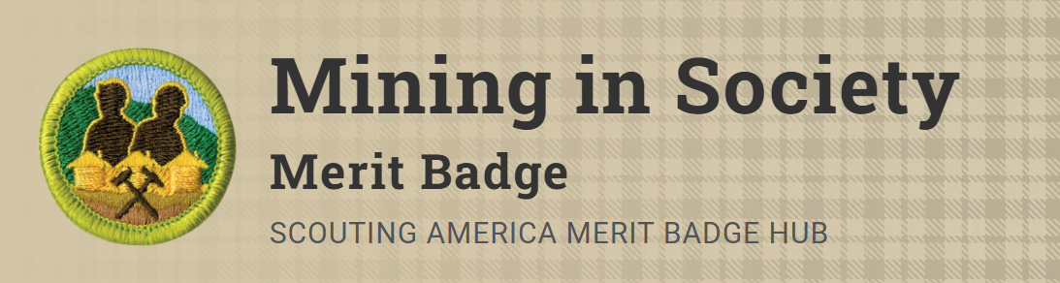
Merit Badge Counselor: Jonathan Hause, hause.surveying@gmail.com
Link: https://www.scouting.org/merit-badges/mining-in-society/
The Mining in Society merit badge covers the history of mining, explores the status of mining in the 21st century, and introduces Scouts to modern mining careers.
Pre-Requisites
None.

