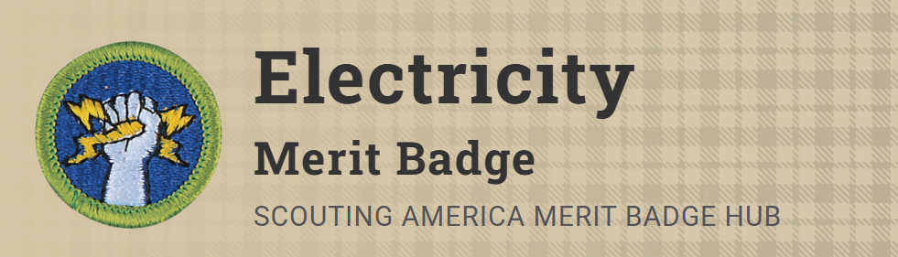
Merit Badge Counselor: Ashton Compton, 2003indyash@gmail.com
Link: https://www.scouting.org/merit-badges/electricity/
Learn why electricity plays a significant role in the economy and how energy consumption impacts our daily lives with the Electricity Merit badge. Scouts will demonstrate how to respond to electrical emergencies, explain how a fuse blows or a circuit breaker trips, and complete an electrical home safety inspection. The Electricity Merit Badge is an excellent opportunity for Scouts to learn how to read an electric meter and determine their household’s energy cost from meter readings.
Pre-Requisites
2. Complete an electrical home safety inspection of your home, using the checklist found in the Electricity merit badge pamphlet or one approved by your counselor. Discuss what you find with your counselor.
Resource: Electrical Fire Safety Checklist (PDF)
8. Do the following:
- (a) Read a meter associated with an electric bill. Determine the total power used since the bill, and the cost of that power.
Resource: Reading a Digital Electric Meter & Calculate Usage and Cost (video)
- (b) Explain other charges on the bill that were taxes or fees.
Resource: Here Are the Costs That Affect Your Electricity Bill (video)
- (c) Discuss with your counselor five ways your family can conserve energy.
Resource: Saving Energy at Home - Energy Efficiency Tips (video)

9. Explain the following:
- (a) Electrical terms: current, energy, power, resistance, and voltage
Resource: Electrical Terms Explained (website)

