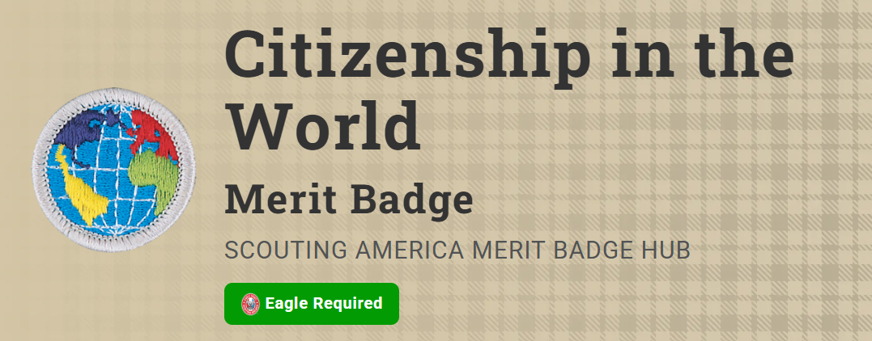
Merit Badge Counselor: Dawn McDonald, dawnmcdonald10@live.com
Link: https://www.scouting.org/merit-badges/citizenship-in-the-world/
Scouts who earn the Citizenship in the World merit badge will discover that they are already citizens of the world. How good a world citizen each person is depends on his willingness to understand and appreciate the values, traditions, and concerns of people in other countries.
Pre-Requisites
7. Do TWO of the following (with your parent or guardian's permission) and share with your counselor what you have learned:
- (a) Visit the website of the U.S. State Department. Learn more about an issue you find interesting that is discussed on this website.
Resources: What Does the State Department Do? (video)
USA.gov (website)
- (b) Visit the website of an international news organization or foreign government OR examine a foreign newspaper available at your local library, bookstore, or newsstand. Find a news story about a human right realized in the United States that is not recognized in another country. (Make sure you do NOT use an American website like CNN or Fox News. BBC News will work, or any other European, African, Asian or Pacific news website.)
Resources: Human Rights (video)
Reuters (website)
The New York Times World News (website)

