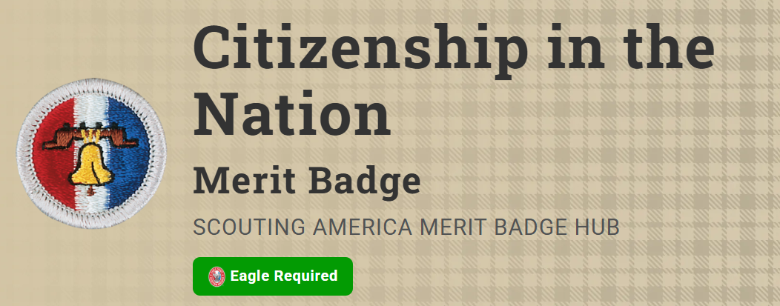
Merit Badge Counselor: Alex Acalde, alex.alcalde@5creeks.org
Link: https://www.scouting.org/merit-badges/citizenship-in-the-nation/
As Scouts fulfill the requirements for this merit badge, they will learn how to become active citizens are aware of and grateful for their liberties and rights, to participate in their governments and protect their freedom, helping to defend their country and standing up for individual rights on behalf of all its citizens.
Materials needed
Each Scout will need to bring their cell phone for use in class.
Pre-Requisites
5. Watch the national evening news for five days in a row or read the main stories in a national media organization (e.g., a newspaper or news website) for five days in a row. Discuss the national issues that you learned about with your counselor. Choose one issue and explain how it affects you, your family, and community.
Resources: Tracking Planner (PDF)
Factbot (website)
FactCheck (website)
AP News (website)
Politifact (website)
7. Do TWO of the following:
- (a) Visit a place that is listed as a National Historic Landmark or that is on the National Register of Historic Places. Tell your counselor what you learned about the landmark or site and what you found interesting about it.
Resources: America's National Parks National Passport Program (website)
National Park Service (website)
National Archives (website)
Does Historical Preservation Even Matter? (video)
Museum of the American Revolution - Virtual Museum Tour (website)
- (b) Tour your state capitol building or the U.S. Capitol. Tell your counselor what you learned about the capitol, its function, and the history.
Resources: Capital Curiosities: Exploring Why State Capitals Aren't Always the Biggest Cities (video)
Live, Virtual US Capital Tour (website)
- (c) Tour a federal facility. Explain to your counselor what you saw and what you learned about its function in the local community and how it serves this nation.
- (d) Choose a United States national monument that interests you. Using books, brochures, the internet (with your parent or guardian's permission), and other resources, find out more about the monument. Tell your counselor what you learned, and explain why the monument is important to this country's citizens.
Resources: US Senate (website)
GovTrack (website)
USA.gov (website)
Common Cause (website)
US House of Representatives (website)

