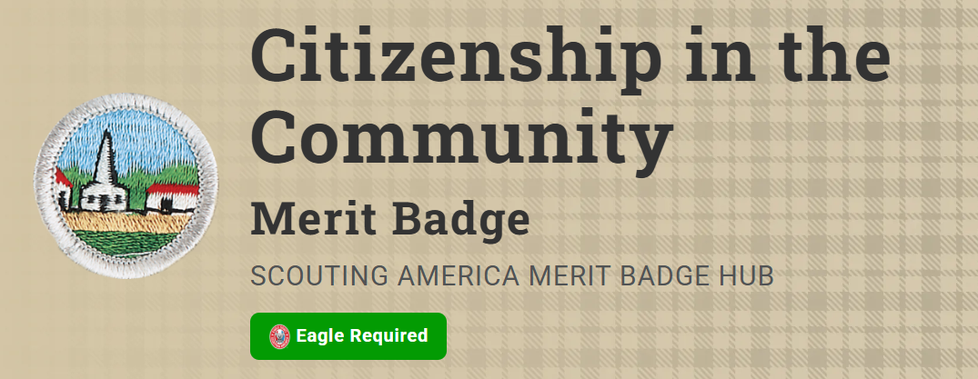
Merit Badge Counselor: Robert Wager, Robert.wager@att.net
Link: https://www.scouting.org/merit-badges/citizenship-in-the-community/
A nation is a patchwork of communities that differ from each other and may be governed differently. But regardless of how local communities differ, they all have one point in common: In the United States, local government means self-government. Good citizens help to make decisions about their community through their elected local officials.
Pre-Requisites
4. Choose an issue that is important to the citizens of your community; then do the following:
- (a) Find out which branch of local government is responsible for this issue.
- (b) With your counselor's and a parent or guardian's approval, interview one person from the branch of government you identified in requirement 4(a). Ask what is being done about this issue and how young people can help.
Resource: Tips and Tricks on Preparing and Conducting an Interview (video)
- (c) Share what you have learned with your counselor.

7. Do the following:
- (a) Identify three charitable organizations outside of Scouting that interest you and bring people in your community together to work for the good of your community.
Resources: How to Find the Best Charities (video)
Charity Navigator (website)
The Tax Exempt Organization Search Tool (website)
Better Business Bureau (website)
American Red Cross (website)
Habitat for Humanity (website)
The YMCA (website)
- (b) Pick ONE of the organizations you chose for requirement (a). Using a variety of resources (including newspapers, flyers and other literature, the internet, volunteers, and employees of the organization), find out more about this organization.
Resources: Finding a Good Charity (video)
Volunteer Opportunities (website)
Charity Navigator (website)
Charity Ratings (website)
Mobile Food Pantry Eagle Project (video)
- (c) With your counselor's and your parent or guardian's approval, contact the organization you chose for requirement 7(b), and find out what young people can do to help. While working on this merit badge, volunteer at least eight hours of your time for the organization. After your volunteer experience is over, discuss what you have learned with your counselor.
Resource: Benefits of Community Service (video)
8. Develop a public presentation (such as a video, slide show, speech, digital presentation, or photo exhibit) about important and unique aspects of your community. Include information about the history, cultures, and ethnic groups of your community; its best features and popular places where people gather; and the challenges it faces. Stage your presentation in front of your counselor or a group, such as your patrol or a class at school.
Resource: How To Organize and Deliver a Great Presentation (video)

