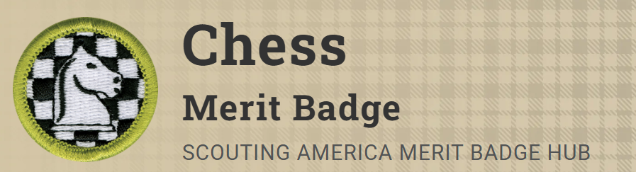
Merit Badge Counselor: Roman Kmicikewycz, roman.kmicikewycz@gmail.com
Link: https://www.scouting.org/merit-badges/chess/
Chess builds critical thinking, forward thinking, and proper sportsmanship in young people.
Materials Needed
Bring your own Chess set.
Pre-Requisites
None.

